Programming Mobile Devices
(Android Mobile Apps Development)
Course Notes, Exercises, Code Examples & Resources
karl mobile. Updated 2018.04.18
About
This document is intended for students wishing to learn how to develop Mobile Apps using the Android platform. It contains the theory, development tools setup and exercises. The original copy is a google document, is.gd/s8bAtC & goo.gl/B4Cic8 where you’ll find the latest version. It's QR Code is on page 2.
It can be downloaded to a desktop platform (File | Download As… ) in PDF, ODF, DOCx etc. formats. ODF seems to work best.

Book
The recommended book is only $20 for a six month subscription and is updated regularly. The price includes both the PDF and Android App versions of the book. Title & link: “The Busy Coder's Guide to Android Development”. Book code examples, free to download without buying the book, are on github.

Code Sources
All Code used in these notes is downloadable from this google drive folder.(.) The format is 7z so use 7z on windows/linux and The Unarchiver on Mac. Alternatively you can download examples individually as you come across them in the notes - there’s a link provided for each example. The examples are mostly in Android Studio project format otherwise they’re in Eclipse ADT format which Android Studio can easily import, as described later.

Skip to: Start of Lecture Notes, End of lecture notes

Lecture Progress HDip 2018
Week | Date | Page | Topics | Recording
1 | 31 Jan | 26 | Intro, Mobile market background, screens, keyboards, android architecture, intro to Activities & Intents. Also see these recording links: Create an AVD, and creating a ‘hello world’ application. | link
2 | 07 Feb | 74 | XML resource files. Referencing XML resources from java and another XML file. ‘hello world’ & addition examples. | link
3 | 14 Feb | 102 | Addition App, Activity Lifecycle, Explicit & Implicit intents, launching a second activity from the first. Labs: continue with exercises in this document up to exercise 3.1. | link
4 | 21 Feb | 119 | Passing Data between activities, Toast, Dialog, started notifications. Labs: Assignment 1 posted on Blackboard, due wk8: 21st March. | link
5 | 28 Feb |  | snow
6 | 07 Mar | 147 | Notifications with pending intents, controlling layout of gui components, EditText, Relativelayout manager, programatically creating a linear layout. | link
7 | 14 Mar | 180 | Changing Text size & colours in text components. Common listener object for multiple GUI components. Checkboxes, radio buttons, toggle buttons, Spinner (+ adapter). | link
8 | 21 Mar | 215 | (Asn1 due 25/03/2018, Asn2 published)  Implicit intents shown using ListActivity, keypresses & intercepting them, menus + contextual menus. | link
-- |  |  | Easter break, no classes
9 | 11 Apr | 250 | Short & long click on a view, Gestures: fling & own gestures saved in a library, persistent data storage - shared preferences | link
10 | 18 Apr | 274 | Persistent data storage (cont'd.): Shared Preferences, Java File IO. Graphics - Canvas, Paint classes & drawing methods. Custom Widget. | link
11 | 25 Apr | 285 | Background Services | link

Page number listed above is where we finished in the lecture

Old Lecture progress 2017 (for reference only):
Old:
- 032 13 Sep
- 053 18 Sep
- 060 20 Sep
- 070 25 Sep
- 081 27 Sep
- 091 02 Oct
- 101 04 Oct
- 108 09 Oct
- 115 11 oct
- 123 18 oct
- 139 23 oct
- 152 25 oct
- 168 01 nov
- 187 06 nov
- 206 08 nov
- 240 13 nov
- 267 15 nov
- 281 20 nov end
- ... 22 nov Tutorials
“Programming Mobile Devices”
This Document, “Android Mobile Apps Development”, QR Code (QR app)

http://is.gd/s8bAtC

Main Index (to get back here there’s a link in each page's footer)
- Lecture Notes Index is on next page, Lecture progress & recordings

- Setting up Development Environment for your own computer
  - Get the Development Tools, Android Studio, for your Computer
  - Emulator Tips, speeding up.
  - Using a real phone connected via USB instead of an emulator
  - Android Studio Installation issues & other issues

- Labs, getting started & Exercises
  - Create Hello World app on Android Studio
  - Import an existing example in Android Studio (AS or Eclipse project)
  - Android Lab Exercises to do (very end of this document)
  - kg to add: LogCat, System.out.println, filters. ***

- Common Tasks
  - Adding a second Activity to an Android studio App
  - Adding a locale to your Android Studio Project
  - Android Studio Keyboard Shortcuts
  - Simulating incoming call & Text message
  - Changing SDK version & other target errors
  - Obfuscating see stackOverflow
  - Signing an APK & Deploying to Google Play (*** to be added)

- Resources - handy links, tutorials, newsletters etc

Notes Index (to get back here there’s a link in each page's footer)
- Lecture notes start page, followed by the following topics:
  - Introduction
    - Mobile Phone Stats
    - Evolution of Android
    - Android SmartPhones, some examples
    - (WIP: add more to this index)
  - Application Basics
    - Simple Activity ye Olde ‘hello world’ program from the book
    - Activity Lifecycle How an Activity launches, runs, and is destroyed.
    - ActivityLifeCycle Code example onPause(), onCreate() etc.
    - Simple Addition Calculator example - introduces an EditText and Button
  - Explicit Intents, Implicit intents
  - Multiple Activities (screens)
    - MenuScreen Creating and launching a second activity from the 1st using an explicit intent.
    - Passing Data between Activities ‘Douglas Adams’ example
  - Alerting the user
    - Toast brief message using pop up toast message
    - AlertDialog box - show a dialog with up to three buttons
    - ShowNotification & pending intents
  - EditText - entering text
  - Screen Layout
    - Width Height UI Layout
    - Relativelayout
    - Programmatic layout: LinearLayout example + 2 others
  - Fonts and Colour
    - Changing Font colour
    - Changing Fonts
  - Text Entry in an EditText object
  - Widgets - various user interface components
    - CheckBox
    - ImageButton
    - ToggleButton
    - RadioButton
    - Spinner Example 1
    - Spinner example 2 using Strings XML array
  - Implicit Intents
  - ListActivity Implicit intents full screen/activity showing a only a list
  - String Array in XML, then inflated in Java
  - Progress Bar also simpler without thread posts ProgressBarDemoKG
  - SeekBar Example 1 - only the user controls the SeekBar
  - SeekBar Example 2 User AND program can control the SeekBar
  - User Interface Events - keypresses, touch events, gestures etc.
  - Page 119 Physical Key Press
  - Menus
    - Options Menu
    - Context Menus
  - Gestures
    - Touch Examples
    - Fling Example
    - Using Gestures - Gesture Builder Setup for P136 example:
    - Pulling a file from a Virtual Device (example gestures file)
    - Using Gestures
  - Data Storage
    - Shared Preferences
    - Preferences Framework Example
    - File Saving and Loading
    - Example using Java.io - AddtionFileIO

Writing and Reading Objects
  - Graphics
    - CustomWidget - draws graphics in custom view
    - DemoGraphicsView - entire Activity used to draw into.
  - Background Services
  - End of lecture notes

Get the SDK for your own Computer (already installed in labs)
You can download the tools, Android Studio based in IntelliJ platform, for your own computer, they’re free. Download Android Studio here: https://developer.android.com/studio/ & Just run the installer.
Supports Linux, Mac, Windows.

Real phone connected via USB instead of an emulator
http://michaelcrump.net/enable-usb-debugging-with-nexus-5-for-android-studio/

Emulator tips (ADT emulator):
- When starting it check setting ‘Scale Display...’ and set to say 10in if your desktop monitor height is ~11in. On a laptop 8in works well
- Turn off Screen lock: Apps | Settings | Security | Screen Lock | -> None
- Extend screen dimming: Apps | Settings | Display | Sleep | -> 30 mins
- It takes ages for the emulator to start up - do don’t close it again until you’re finished with the ADT.

Speeding up the Android Emulator
- If possible use a real android phone and connect that via usb instead of the emulator - you may need drivers, check what s/w came with your phone and/or google it.
- Use intel x86 emulation instead of ARM which is the default http://software.intel.com/en-us/android/articles/speeding-up-the-android-emulator-on-intel-architecture Check the option 'use Host GPU'. 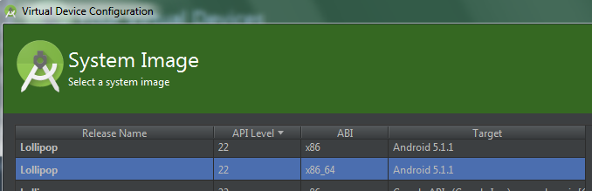

Android Studio Lab Installation Issues
open the file c: AndroidStudio/bin
Edit the file idea.properties
add this line to the end of that file:
disable.android.first.run=true
If you get this error:

Then follow the instructions in the dialog and so you have the Android Studio SDK set up as follows:

Android Studio other Issues
To move the emulator window in windows: Alt-space m, then use arrow keys to move.
If the XML layout file fails to render to to them icon:
and then select e.g. holo dark:
_______________________________________________________________

Android Studio Skipped Frames Error:
“Choreographer(abc): Skipped xx frames! The application may be doing too much work on its main thread.”
This probably means the emulator is slow especially if the number of frames skipped is <100. It probably wouldn't happen on a real phone. More info.

Changing SDK versions: Android Studio failed to sync Gradle project… (also changing Minimum SDk & compiled SDK)
Failed to sync Gradle project ‘addition’
Cause: failed to find target with hash string ‘android-21’ in c:....\Android\sdk
Two solutions:
- Either update your sdk with the required tools version and tick SDK Platform
- Change the compile SDKVersion in your build.gradle (module script) to what you’ve installed under SDK tools, see following screens →
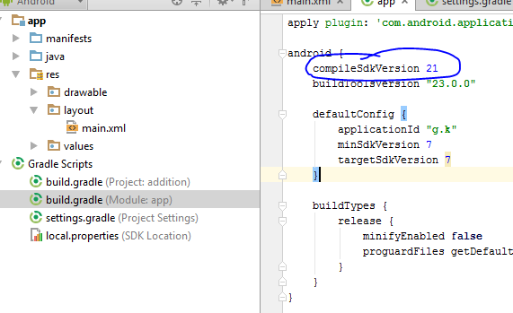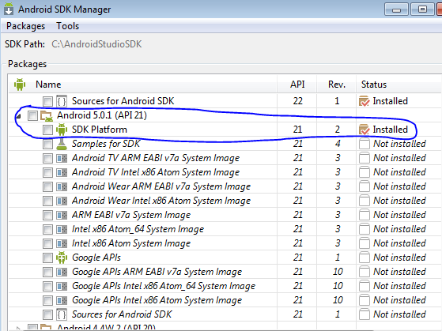
Save you build.gradle file and you may get this error:
Gradle project sync failed….
so select clean project from Build menu then Rebuild project
so click on Try Again.

Changing compiled SDK version:
R-Click on App folder, Open Module Settings

This error:
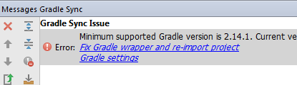
Just click on link.

Missing theme (Same as first problem above) below is Text view of layout file:
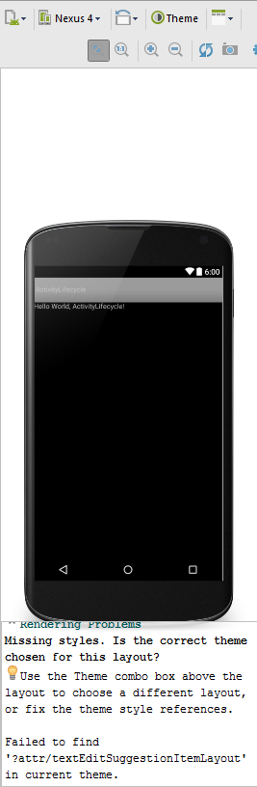
Select from theme - e.g. holo dark & then holo

No Render problem:
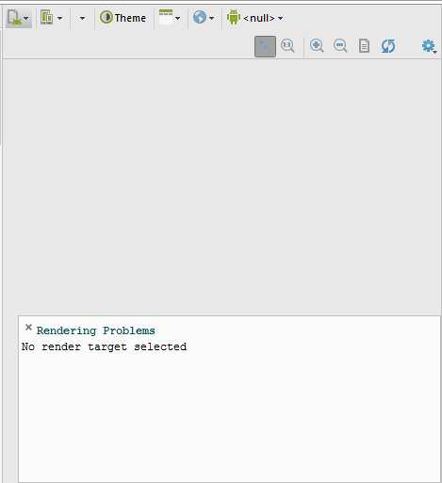
I fixed this but don’t know how! It might be and AS bug.
Tried changing the target SDK in build.gradle (module app), created a new AVD with same SDK level as installed in android studio.

Problems Importing an Eclipse project:
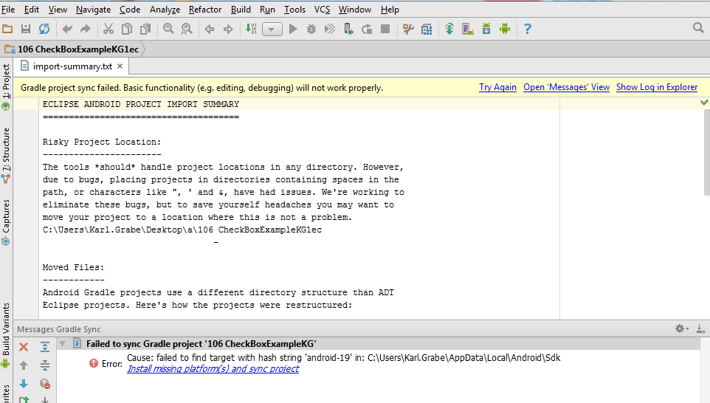
Click on install missing platforms OR
Check what platform you have: on the menu Tools|Android|SDK Manager we see that we have Android 7 which is level 24 (and 23)
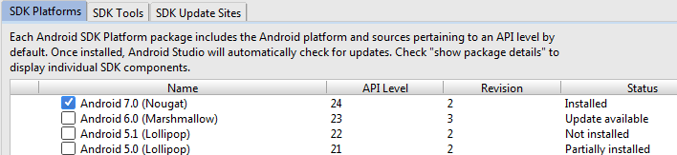
Edit build.gradle in src from:
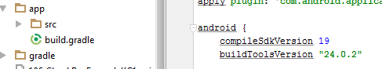 to…
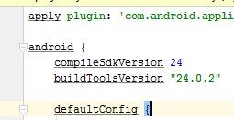
Click try again:
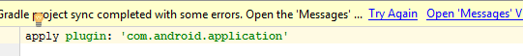
And click this:
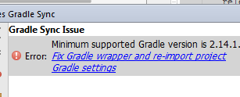

Create Hello World 1st App - Android Studio

2016: First Android Studio is not fully installed and configured in the lab so follow the screenshots in this document:
https://docs.google.com/document/d/1QdyzGNgLmJnfCnStt7Ma1WG1UyEEpzFoXrKeP4t8S6Q/edit?usp=sharing
It will take you 30+ mins so take your time and follow each screen exactly and the document also describes how to create and run an ‘hello world’ App.

Thereafter you can create a new project this way
File new | Project
choose blank activity (update: choose empty activity - see install activity above)

Select name of Activity file & XML layout files
There’s also a tutorial on the above here: https://developer.android.com/training/basics/firstapp/creating-project.html

Create an AVD in Android Studio
OR Using the (slower) Android ADT emulator create an AVD as follows
- “+Create Virtual Device” button
- Select a phone e.g. Nexus 5
- Select Lollypop 22 X86… Android 5.1.1 - see screenshot below
- Next
- Scale 4dp on device = 1px (or else use AUTO)
- Finish.
- Wait a while and once it’s running go back to android studio and click green play button to which will launch your app on the phone.

Importing an existing example in Android Studio (or import Eclipse project)
Instructions:
- Get the examples from the google drive location mentioned on page 1 above.
- Locate the example you’re interested in from this google drive folder. e.g. 025_1_SimpleActivity.7z (expand it to your harddrive), we’ll import it into Android Studio…
- From Android Studio… File | New | Import Project…
- On the dialog click the icon to the right of the Home icon
- Find the project…
- Click OK then next
- Choose directory (use a local drive NOT network drive), Next, use defaults, Finish
- If there’s an error “failed to find target…” then click “install missing platforms “ click it then Accept License agreement, Next, Finish. You may get a second error, click the fix for that too.
- Click green ‘play’ icon to run.

NOTE: For item 9 you can also change the target to one already installed instead of installing the missing one. Go to Gradle Scripts and select Build Gradle (modile app) and change the versioni to one that is installed on your android studio E.G. these lines see Changing SDK version:
android {
compileSdkVersion 24
buildToolsVersion "24.0.2"

NOTE: The examples have individual links in the notes section of this document.

Now go here:
  - Android Lab Exercises to do (very end of this document)

Add a Second Activity (using Android Studio Wizard, see next page to do it manually)
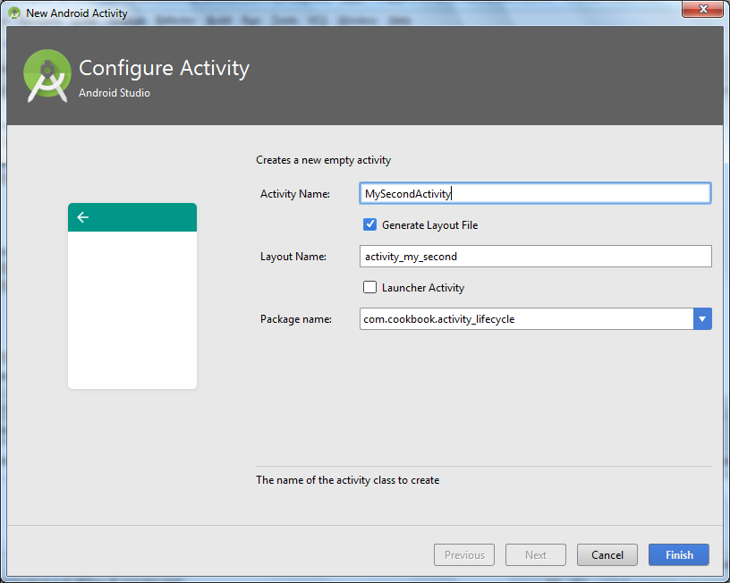
From Android Studio, right-click on project “Java” folder and select New | Activity | Empty Activity.

Name your second Activity e.g. MySecondActivity Click Finish.
You should now have two new files added:
- Under java source - MySecondActivity.java
- Under Res/layouts - MySecondActivith activity_my_second.xml. Add components using visual tool as usual.
You may need to switch themes if there are rendering problems, use e.g. ‘Holo Dark’ -->
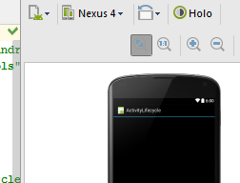
Check if Android Studio correctly added a second activity tag in the Manifest file for your second activity - if not add/edit it to look like this:
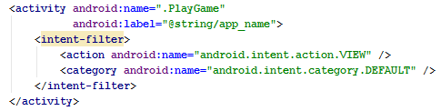
Where “.PlayGame” is the name of your new activity class and @string/app_name is the string to display in the activity title (app name in this case but can be some other string resource). Note also the action and category tags are VIEW and DEFAULT respectfully.
To test all is working create a Button in the first Activity that, when clicked, takes you to the second activity. The code the button press launches would look like the following (See MenuScreen example further back) but replacing PlayGame with mySecondActivity:
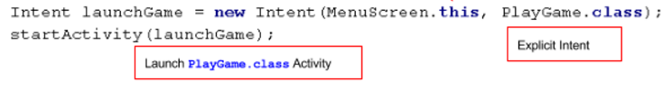

Add a Second Activity - Manually

- Create a new class, File | New | Java Class
- Call it e.g. mySecondActivity, extend from Activity or AppCompatActivity.
- Create a new XML Layout File File | New XML | Layout XML File
- Follow the steps on the previous page from “You need to update the manifest file…”

Add a Locale
File | New | Android Resource File
type the file for the resource e.g. strings.xml
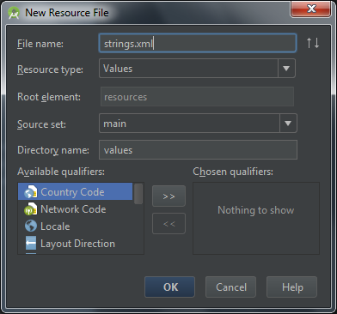
select available qualifiers to select Locale and >> to pick a locale & region e.g. et Estonian
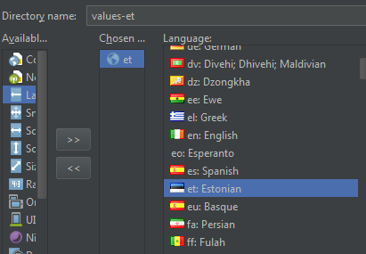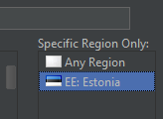
Press OK and add to new resource file.
Build | Clean Project to make the new strings.xml file appear:
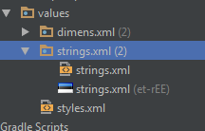
+++ (kg - check this) also r-click strings.xml | open translations editor | Click on ‘world’ icon to add locale
Simulating an Incoming Call - Android Studio
- Run an emulator and wait for it to boot up
- Tools | Android | Android Device Monitor
- Select the emulated device under devices tab
- Select Emulator Control tab
- Enter incoming number e.g. 123
- Select voice (instead of Text)
- click Call
- go to AVD emulator and answer the call
- hang up
- check your app correctly resumes
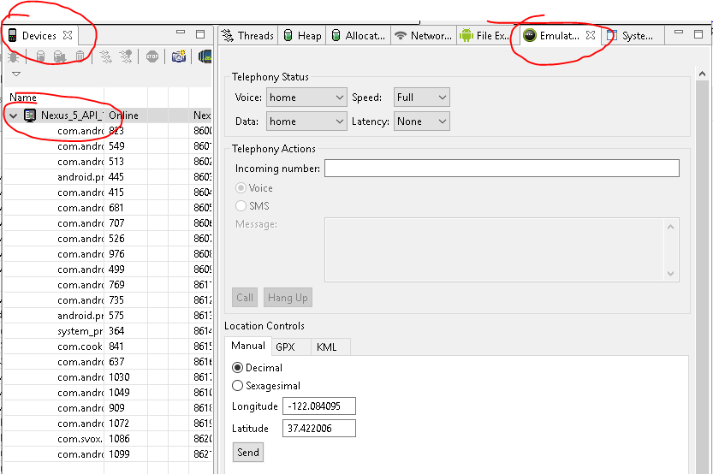

Simulating an Incoming Text Message
Same procedure as above, select Text instead of voice

Lecture Notes

- Mobile Apps Lecture Notes. The Notes index link is in the footer of this document (on mobile devices select print layout in settings).
These notes contain extracts (and so copyright) from various places including:
- The Android Developer's Cookbook (1st Edition)
- Developer.android.com - Android developer resources - API, tutorials, samples etc
- Wikipedia
- karl

FYI the start of this subject...
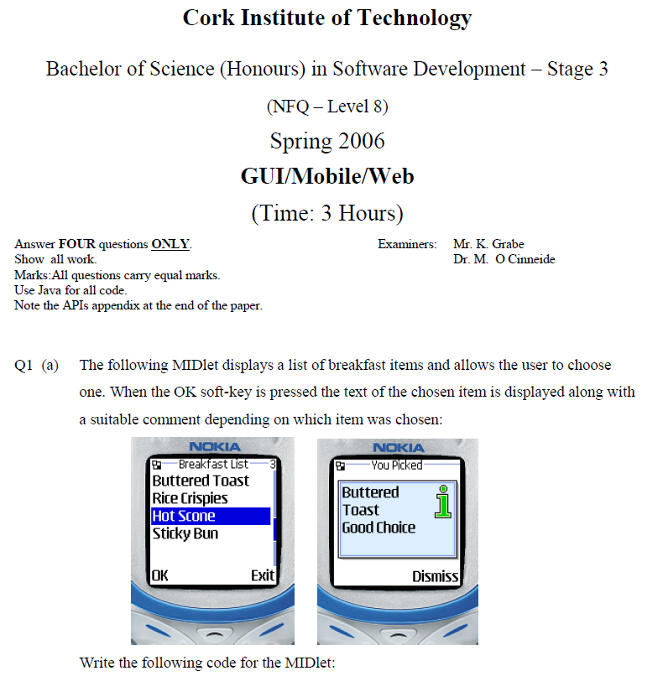

Mobile Statistics (2011+)

- People 7 Billion
- FM Radios 4 Billion
- Land Lines 1.15 Billion
- PC's, laptops, notebooks 1.4 Billion
- Internet users 1.8 Billion
- TVs 1.6 Billion
- Cars 950 Million
- Mobiles 7 Billion 2015

AA Phone Box
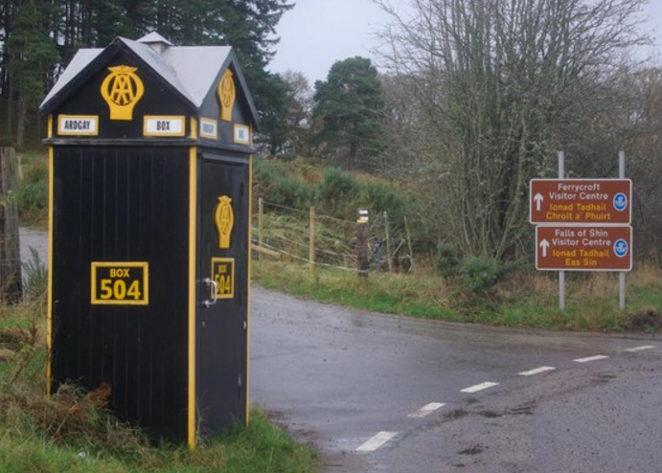

Mobile Explosion
List of years where the number of mobile devices exceeded other technologies:
2000: 500 Million mobiles
2002 > Landlines
2003 > TV sets
2004 > Credit cards
2008 > FM Radio
Mobile now the most used technology
Mobile growth: X10 in 10 years, others X2
#Mobiles > # of people that have running water
#Mobiles > # of people using a toothbrush

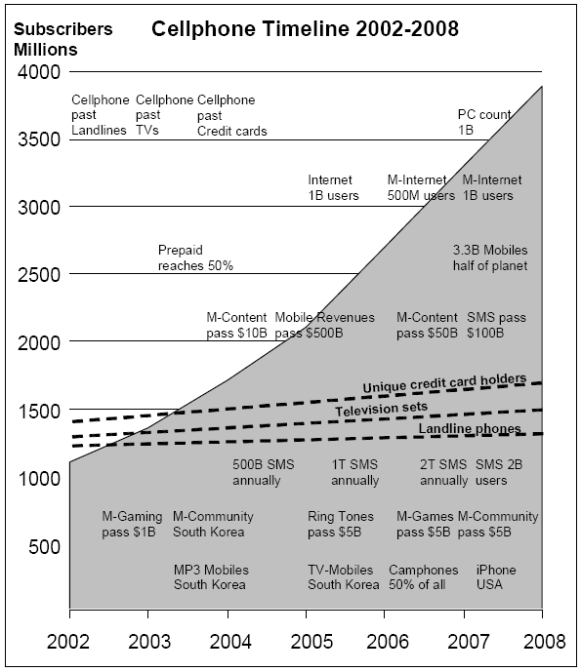

Number of Connected Devices

In the Beginning….

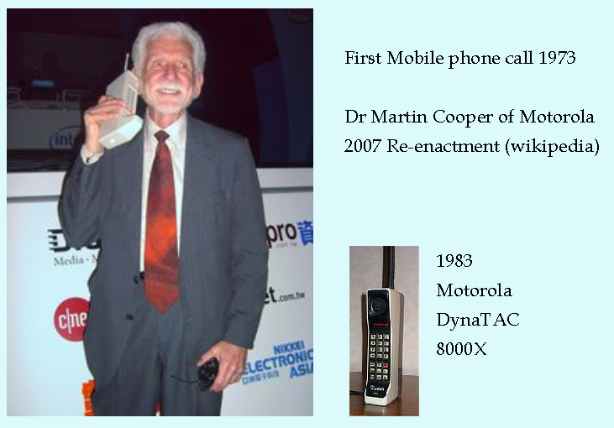
Interview with Martin Aug 2015 at age 86 https://youtu.be/Xi5-CyFAoWY

The Future is...

Wearables?


Evolution of Android
In the mid 2000’s the search engine giant Google noticed an increase in mobile internet usage and mobile search. It wanted its own mobile platform. So in 2005 it acquired a company called Android Inc. that was developing its own mobile platform since 2003 based on the Linux kernel. wiki
In 2007 Apple introduced the iPhone with innovative features such as multi-touch and an App store. Android was then adapted to have these and additional features like multitasking and allowing more control for developers. Android was to target enterprise requirements such as exchange support, VPN (virtual private network). RIM (Research In Motion) had a large proportion of the enterprise market and Google wanted to target that with Android.
Nokia, who was the number one phone manufacturer in 2005, failed to see the significance of smartphones and the App market. It lost market share in a dramatic fashion: source
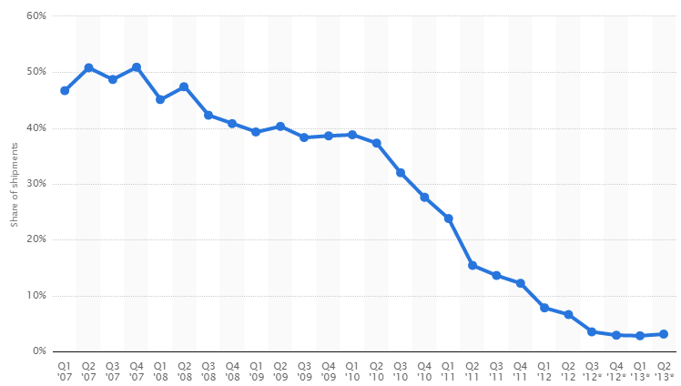

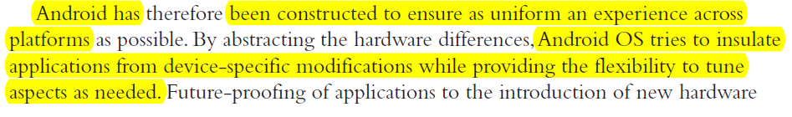
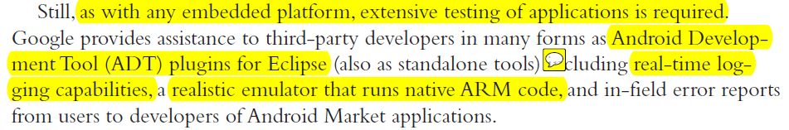

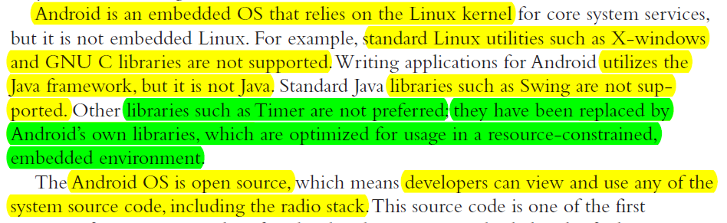

A dichotomy is any splitting of a whole into exactly two non-overlapping parts

Devices Running Android
Phones, Tablets, TV’s, Smart TV box. embedded devices (Android is a generic embedded platform), wearables - Android Watch
In May 2013, at Google I/O, Sundar Pichai announced that 900 million Android devices had been activated.^{[226]}

Google Play Store (wiki)
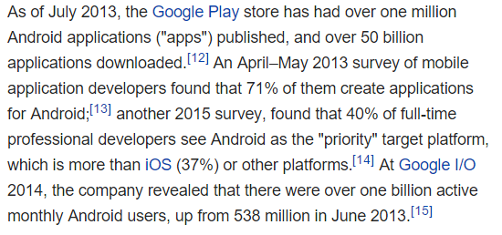

P3
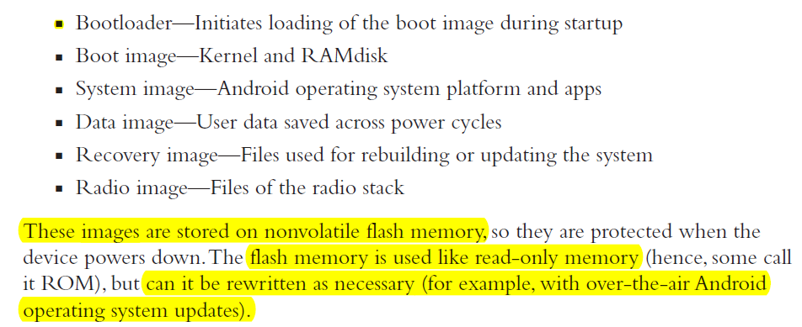

Android Smartphones, examples

Nexus 6 (€450 Sept 2015)
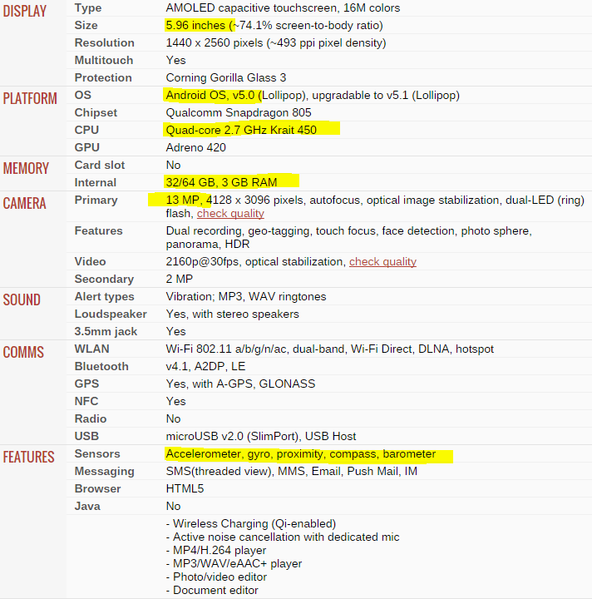

Galaxy Core Prime (€90 pre-pay Sept 2015)
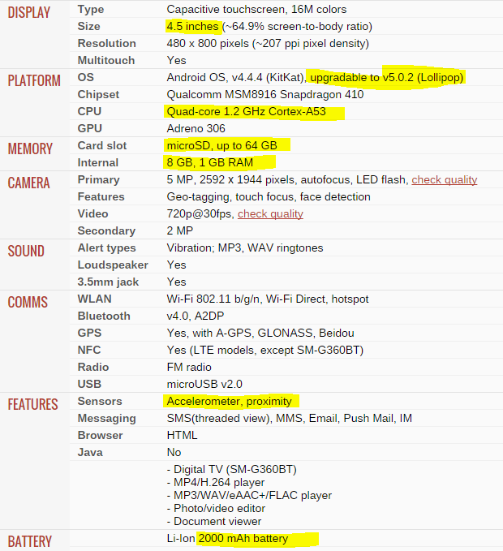

Some Android devices come with an SD card slot.

Screens
Mainly LED or LCD
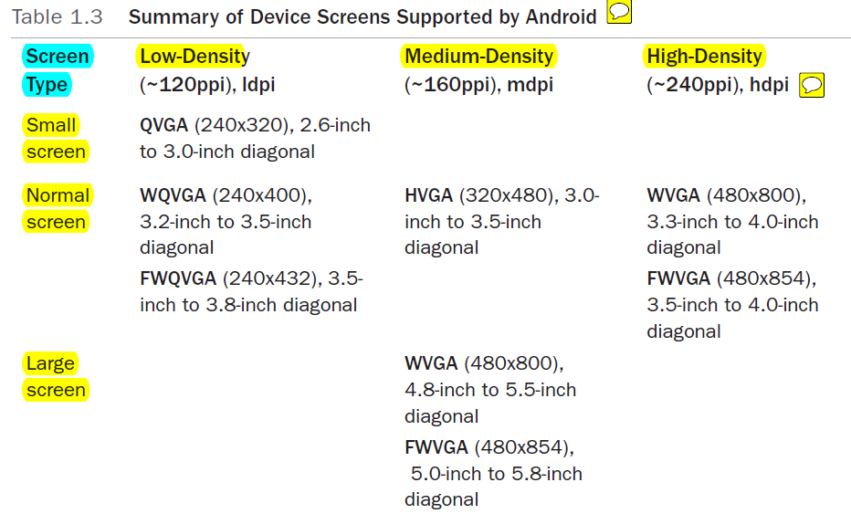

Definitions:
- ppi - pixels per inch
- dip - dots per inch
- hdpi - high resolution
- http://www.ideastraining.com/PDFs/UnderstandingResolution.pdf

User Input Methods
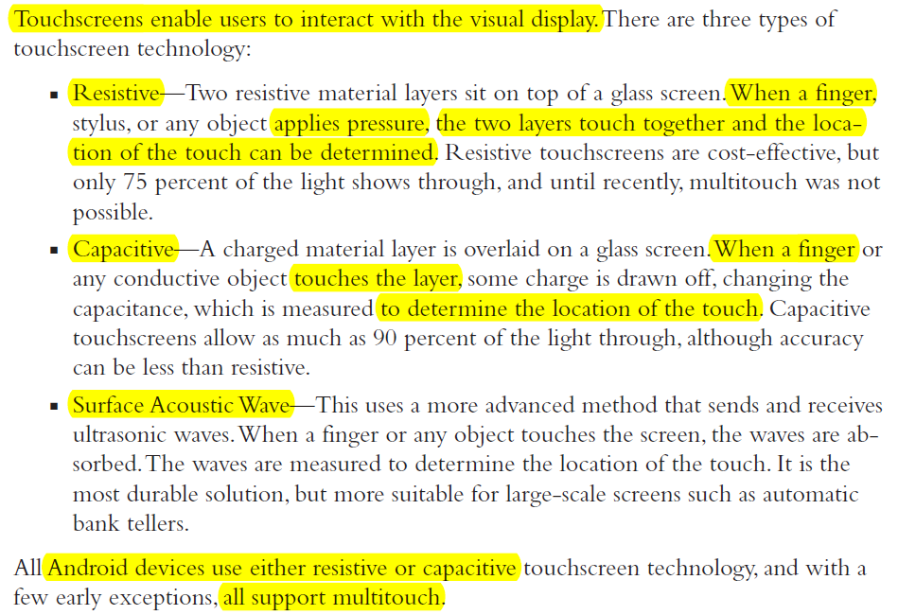

Sensors
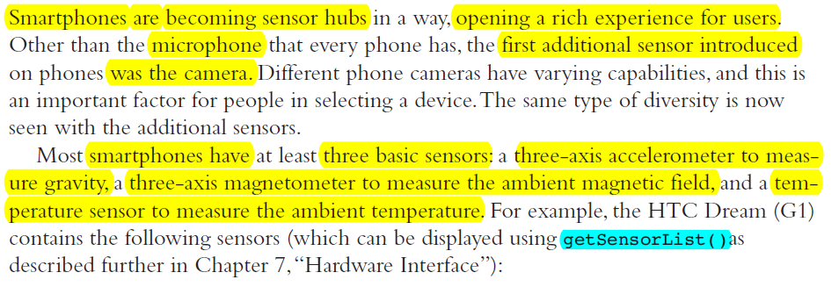
Richer i/o than laptop or desktop
- The orientation sensor is a virtual sensor that uses the accelerometer and magnetometer to determine the orientation.
- Short-range proximity detector that turns the screen off when an object (such as the ear) is within about 40mm distance

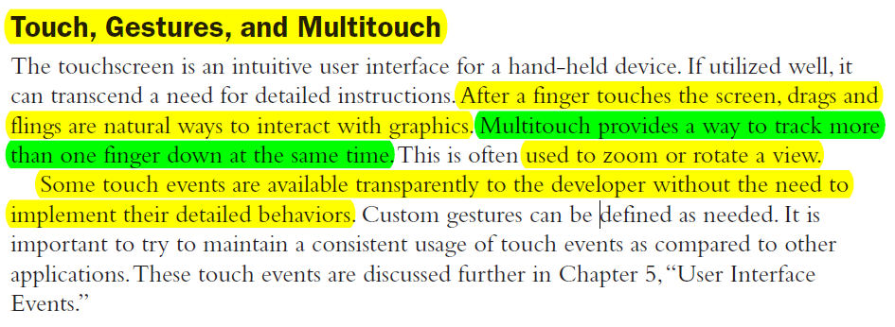

Hard and Soft Keyboards
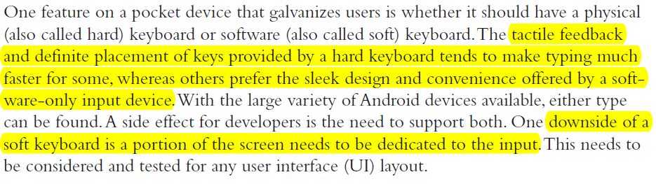

Pressure-Sensitive Touch Screens becoming available e.g. iPhone 6s
On android OS GUI a widget can register long-press as a different event to a normal press.

Android Development Tools
- Android Software Development Toolkit (SDK)
- Eclipse with Android SDK plugin (upto 2014) downloadable from karl’s sources (pw needed)
- Android Studio developer.android.com/sdk/ (after 2014) Based on JetBrains' IntelliJ IDEA
- Design guide inc Material Design: developer.android.com/design
- Action Bar and Tab Icon generator.

Maintaining Forward Compatibility
New Android versions are generally additive and forward compatible at the API level.
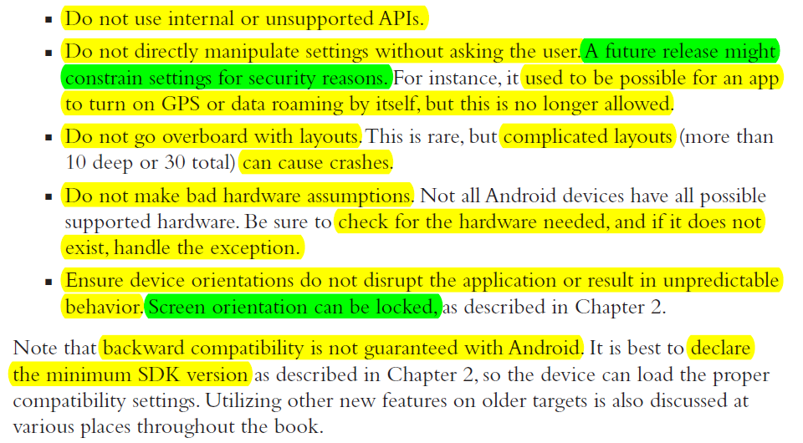

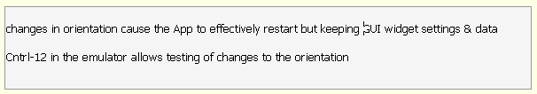

Robustness
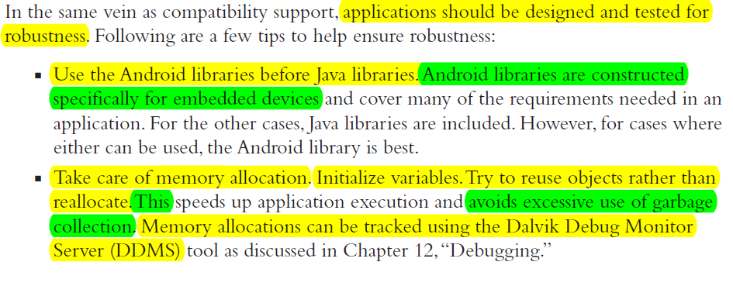

Software Features and API Level

There are THREE ways to describe the version of the android OS
- The Version - text in format X.X.X etc
- A code name - text
- The API level - an integer- each major or minor upgrade goes up by 1.
Examples (as of Sep 2015 Wikipedia) :
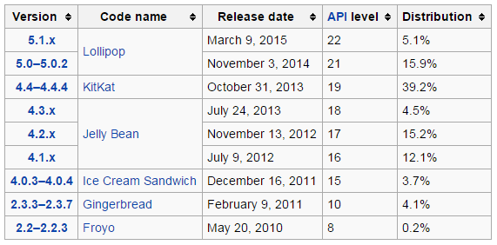
Each update adds its own features to Android OS, like this early version:
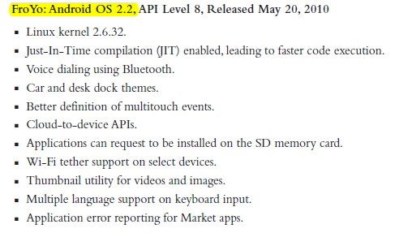
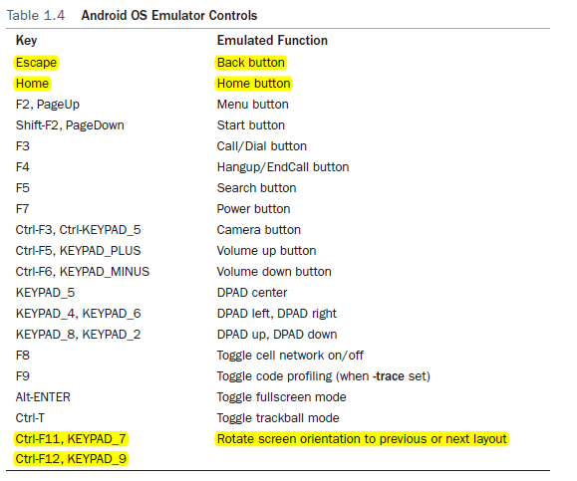

NB: This option should normally be OFF to prevent accidental App installation via email or rogue website.

Debugging
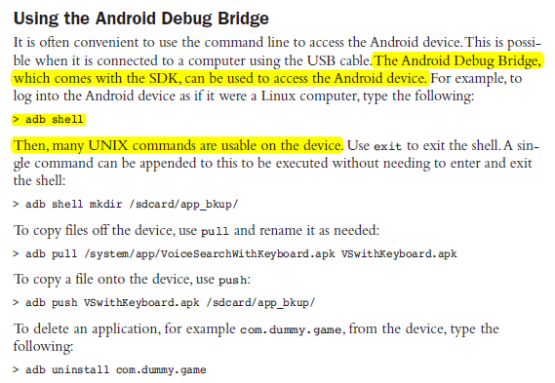

Signing and Publishing
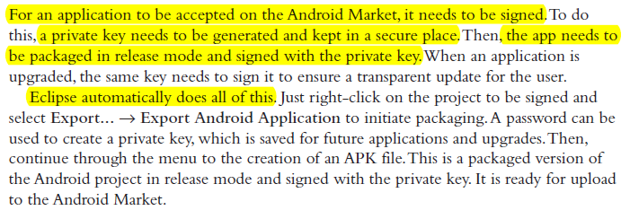
During development Eclipse automatically signs apps with a debug signature which works for testing but might not install on a device in a few months time.

Google Play is an App store was previously called Android Market and then Google Play Store. Google Play now sells Apps, Chromecast, watches etc.
To be able to upload your Apps to Google Play you must register once off as a developer, it’s not expensive.
Google Store is an online hardware retailer operated by Google that sells Google Nexus devices,

Making Money from Apps
- Provide a free app, but include advertisements - see screenshots below.
- Provide the app for a charge. Google handles its charges, but takes 30 percent
- Post a free, limited version, but charge for a full version.
- Sell virtual goods inside the app. This is an important way Facebook Apps work, and is now common in the mobile world. The App itself is normally free.
- A company commissions an App which you develop for them and they may give it away for free. E.G Banking apps, Service Station Apps etc.

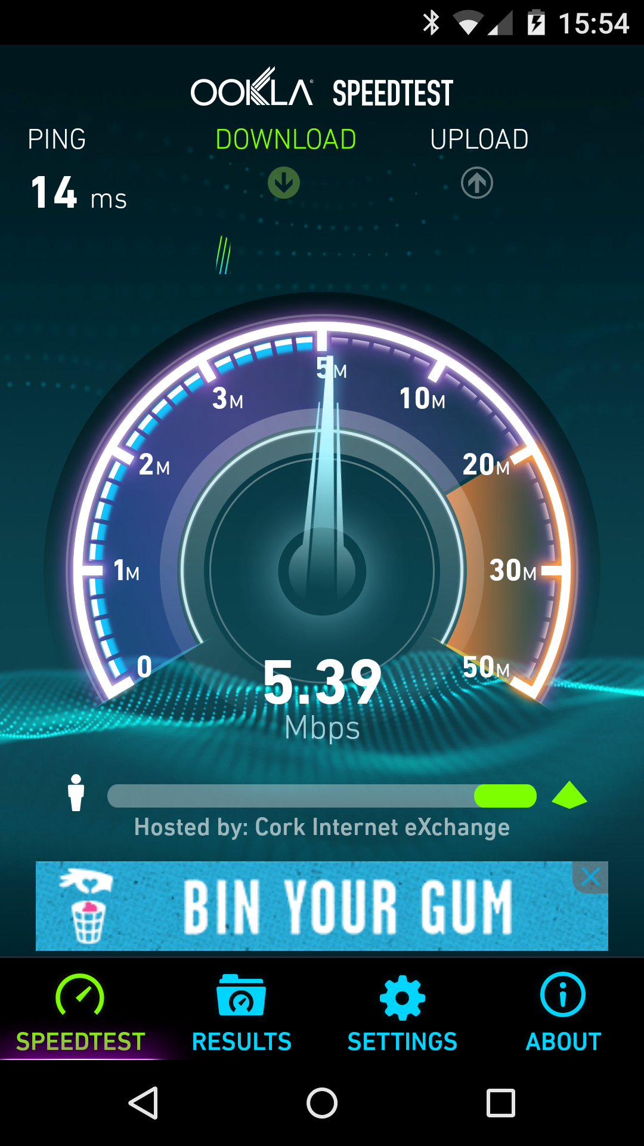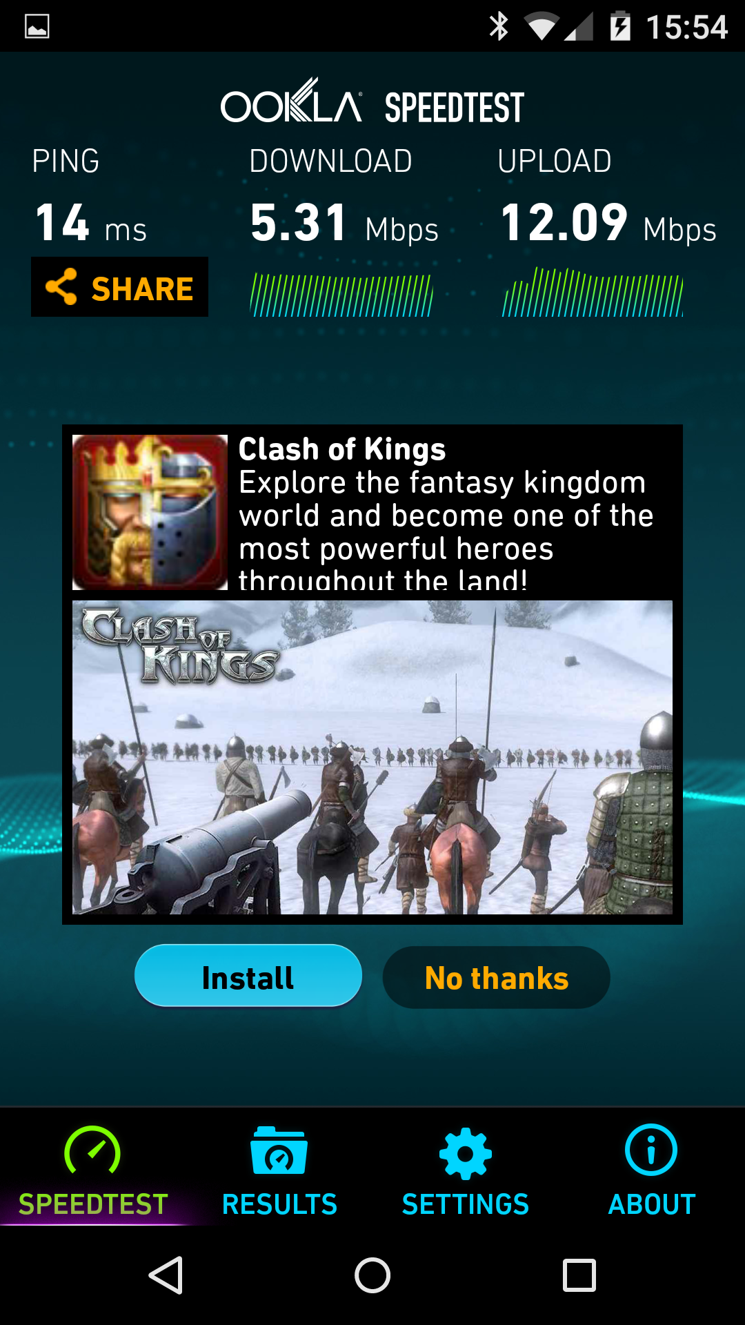
Ads in an App

Google Play - Managing App Feedback

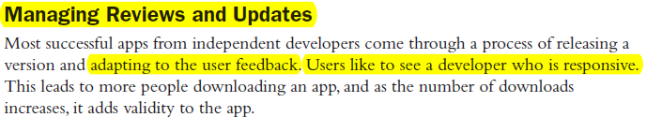
About 1 in 200 people rate an application, and a small subset of those actually leaves a review.
If someone takes the time to type a review, it is usually worth listening to it, especially if the review comments are constructive.

Alternatives to Google Play
Google allows other independent Android app stores. E.G. Slideme.org.
Android manufacturers create customized app stores: apps.samsung.com.

Application Basics: Activities and Intents
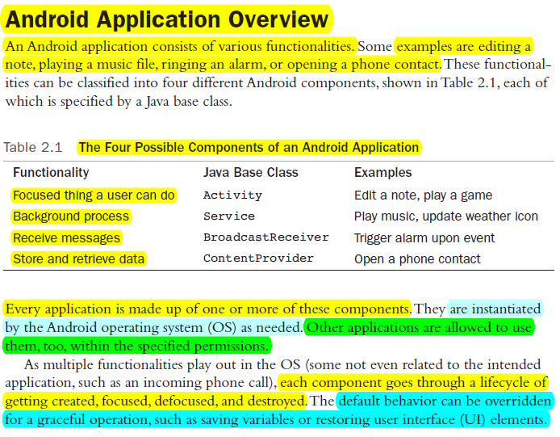
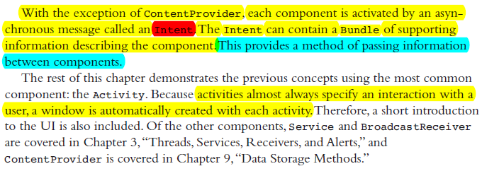
Content providers store and retrieve data and make it accessible to all applications.

Activities and Intents contd
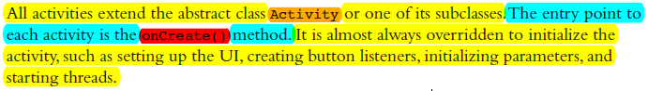

Looking up the API for a class
go to developer.android.com/reference and simply search for the class e.g. Activity

Activity Class:
developer.android.com/reference/android/app/Activity.html

Summary of Activities and Intents
An App will consist of one or more Screens. Each Screen is called an Activity and can be defined as “a single focussed thing a user can do”. Below are 3 Activities that belong to the Applegreen service station App: https://play.google.com/store/apps/details?id=ie.applegreen.applegreen
Aside: From the Google Play URL we see that the package name for this app is ie.applegreen.applegreen. That package name must be unique worldwide.
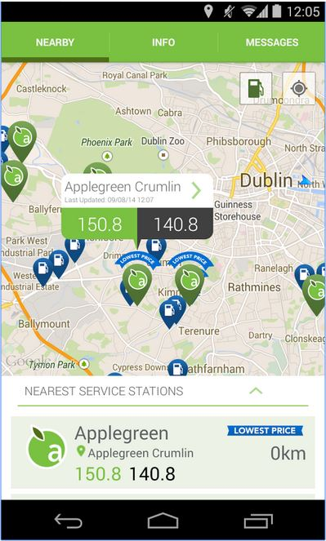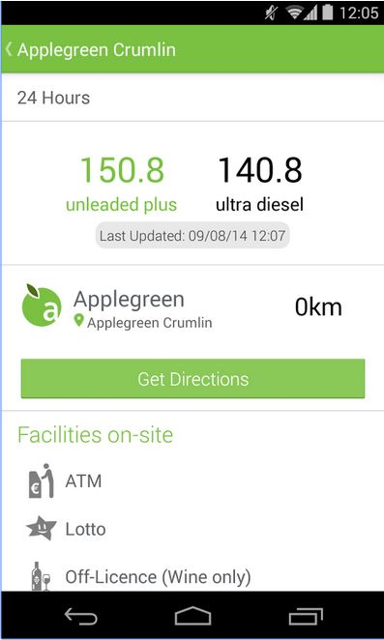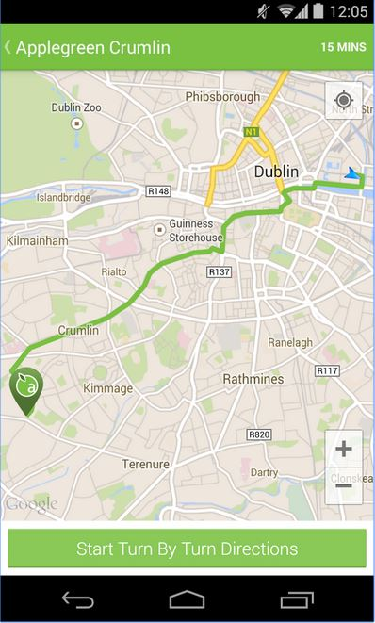
Each Activity in our project will consist of a Java source code file AND at least one XML layout file. If we want a different layout for portrait and landscape modes then we will need two XML layout files. More on these soon.

Intents allow one Activity to invoke another in the current App or an activity in another App. Data can be passed back and forth between Activities using “Bundles”.
In the above example tapping on “Get Directions” button creates an intent object, adds navigation data to a Bundle and the intent is used to launch the third Activity which navigates to the desired service station by reading the passed in Bundle data.
Aside: The “Get Directions” Button logic could have been designed to launch ANY other navigation App on the phone by passing the Bundle to the Android Operating system and letting IT decide. It may have chosen Google Maps or asked YOU
if you have multiple navigation Apps installed on your device. YOU can set a default app for future situations.

Steps to Create an Activity in an Android Project

- Create a class to extend Activity. You can also extend from a subclass of Activity e.g. AppCompatActivity, ListActivity etc.

- Override the onCreate() method. The development environment has probably done this for you already. Note, unlike a desktop application, there is NO main () method. Our activity starts when the Operating System calls our onCreate() method.

- As with most overridden methods, it must invoke the superclass method as it may need to perform some expected functionality. Here, the super.onCreate() should be invoked first to properly initialize the activity, as shown in our “hello world” example below.

Creating our First ‘Hello World’ Activity

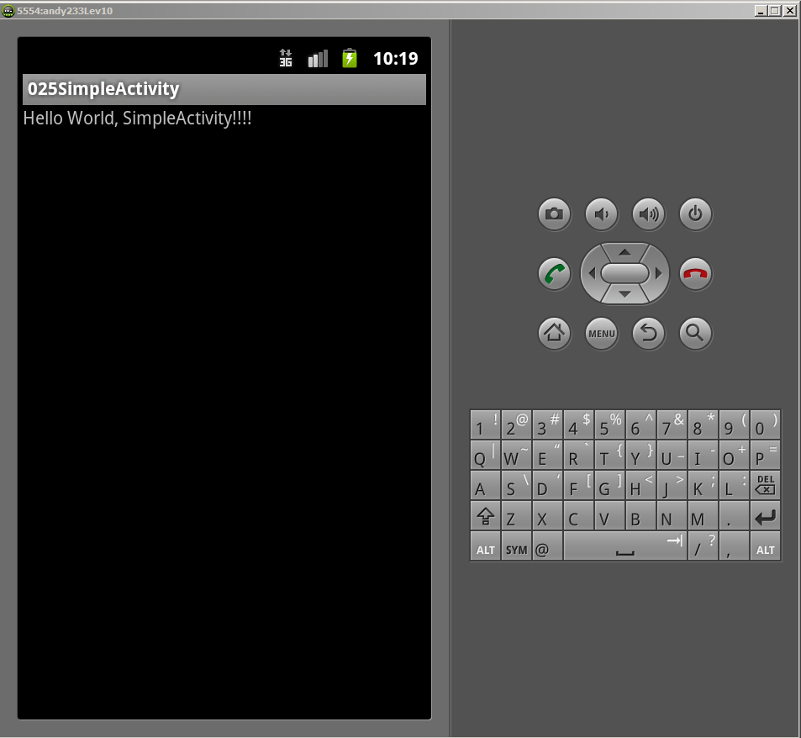

“SimpleActivity” Program running, java code on the next page

SimpleActivity: ‘Hello World’ folder / source
Example program SimpleActivity.java source: Ch2 1_SimpleActivity 025
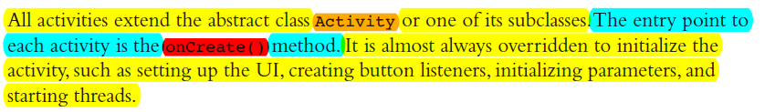
Steps to create an emulator (AVD) and then Activity in Android studio - link
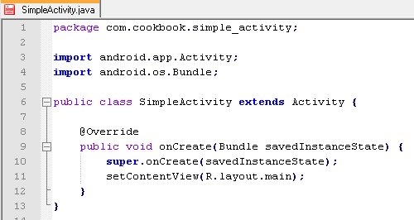
Package: also acts as unique
world wide App identifier for Google Play
and will be listed in Manifest.xml
All Apps will have at least one Activity
which will include this Java file and a
screen Layout XML file e.g. Main.xml
setContentView() displays the Activity’s screen layout file: Main.xml
The class SimpleActivity must be listed in the Manifest.xml file so that the OS can find, understand what it does and so be able to use it.
onCreate( ) called once and once only when this Activity is created
kg Dec 2015
BUT - where the hell is the “Hello World” text???
It’s in Strings.XML file that Main.xml references..

NB replace the word function with method in the book.

- Do not put English etc. text (Strings) that the user will see in java source files.
- Instead keep ALL strings in the strings.xml file.
- This makes localising into different languages easy.
- Note that the name of the string resource is string (singular) and it is in a file named strings.xml (plural strings).
  - The resource name is important and is always string, the filename can be renamed and the project will still compile.

Page 025 Simple Activity (hello world)
Listing 2.1:
- Bundle is generally used for passing data between various Activities
see also:
- http://stackoverflow.com/questions/4999991/bundle-in-an-android
- http://miragemiko.wordpress.com/2010/03/20/android-using-bundle-for-sharing-variables

Android Project Package Explorer - Android Studio (2014+)
R.java file AoidStudioProjects\025_1_SimpleActivity\app\build\generated\source\r\debug\com\cookbook\simple_activity
One of images C:\Users\karl\AndroidStudioProjects\025_1_SimpleActivity\app\build\intermediates\res\debug\drawable-ldpi-v4

Android Project Package Explorer - Outdated ADT, Eclipse

R.java for SimpleActivity

Find the “hello” string in strings.xml and R.java file

How Different Resources are Referenced from Java & XML:

The Manifest File: AndroidManifestFile.xml

The Manifest File contd p29

The minSdkVersion should always be specified to ensure the application is not installed on a device of a lower SDK version, this preventing application crashes (Force Close or FC)

Always choose the lowest API level possible for maximum audience.

Android Package and Manifest File:
The package name defined in our source files is normally same as defined in the file: manifest.xml. In that case all classes defined in the manifest’s <Activity… tag can simply refer to the class by proceeding it with with a dot.
Example: if our manifest file package, which must be unique in play.google.com, is
package = "com.example.testonly"
AND our java source file SimpleActivity.java, which compiles to SimpleActivity.class*, has its package also defined as:
package com.example.testonly;
THEN we can refer to our class in the manifest <activity… tag simply as
.SimpleActivity
“shorthand” for com.example.testonly.SimpleActivity

But if our manifest file package is e.g. com.example.test then in the <activity… tag we must define our java class file as:
com.example.test.SimpleActivity

* The the .class extension is assumed in the Manifest file.

Addition Example - with an EditText (=TextField) and Button
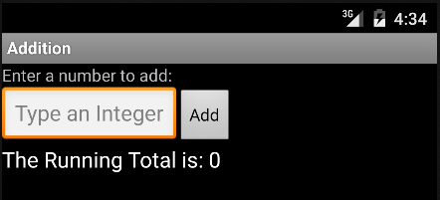
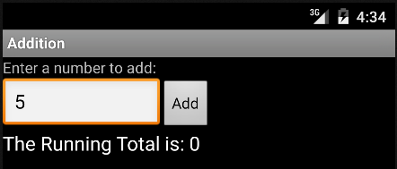
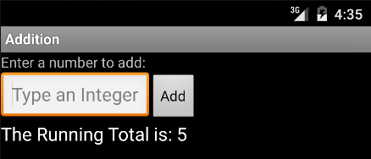
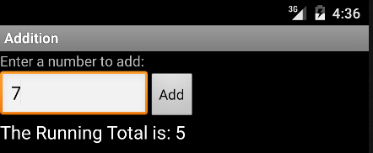
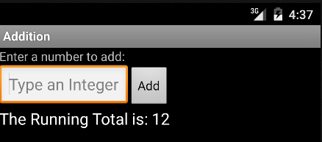
Enter a number and click Add. Repeat with new numbers, clicking add adds them to to the sum of the previous numbers added. So it’s a simple running totals calculator. Later we save the runing total using Java.io - see example below AdditionFileIO.

Addition Example source AS
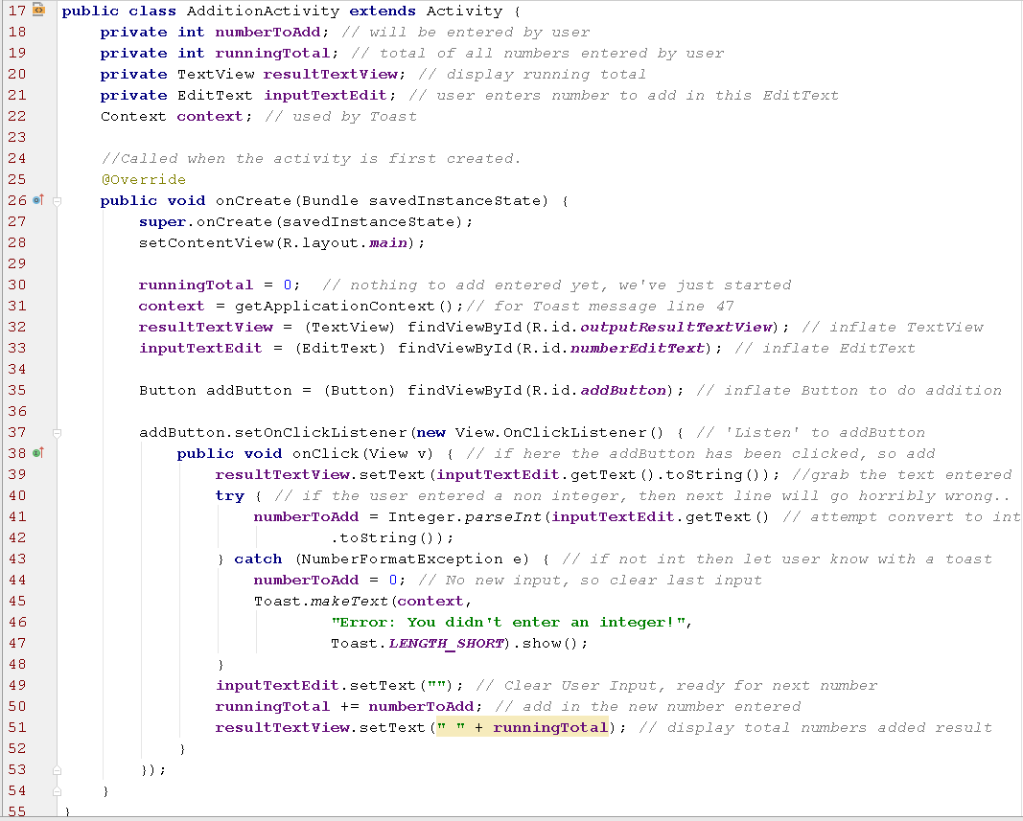
The example is to get a simple app running that can input and process user input.
EditText, Button and onClick event handler etc. to be explained later.

Activity Lifecycle
Each activity in an application goes through its own lifecycle.

Once and only once when an activity is created, the onCreate( ) method executed.

If the activity exits, the onDestroy( ) method is executed. In between, various events can lead to the activity being in multiple different states, as illustrated in the next Figure.

Note that it’s the Activity lifecycle and NOT the Application lifecycle. Each Activity in the App has it’s own independent life cycle.

Activity Lifecycle Figure: https://developer.android.com/reference/android/app/Activity.html

Activity Lifecycle - Important Methods

onCreate( )
- Sets up the Activity’s screen with it’s user interface components, using the XML layout file
- Initialises any class wide variables
- Sets up event delegation for those components that require it e.g. Button, EditText
- Restore any saved variables the onPause ( ) method may have stashed away.
- May open comms connections and/or database connections
- Start background Threads (e.g. for gaming)

onPause( )
There is no guarantee the Activity will survive beyond the onPause( ) method so here is where, if needed, you need to save any variables/state to permanent storage.

ActivityLifeCycle App ch02 folder / source
ActivityLifeCycle App … some notes

onStart( )
you can register a BroadcastReceiver in onStart() to monitor for changes that impact your UI, and unregister it in onStop().

Activity Lifecycle youTube video: https://www.youtube.com/watch?v=Qs-lGmaMIDk

Toast Class api
Allows a ‘pop up’ short message to be displayed in front our our user interface for a brief time.
Either
Toast myToast = Toast.makeText(this, "onCreate", Toast.LENGTH_SHORT);
myToast.show();
or
Toast.makeText(this, "onCreate", Toast.LENGTH_SHORT).show();

Context - this Activity
reId - a reference to a string in XML or string literal
duration - how long to show the Toast

Activity LifeCycle Application Start...

ActivityLifeCycle: Application Exit (back pressed, Activity is destroyed)

ActivityLifeCycle: Home pressed - Activity not destroyed (maybe later…) so is only paused

Then restored:
onRestart; onResume

To Try in the Lab - try the above, back button, home button, screen orientation - use icon (depends on emulator, may not work with ADT)

Forcing Screen Orientation

Any Android device with an accelerometer can determine which way is down.

As the device is tilted from portrait to landscape mode, the default action is to rotate the application view accordingly.

However, the activity is destroyed and restarted on screen orientation changes & instance variables are lost.

One option is to force the screen orientation to stay constant.

To force the activity to always stays in portrait mode, add this to activity element in the Manifest file:
android:screenOrientation="portrait"
Similarly, landscape mode can be specified using the following:
android:screenOrientation="landscape"

Saving and Restoring Activity Information
A better option to deal with orientation changes is to save & then restore variables.

Whenever the phone is rotated, the onSaveInstanceState() method is invoked. Override this to save relevant information.

When the phone is in it’s new orientation onRestoreInstanceState() is called. Override this to retrieve the saved information.

This allows for a seamless user experience when an activity undergoes life cycle changes.

Note that most UI (user interface) states do not need to be saved as they are taken care of by the system.

Example: Saving and Restoring Activity Information p35 source
NB The above works only for screen orientation changes, NOTHING is permanently saved. All variables are lost when the Activity is destroyed.

the Bundle API...
https://developer.android.com/reference/android/os/Bundle.html
A Bundle method example:

Multiple Activities

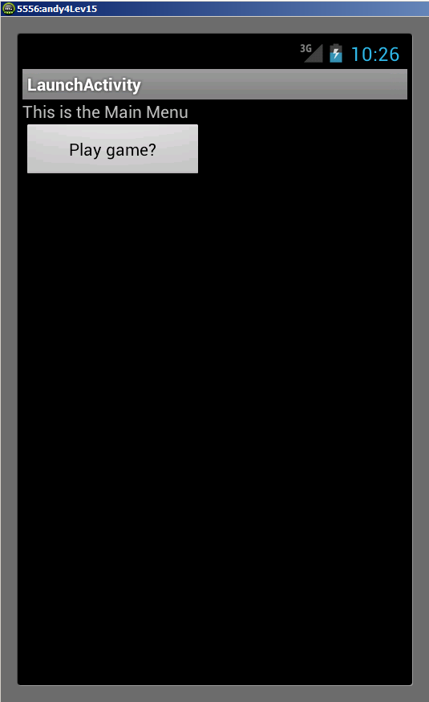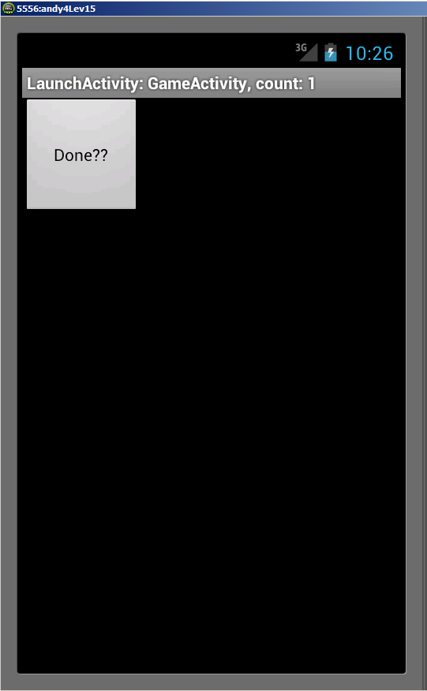

We will look at how to create a second activity and launch it from the “Play Game” button press in the first.
The“Done??” button in the second activity allows control to return to the first Activity.

Multiple Activities
Even the simplest applications have more than one screen. A game could have two activities: a high scores screen and a game screen.

A notepad can have three activities: view a list of notes, read a selected note, and edit a selected or new note.

The main activity, as defined in the AndroidManifest XML file, is started when the application is started.

This activity can launch another activity(s), usually after a trigger event.

This causes the main activity to pause while the second activity is started and then activated.

When the second activity ends, the main activity is brought to the foreground and resumed.

Launching a Second Activity

Explicit & Implicit Intents

To activate a specific known component of an application, e.g. a second Activity belonging to our App, an intent naming the component explicitly is used. Example: launch my2ndActivity.class

If, instead, the requirements of an application can be specified in a more general way e.g. “navigate to Blarney” or “dial Snoop Dogg” then intent filters can specify the request, and an implicit intent can be used. The system then determines the best component to use, even if it is in a separate application or native to the OS.

The second option, implicit intents, is far more powerful as any App’s Activity could be called by our program including those belonging to Apps not yet installed on the device.
Implicit intents are covered in more detail later: link.

Explicit & Implicit Intents cont
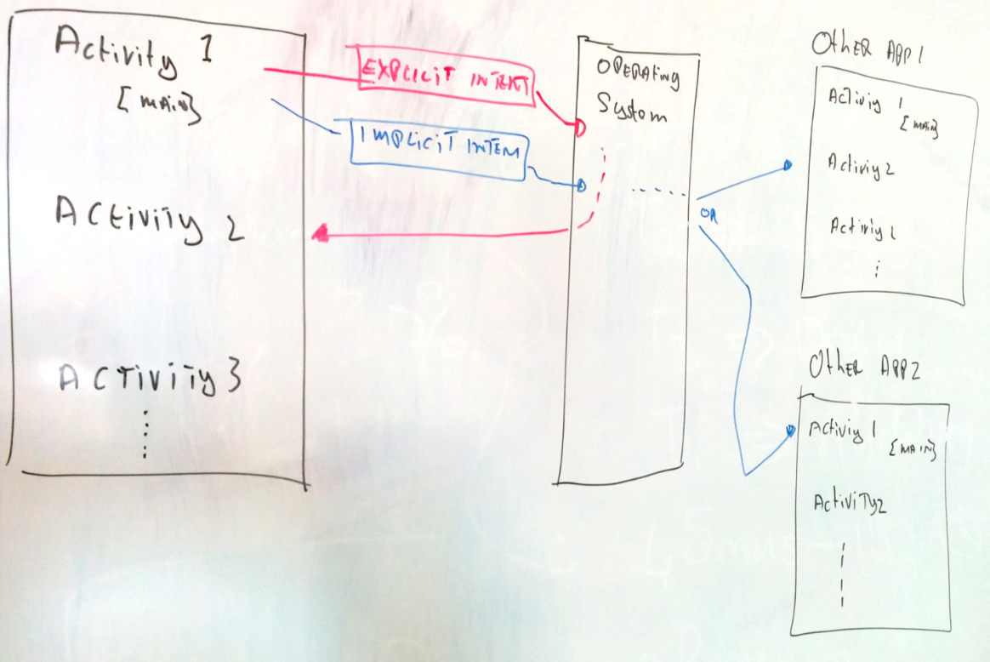

Our App, on the left, has multiple activities. If the user is looking at Activity 1 then a button in that activity could switch the screen to our App’s Activity 2. by sending an Explicit intent to the operating system specifying the exact .class file to use.

Alternatively an Implicit intent can launch an activity in any App installed on the device. This time the Intent won’t specify an exact .class file, instead e.g. “navigate to Cork” and the operating system decides which activity to launch.

Using Buttons and TextView p36
To fully demonstrate multiple activities, we need a trigger event e.g. a button press.
To add a Button to our Activity:
Notes:
dip: Density-independent pixel is equivalent to one physical pixel on a 160 dpi screen, which is the baseline density assumed by the system for a "medium" density screen.
setOnClickListener:
- From class android.view.View
- setOnClickListener(View.OnClickListener l)
- Register a callback to be invoked when this view is clicked.
- need to implement method: onClick(View v)

Showing the result of the trigger - using a TextView
To show the result of an action, it is useful to change the text on the screen and display it in a TextView.
The steps for defining a TextView and changing it’s text programmatically are:

Implementing a trigger - We’ll use a button Tap (=Click)

Button extends the View class. The View class represents the basic building block for user interface components. A View occupies a rectangular area on the screen and is responsible for drawing and event handling using method setOnClickListener -->

So We’ll:
- Create a Button in Java by inflating it from it’s definition in the XML layout file main.xlm - line 24
- Register it’s events with event listener object, That listener object will have an event handling method - we’ll see it will be called onClick () - line 25
- Handle the Button’s events to launch the second Activity (PlayGame.class) - Line 37

API lookup to see how to implement the View.OnClickListener interface:

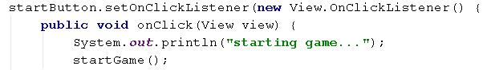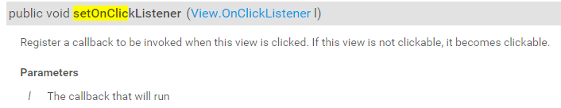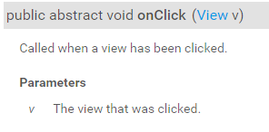
View.OnClickListener is an interface with just one method we must implement
kg 20015

Launching Another Activity from a Trigger Event

MenuScreen.java 1st Activity, launches a 2nd: p37 source Ec

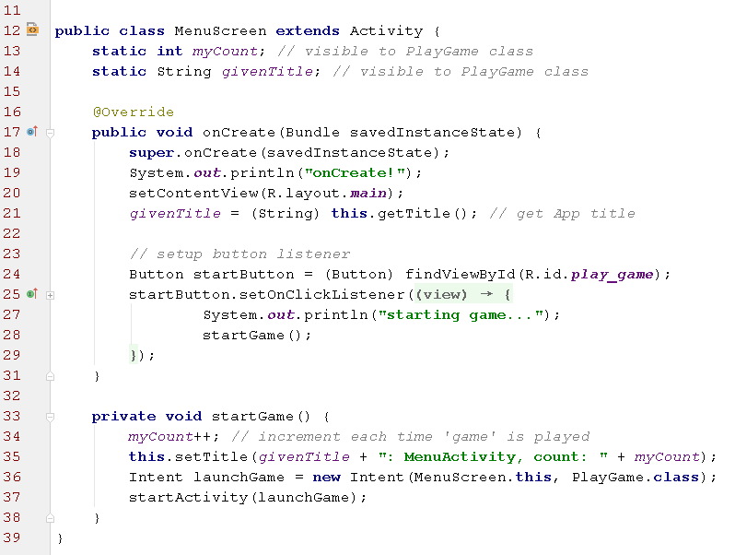
Anonymous inner class so 'this' won't refer to our activity so we need to write a separate method startGame ( )
Explicit Intent
Launch PlayGame.class Activity
“Inflate” the button defined in the layout XML file
NB these are equivalent in the code above and explained on the next page:

The Second Activity PlayGame.java

Similar handling of it’s Button but this time is invokes the Activity method finish ( ) on line 19.

main.xml for 1st Activity with TextView and Button defined

game.xml for 2nd Activity with a Button defined

The Manifest file with TWO activities defined

For more on intents & filters see:
https://developer.android.com/guide/components/intents-filters.html

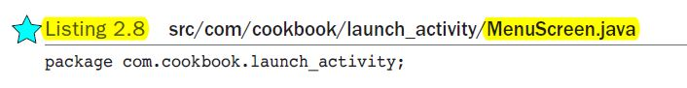

Page 37 MenuScreen

Clicking Play in first activity launches the second one by calling startGame ( ) method.
Pressing the Done button in second activity invokes the finish () method which activates the first activity again. Call finish () when your activity is done and should be closed.
The above example has a counter added - see in the source code how the title is updated with the counter.

Passing Data Between Activities
Sometimes data needs to be passed to a launched activity.
Also, a launched activity may create data that needs to be passed back to the calling activity. For example, a final score of a game needs to be returned to a high-scores screen.

Ways to pass data between activities are:
- Not Recommended: Use a static variable in the calling activity. E.G. public static int finalScore;
then set it in the launched activity e.g. CallingActivity.finalScore=6;

- Attach extras onto Bundles (demonstrated here).

- Use SharedPreferences to store data to be retrieved later (Demonstrated later)

- Use the SQLite database to store data to be retrieved later (shown later)

- Use standard Java I/O to write then read from a file(s) (demonstrated later)

Passing Data Between Activities : Bundle

- A Bundle is a mapping containing key-values pairs where the keys are strings and the value a primitive data type or a String. e.g. “userHeight”, 1.8

- It can be created by “adding extras” to an intent object.

- The following example shows data being passed from the main activity to the launched activity, where it is modified and passed back.

- The variables (in this case, an integer and a String) are declared in the StartScreen activity.

- When the intent is created to call the PlayGame.class, these variables are attached to the intent using the putExtra method.

- When the result is returned from the called activity, the variables can be read using the getExtras method.

Passing Data between Activities p46
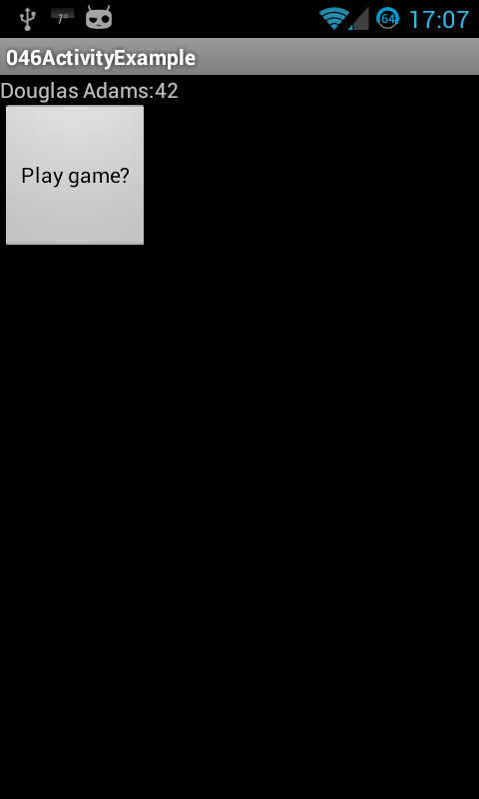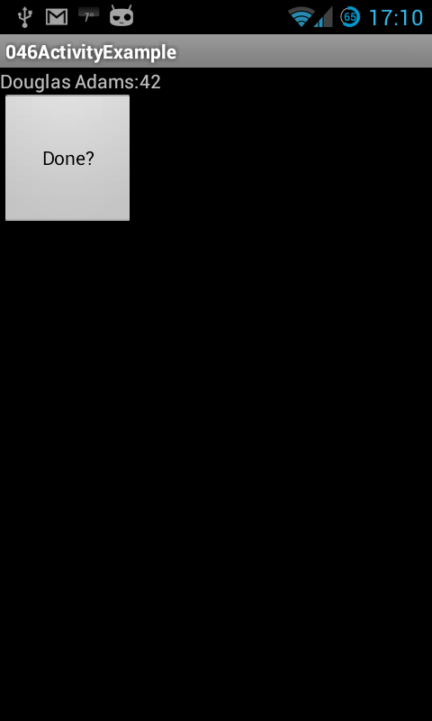
Press ‘Play Game’ button in ‘PlayGame’ activity with String ‘author’ = “Douglas Adams” and int ‘answer’ = 42 both of which are passed to and displayed by the the launched activity ‘PlayGame’.
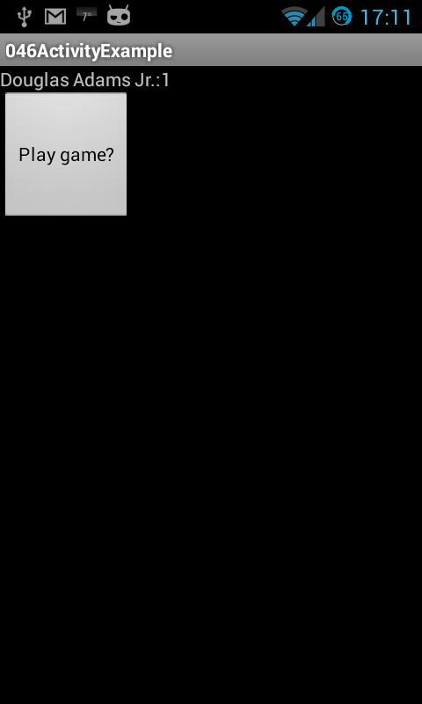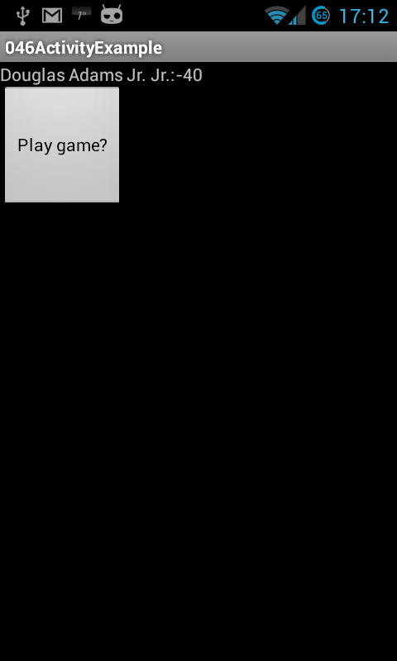
Pressing the ‘Done?’ button modifies the both ‘author’(adds Jr) and ‘answer’ (subtracts 41) each

Activity 1: StartScreen.java 1/2 source
Two variables, the int 42 and String “Douglas Adams” to be passed to 2nd Activity, modified and then passed back.
The ‘modification’ will see 41 subtracted from the int and “ Jr.” appended to the String.
Douglas Adams’s “Hitchhiker's Guide to the Galaxy” recently in the news:
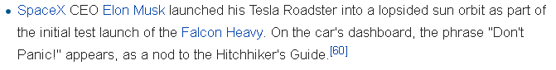

Activity 1: StartScreen.java 2/2
- Linexx: Explicit Intent
- Line 55: void startActivityForResult (Intent intent, int requestCode)
- Line 39:

Activity 2: PlayGame .java 1/1

Notes for PlayGame.java
Line 22

Line 24

Also in the first activity this is defined:
private static final int PLAY_GAME = 1010;
It’s our reference put in the request so we know that result matches our request.

Passing Data between Activities p46
Press ‘Play Game’ button in ‘PlayGame’ activity with String ‘author’ = “Douglas Adams” and int ‘answer’ = 42 both of which are passed to and displayed by the the launched activity ‘PlayGame’.
Pressing the ‘Done?’ button modifies the both ‘author’(adds Jr) and ‘answer’ (subtracts 41).

Notifying the User - Alerts, Toast, Notifications p74

There are several way to notify the user with a message while remaining outside of the application’s main UI.
We can choose from:
- An overlay Toast message
- An overlay AlertDialog box
- A notification in bar at the top of the screen with our without follow on actions

The Toast message provides a pop up message, for a brief time, to the screen with a single line of code. There is no need to work with the layout files.

Toast can be used as a handy debug tool, although not as useful as println ( ) that displays in the LogCat with timestamp.

Using Toast

Using Alert Dialog Box p75

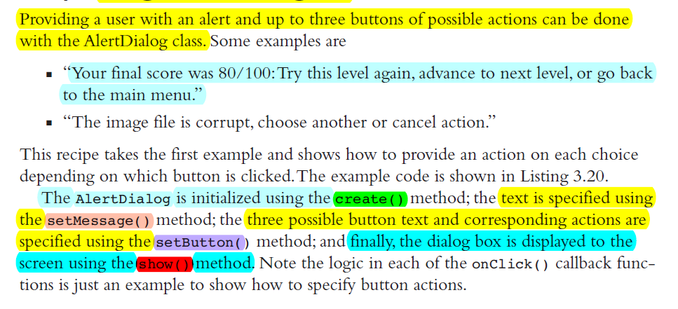

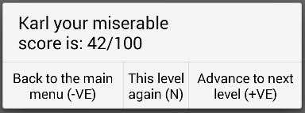
Example using Alert Dialog box, code follows API info. source AS

AlertDialog - some API info:
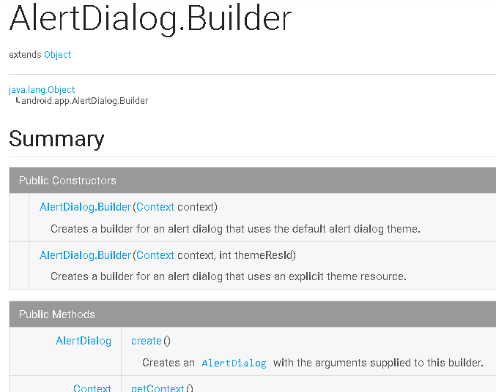

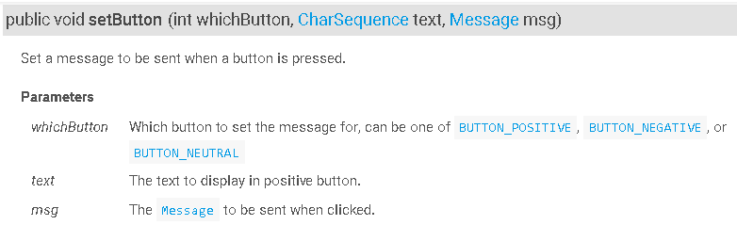

DialogInterface.OnClickListener

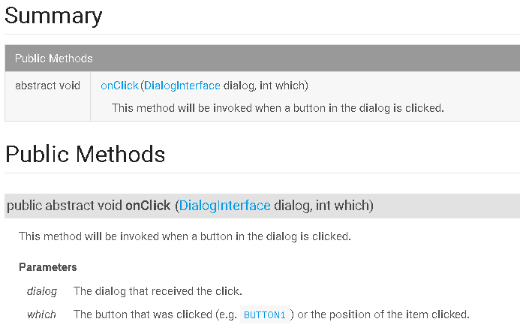

Reference: Nested Classes Tutorial http://download.oracle.com/javase/tutorial/java/javaOO/nested.html

AlertActivity code source AS
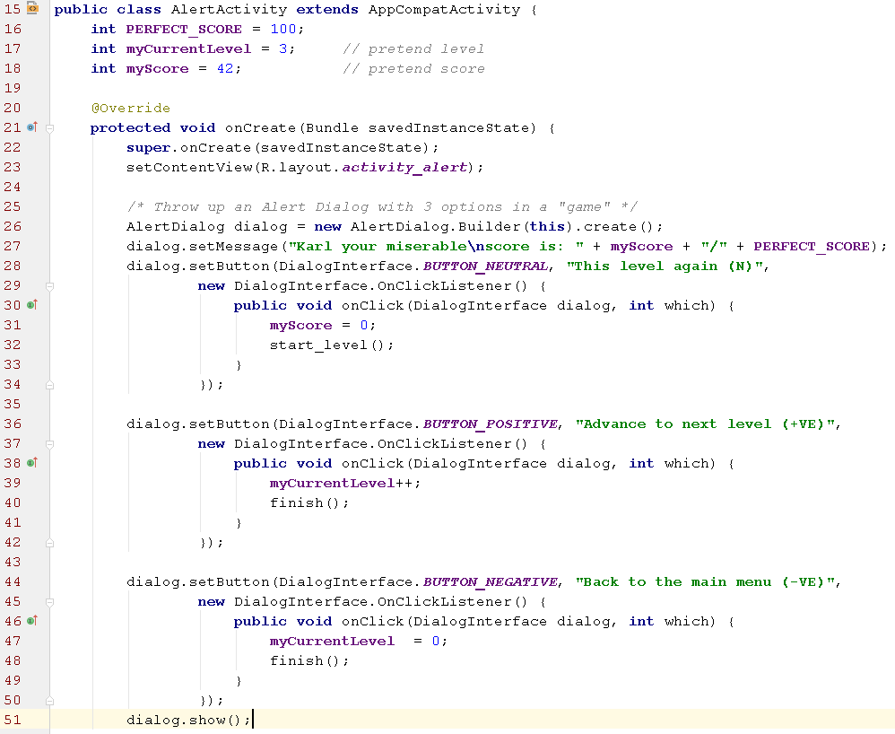
If a dialog box with only one or two options is needed then just use setButton only one or two times.

Page 77 ShowNotification

The status bar across the top of the device screen shows pending notifications for the user to read at a convenient time.

In general, because an activity mostly interacts with the user, services are more likely to utilize this feature. In our case we will create notifications from an Activity

As a rule, notifications should be concise and minimal for the best user experience.

Example Screenshots follow



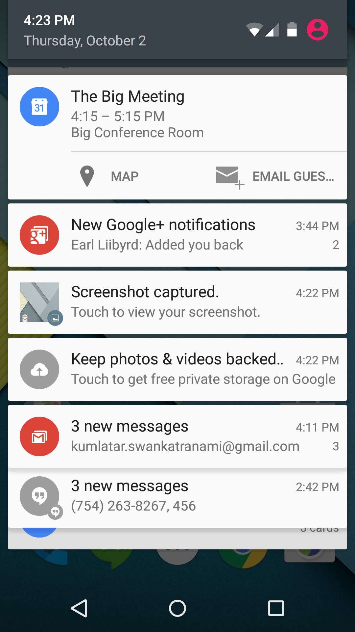

Show Notification & process pending intent example
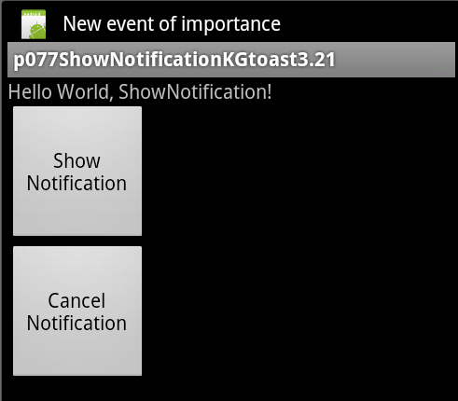
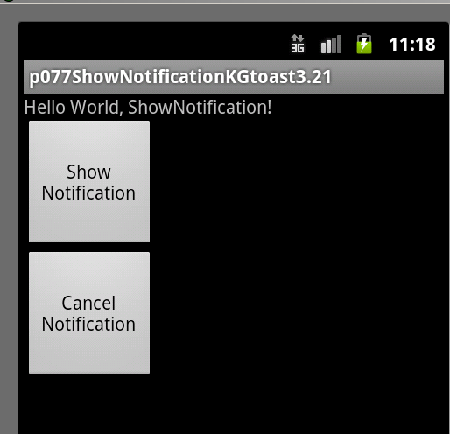
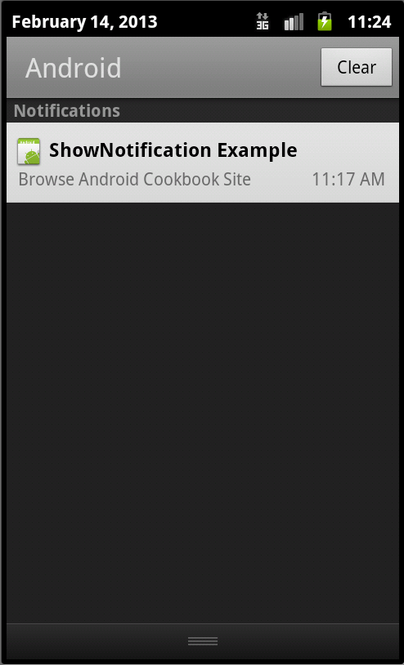
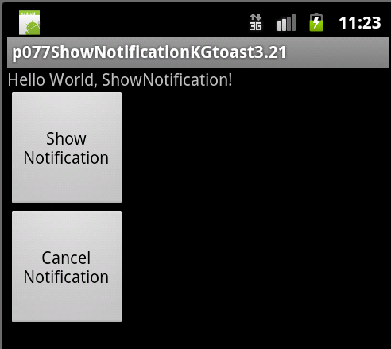

After dragging down the notification bar link on notification to run the pending intent - the pearson website on the next page:

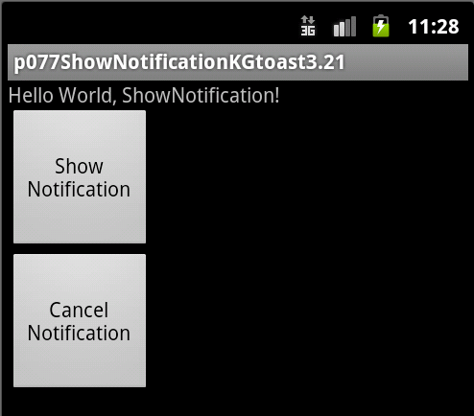

The web site is shown, returning from the website brings us back to our app but with the notification automatically cleared. Pressing the Cancel Notification button straight after pressing the Show Notification button will cause the notification to be cleared.

Notifications - steps to create: 1
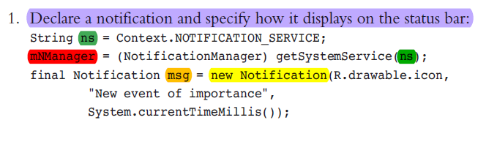
Context
Interface to global information about an application environment.

NOTIFICATION_SERVICE ("notification")
A NotificationManager for informing the user of background events.

public Notification (int icon, CharSequence tickerText, long when)
icon The resource id of the icon to put in the status bar.
tickerText Flowing text in the status bar at notification activation.
“new event of importance” in our example
when The time (ms) to show in the time field in expanded notification.

Object getSystemService (String name)

Return the handle to a system-level service by name examples. NOTIFICATION_SERVICE, POWER_SERVICE, VIBRATOR_SERVICE, BATTERY_SERVICE etc

Notifications - steps to create: 2.

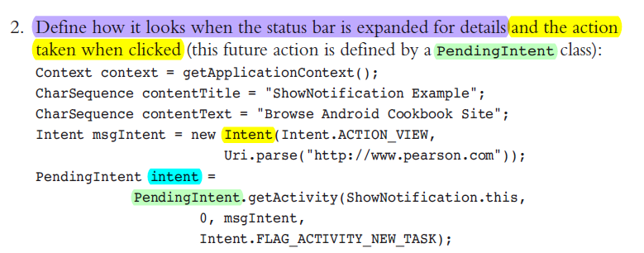
CharSequence contentTitle = "ShowNotification Example";
Appears on expanded notification: Content Title

CharSequence contentText = "Browse Android Cookbook Site";
Appears on expanded notification: Content Text

PendingIntent intent = PendingIntent.getActivity(ShowNotification…
opens web browser going to pearson site

Notifications - steps to create: 3...6.
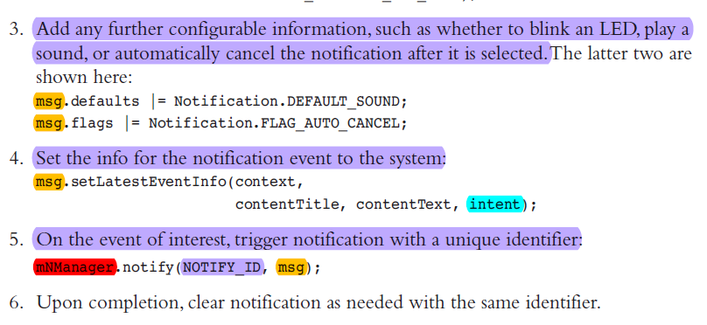

3. msg.flags |= Notification.FLAG_AUTO_CANCEL;
set if the notification should be canceled when it is clicked by the user

4. msg.setLatestEventInfo(context, contentTitle, contentText, intent);
deprecated Use Notification.Builder instead help constructing the typical notification layouts.

5. mNManager.notify(NOTIFY_ID, msg);
Post a notification to be shown in the status bar.

If any information gets changed, the notification should be updated by updating the relevant information in step 2, and then again calling setLatestEventInfo.

077 ShowNotification.java source screenshots
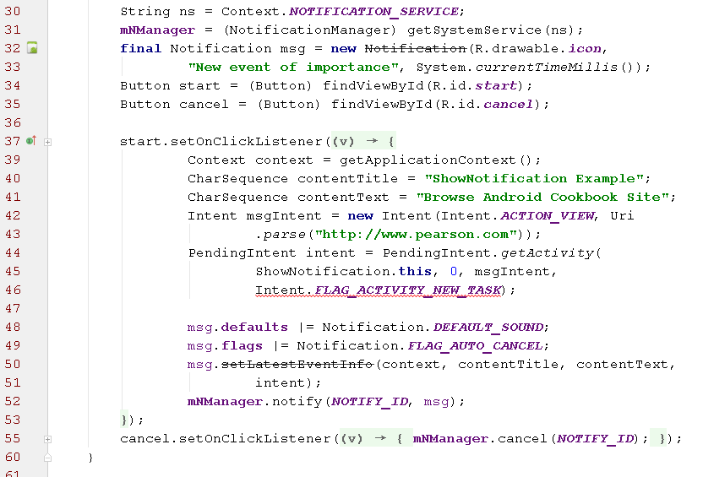

NB Notifications - Additional info - there there are deprecated methods used in the book - newer examples are here:
- http://developer.android.com/guide/topics/ui/notifiers/notifications.html
- http://www.vogella.com/tutorials/AndroidNotifications/article.html
Example derived from #1. above - the expanded notification launches MySecondActivity.class which you need to write.
import android.app.NotificationManager;
import android.app.PendingIntent;
import android.support.v4.app.TaskStackBuilder;
import android.support.v7.app.*;
import android.content.Context;
import android.content.Intent;
import android.os.Bundle;
Add the import statements above then put the following code where you want the notification to be created (after button press maybe):
NotificationCompat.Builder mBuilder =
(NotificationCompat.Builder) new NotificationCompat.Builder(this)
.setSmallIcon(R.drawable.ic_notification)
.setContentTitle("My notification")
.setContentText("Hello World!");
// Creates an explicit intent for an Activity in your app (replace TestMain.class)
Intent resultIntent = new Intent(this, MySecondActivity.class); // change TestMain.class
// The stack builder object will contain an artificial back stack for the started Activity.
// This ensures that navigating backward from the Activity leads out of your application to the Home screen.
TaskStackBuilder stackBuilder = TaskStackBuilder.create(this);
// Adds the back stack for the Intent (but not the Intent itself)
stackBuilder.addParentStack(MySecondActivity.class); // change TestMain.class
// Adds the Intent that starts the Activity to the top of the stack
stackBuilder.addNextIntent(resultIntent);
PendingIntent resultPendingIntent =
stackBuilder.getPendingIntent(
0,
PendingIntent.FLAG_UPDATE_CURRENT
);
mBuilder.setContentIntent(resultPendingIntent);
NotificationManager mNotificationManager =
(NotificationManager) getSystemService(Context.NOTIFICATION_SERVICE);
// mId allows you to update the notification later on.
int mId =12345; // any number
mNotificationManager.notify(mId, mBuilder.build());

EditText - TextField for entering text.
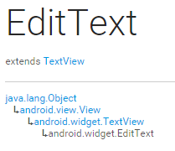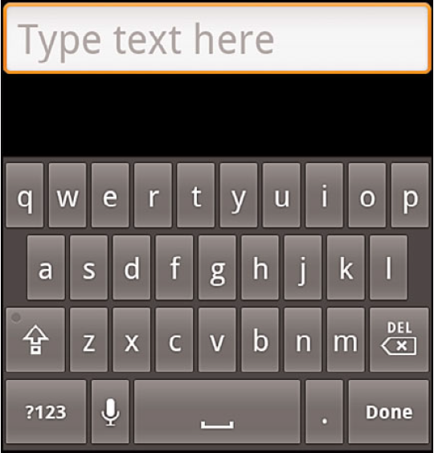

from the EditText class →
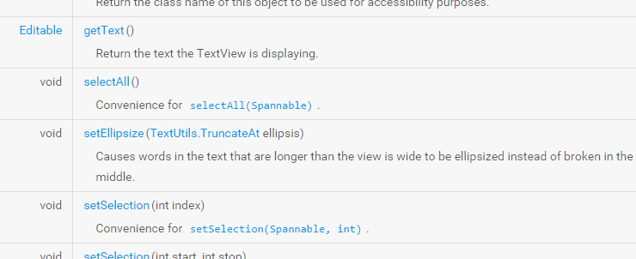

from View class →
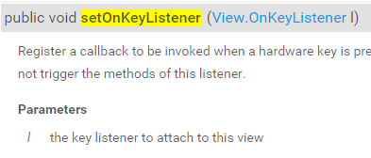

ONE public method in View.OnKeyListener interface →
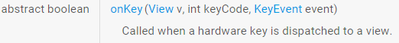

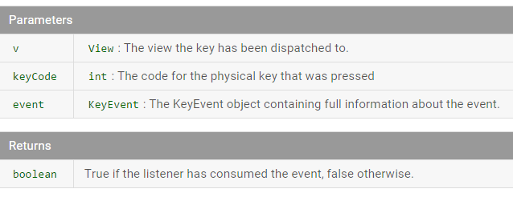

EditText - Defining in XML
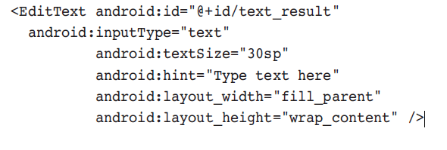

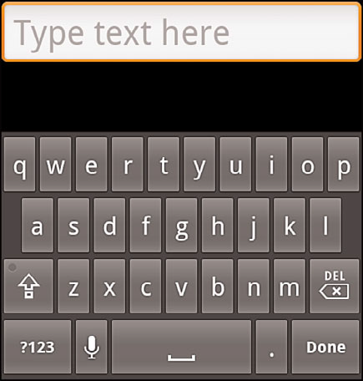
“Type text here” displayed in grayed out text as a hint and disappears once the user types the first character. It can be set in XML as above or in Java using:
public final void setHint (int resid)
Where resid is a string resource in the Strings.xml file

Capturing Text from a TextView source (modified to do extra stuff)

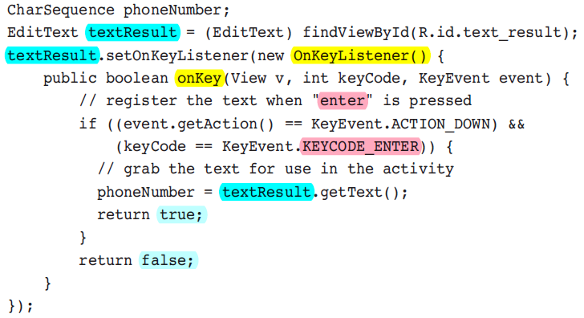
public abstract boolean onKey (View v, int keyCode, KeyEvent event)
- v The view the key has been dispatched to.
- keyCode The code for the physical key that was pressed
- event The KeyEvent object containing full information about the event.
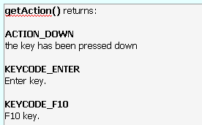
see constansd in keyEvent class: http://developer.android.com/reference/android/view/KeyEvent.html#ACTION_DOWN

Controlling Width and Height of UI Elements example: book p86
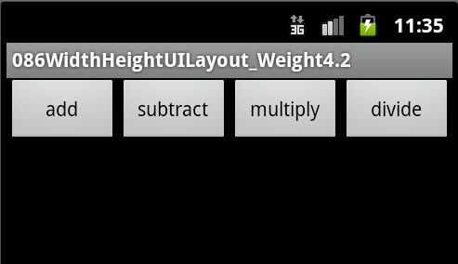

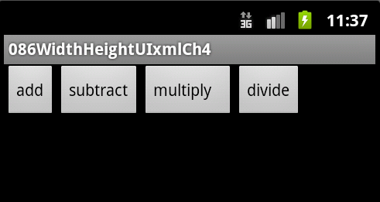

Controlling Width and Height of UI Elements:
We see how specifying the width and height of UI elements changes the overall layout.
Each View object must specify a total width & total height:
- android:layout_width
- android:layout_height

This is done in one of three ways:
- exact dimension—Provides control, but does not scale to multiple screen types well.
- wrap_content—Just big enough to enclose the contents of the element plus padding.
- fill_parent (renamed MATCH_PARENT in API Level 8+) —Size maximized to fill the element’s parent, including padding.

Controlling padding UI Elements:
Padding is the blank space surrounding an element, and defaults to zero if it is not specified.
It is part of the size of an UI element and must be specified as an exact dimension, but can be specified using one of two types of attributes:
- padding—Sets padding equal on all four sides of an element.
- paddingLeft, paddingRight, paddingTop, paddingBottom—Sets padding on each side of an element separately.

Another attribute is android:layout_weight, which can be assigned a number. It provides the Android system with a way to determine relative importance between different elements of a layout.
Consider this example, the XML layout is on next page:
The buttons are not evenly sized and there’s unused space to the right.

XML layout example for screenshot on previous page
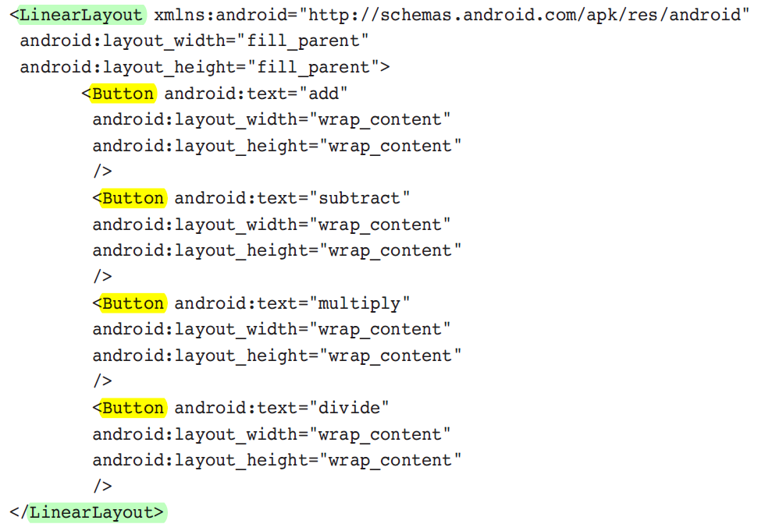

On the next page we’ll make some changes to get a better layout for the buttons...

If the height of the “add” button is changed to fill_parent (or MATCH_PARENT), the button fills the vertical space of its parent while keeping the words aligned →
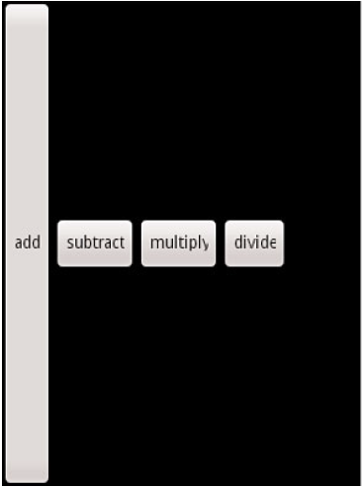

If the width of any button is changed to fill_parent, then all subsequent buttons in the horizontal layout are washed out e.g. as with the “subtract” button →
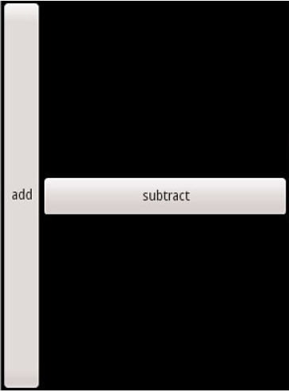

Solution: layout_weight
Here all buttons use fill_parent for width but also add layout_weight and assign it the same value for all buttons.This gives the most satisfying layout →
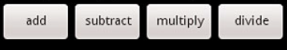
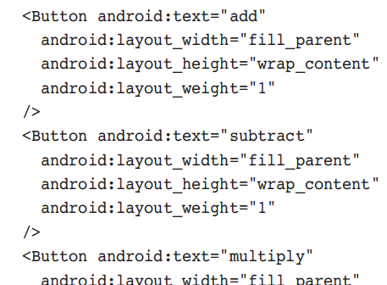

Relative Layout p89

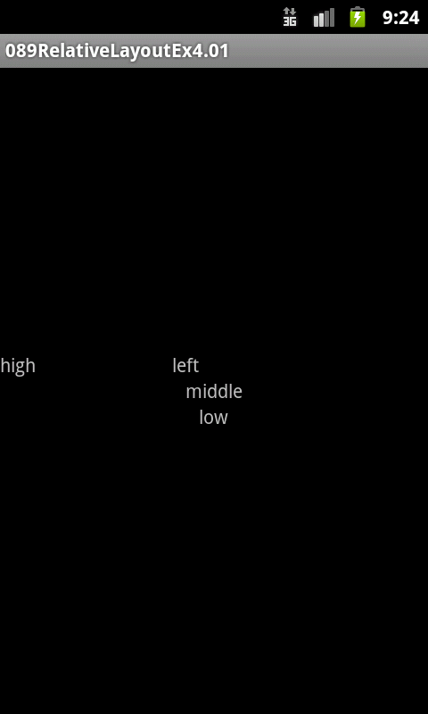

RelativeLayout sets the layout relative to a starting object or parent object rather than absolute rules as in the above example. XML on next page →

RelativeLayout XML for previous page screenshot
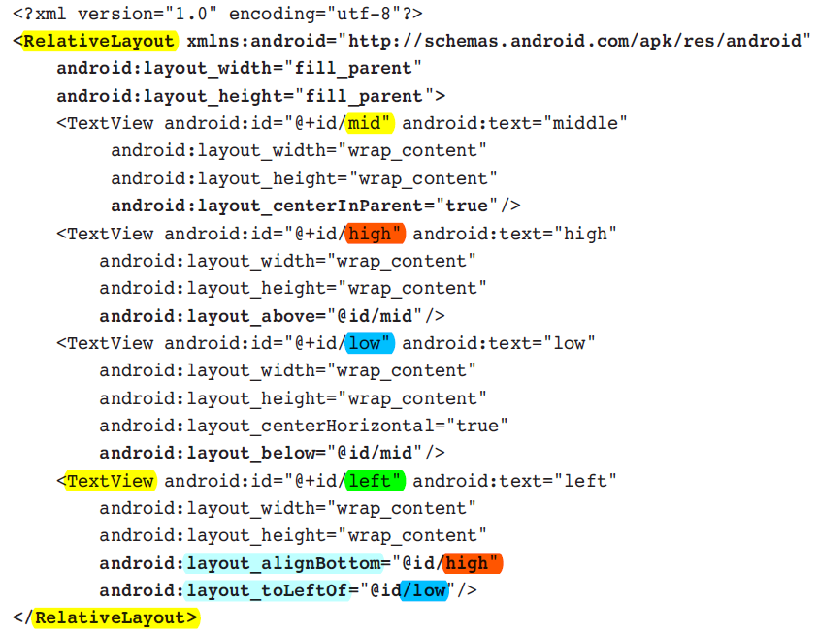

For example, in the last yellow highlighted TextView “left” is aligned with the bottom of TextView “high” and left of TextView “low”.
If we remove either TextView “high” or “low” the TextView “left” loses it’s positioning. Creating a Relative layout manually in XML is a nightmare and it’s even worse programmatically so for that we’ll use LinearLayout…..
LinearLayout Programmatically
Note there’s NO XML layout needed. Download Code. (folder)
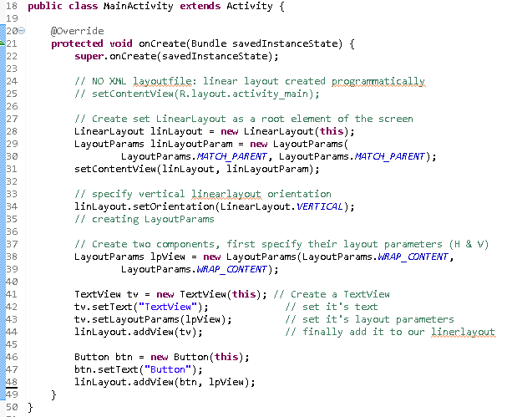
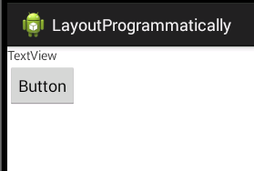

API- Layout Programmatically

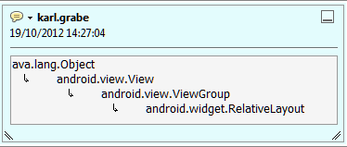

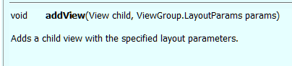

Programmatic Layout to compliment XML layout:
Use normal XML layout file with a Button, then add a TextView programmatically - Download Code. NB note layoutID for LinearLayout in XML and Java.
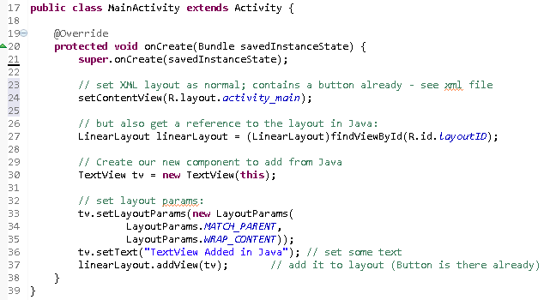
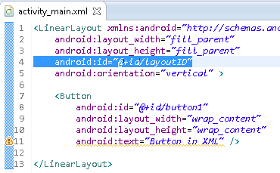
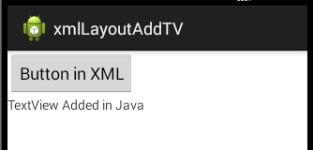
Yet Another LinearLayout Example; XML layout then add a TextView in Java.
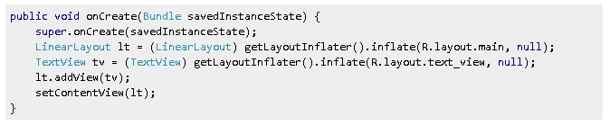
Source article from StackOverFlow.
Another example of programmatically creating a linearlayout:
http://www.startandroid.ru/en/lessons/complete-list/220-lesson-16-creating-layout-programmatically-layoutparams.html

Text Manipulation

In views that incorporate text, such as TextView, EditText, and Button, the text is represented in the XML layout file by the android:text element.
To add text to an UI element, such as TextView, it would look like the following:
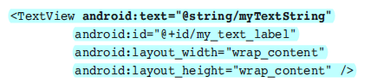

The default font depends on Android device and user preferences. Font attributes can be changed from the App as in table on next page. →

Some Useful Text Attributes
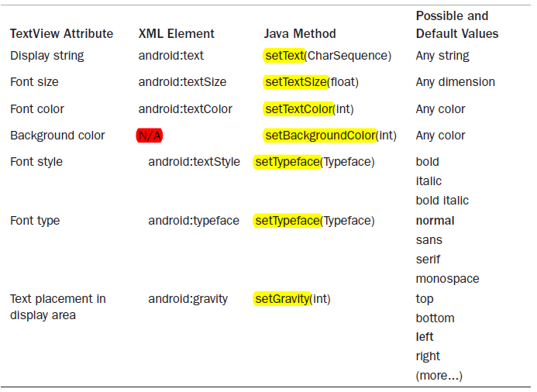

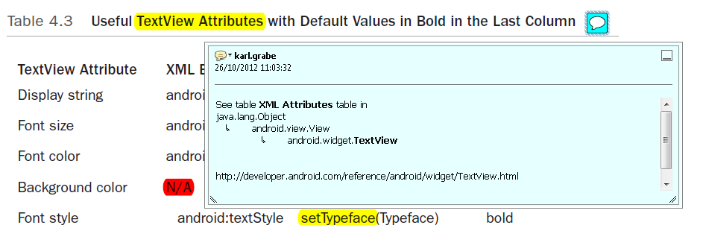
TextView API: http://developer.android.com/reference/android/widget/TextView.html

Setting and Changing Text Attributes
Next program repeatedly changes the color of displayed text when a button is clicked.

Changing Font colour 96a sourceAS
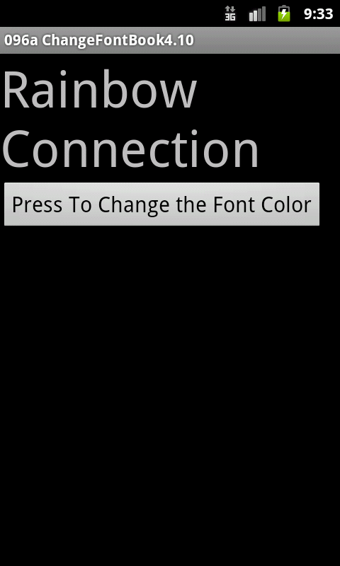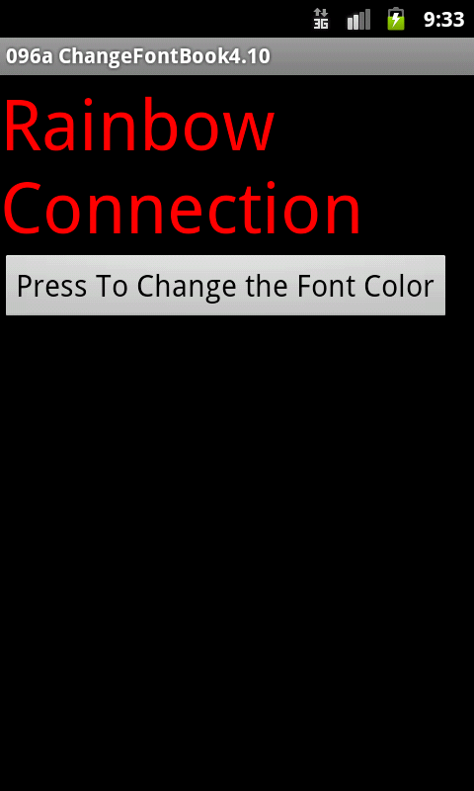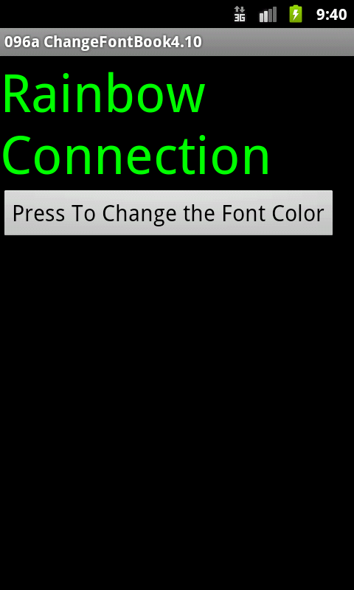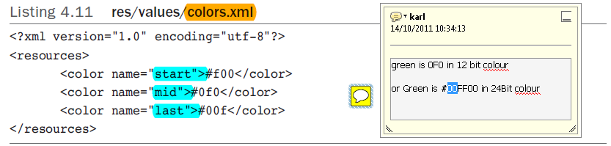

Defining Colour examples
Green is #0F0 in 12 bit colour or #00FF00 in 24 Bit colour
12 bit 2^12 = 4096 colours
24 bit 2^24 = >16K colours
See also Alpha (transparency): setAlpha(float)

(Changing font colour example)
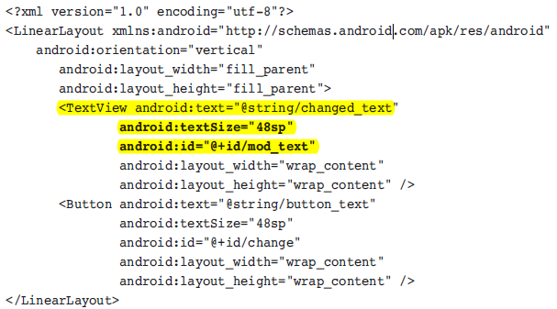

Changing font colour example
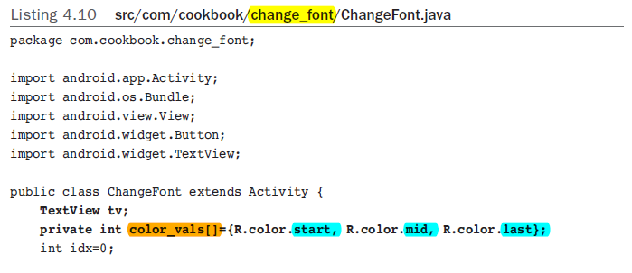
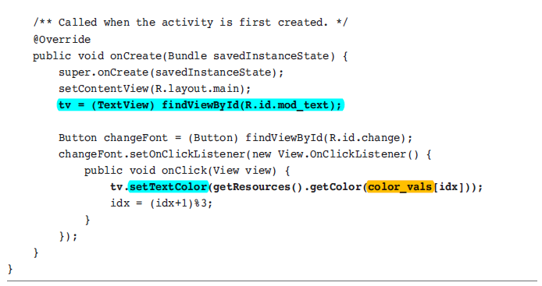

Changing font colour example - output

The next Example modifies the above program to change the text size instead of colour.

Changing Text Size p96b sourceAS
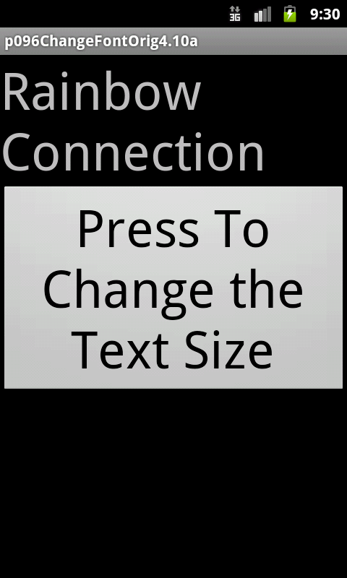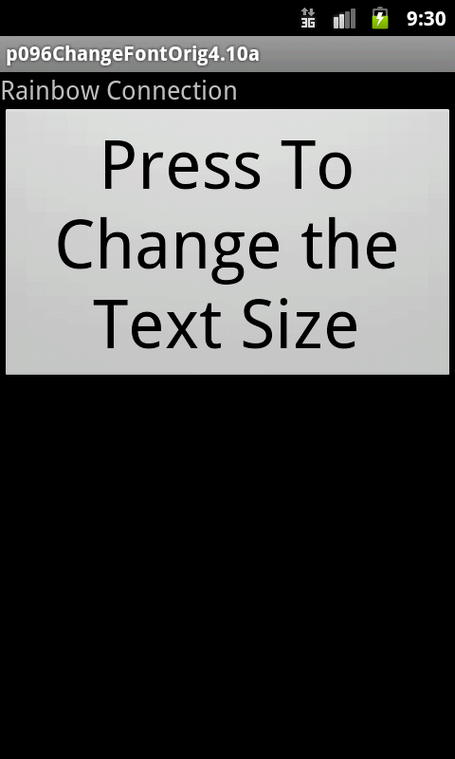

Changing Text Size

We’ll define the sizes as dimen resources in res/values/dimensions.xml

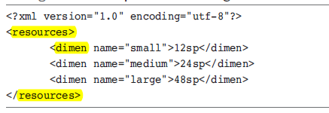
sp: scale independent pixel
Usage in the previous program modified...
Note that the R.java file contains references and not the actual values, so use getResources( )…. as above

Changing Text Size, output

Providing Text Entry

EditText class provides a simple view for user input. It can be declared just like a TextView.
Key events are received by the onKey method:

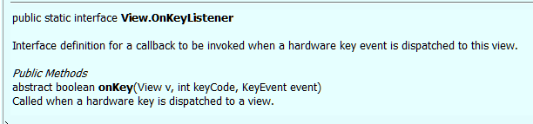

Providing Text Entry p99/100 sourceAS
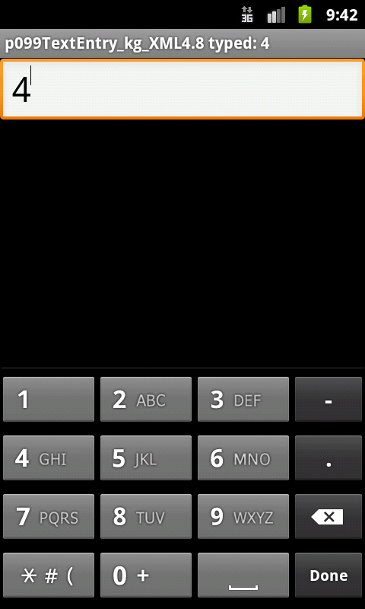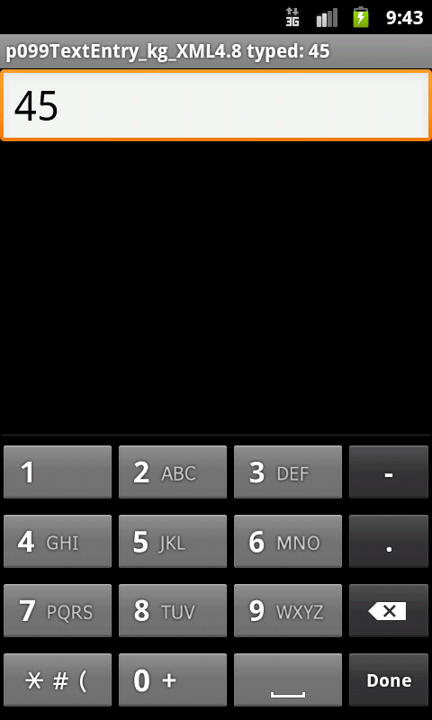
In the modified example (screenshots above) this line retrieves the current title of the Activity:
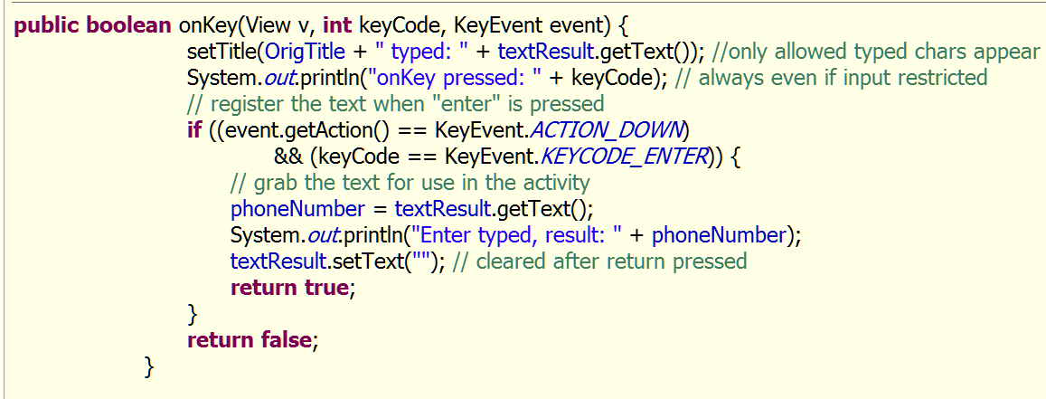
Returning true from onKey indicates that the keypress was consumed and no further processing needed.

Useful EditText Attributes: 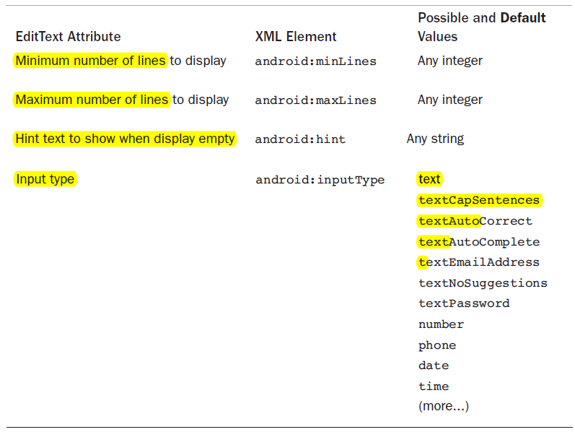

The text entry method can be specified as shown above to automatically capitalize each sentence as typed, automatically correct mistyped words, or turn off word suggestions during typing.

EditText Examples
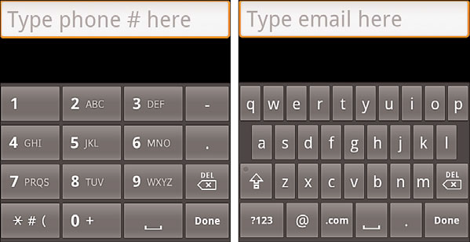

First EditText above (no text input restriction):
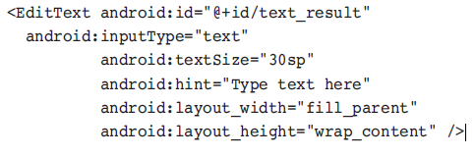

The second two above additionally restrict input →
android:inputType= "phone"
android:inputType= "textEmailAddress"

The soft keyboard conveniently modifies accordingly. Also there's less processing needed to catch bad user input.

Other Widgets: From Buttons to Seek Bars

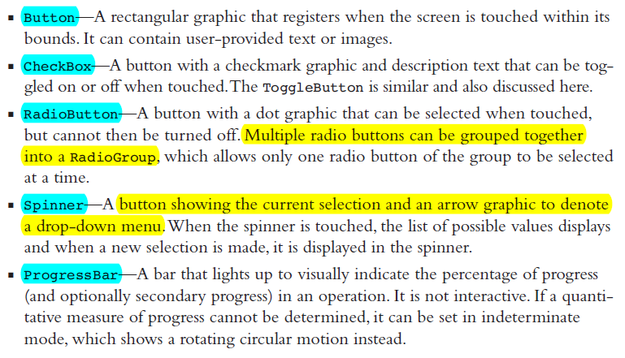

ImageButton sourceAS
When multiple image buttons are placed together in a layout, it is often useful to utilize the TableLayout
The TableLayout view group is similar to a LinearLayout with vertical orientation.
Multiple rows can be specified using the TableRow view group for each row
Here we specify an ImageButton and TextView view in each row:

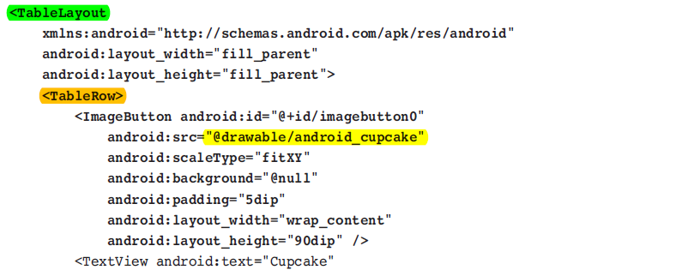

public static final ImageView.ScaleType FIT_XY
Scale the image using FILL. From XML, use this syntax: android:scaleType="fitXY".

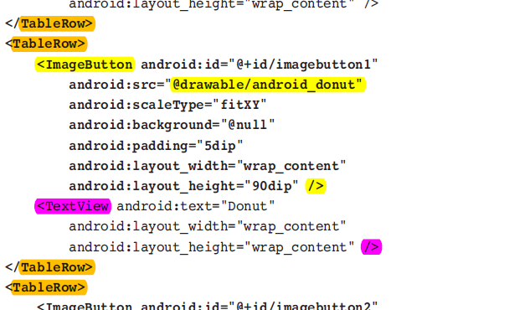

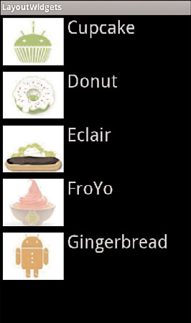

CheckBox Example source (Eclipse)

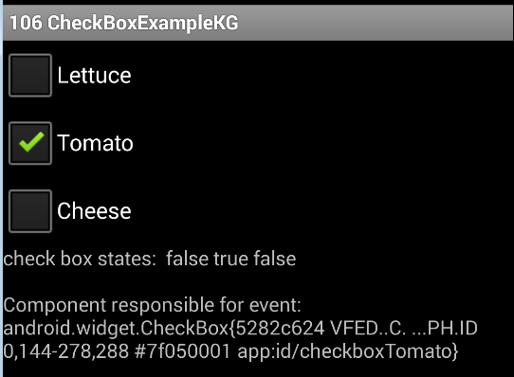

CheckBox
Check boxes have a predetermined checkmark graphic, colors for selection, and colors for behavior when pressed.
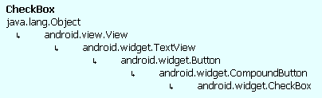

However, if a custom graphic to denote selection is required, the setButtonDrawable()method can be used →
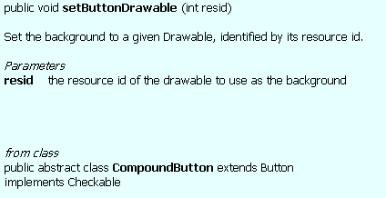

Checkbox - XML declaration in Layout file (update 2016.04.05)
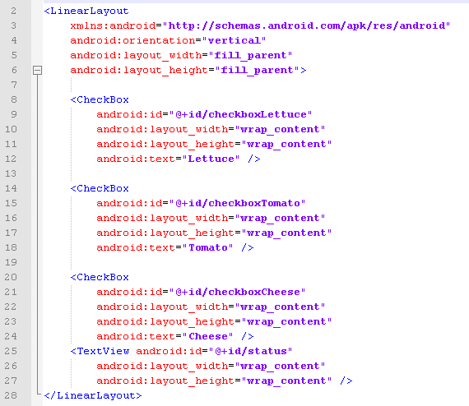

Checkbox Code Source: http://goo.gl/bFCZot (Eclipse)
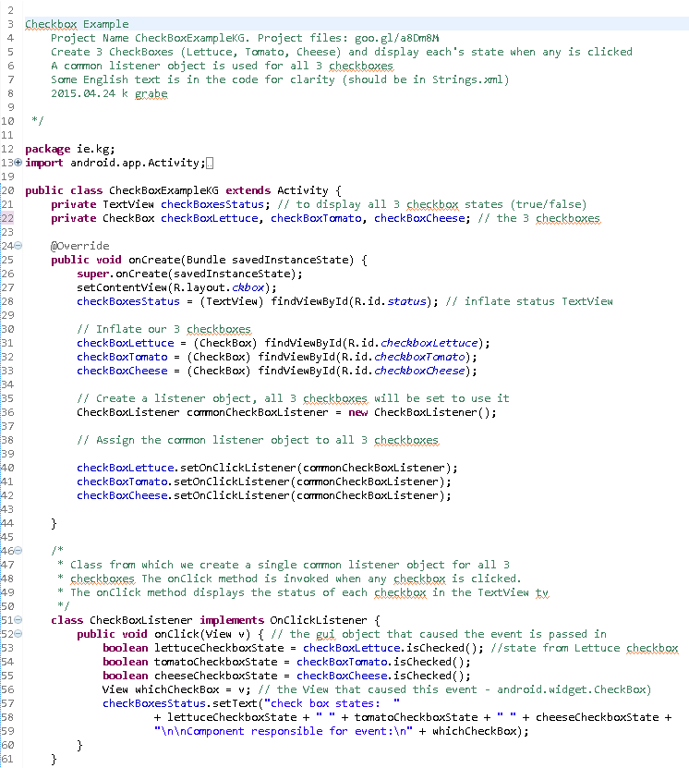
Note that the object whichCheckBox is of type View and a compile error doesn’t occur in the last line as View, like every other class in Java, inherits ultimately from class Object which has a toString( ) method. View overrides the Object’s toString method to provide a textual representation of the View object.

Checkbox Example, some notes →

A common listener object is created from inner class CheckBoxListener. Each checkbox object: checkBoxLettuce, checkBoxTomato etc. uses the single listener object. So the listener object event handler method onClick() is invoked when any of the checkboxes change state.
The checkbox responsible for the event is passed into the onClick (View v) method and assigned to whichComponent which is only used to display the checkBoxStatus TextView using its toString () method.

ToggleButton 108 - source similar to checkbox so none provided
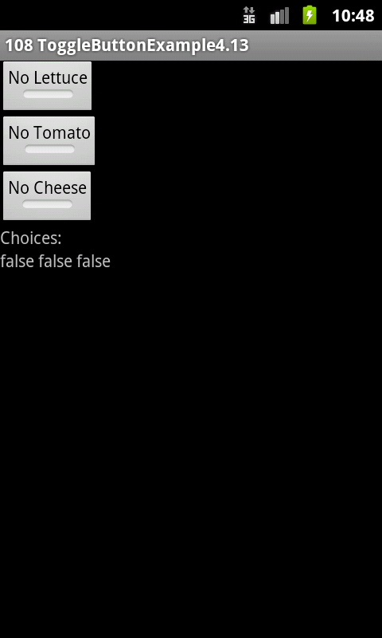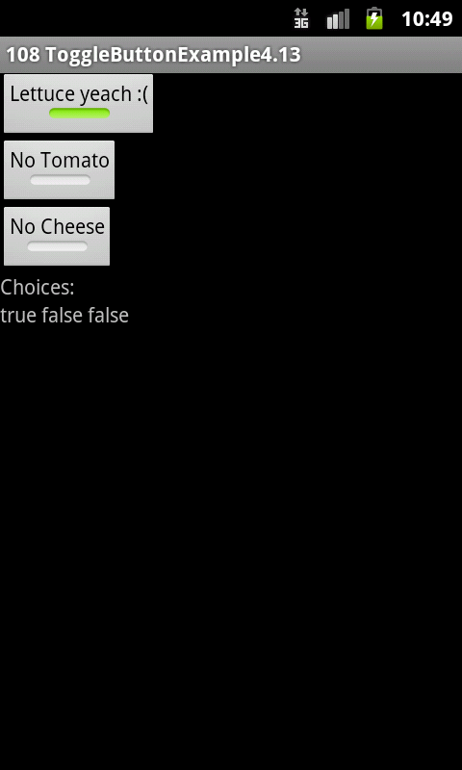

ToggleButton

Toggle buttons are similar to checkboxes, but use a different graphic. In addition, the text is incorporated into the button rather than put alongside.
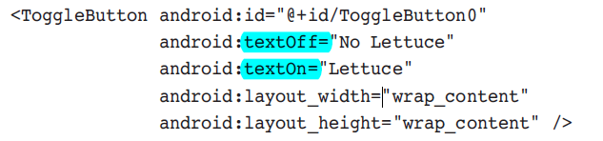

The android:text element is replaced by:
- android:textOff (defaults to "OFF" if not specified)
- android:textOn (defaults to "ON" if not specified)
for displaying the elements Text but what’s actually displayed depends on the selection state of the toggle button.

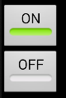
Default appearance if the textOff & TextOn elements are not included.

RadioButtons

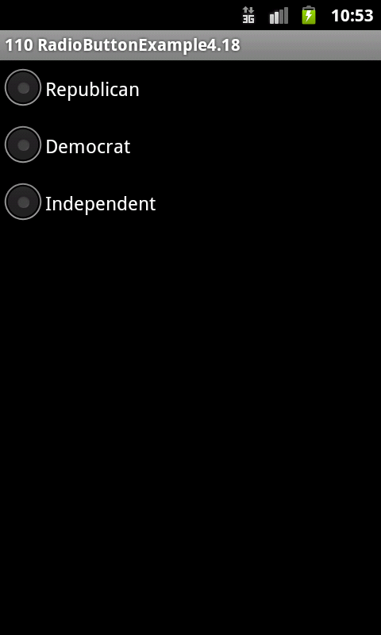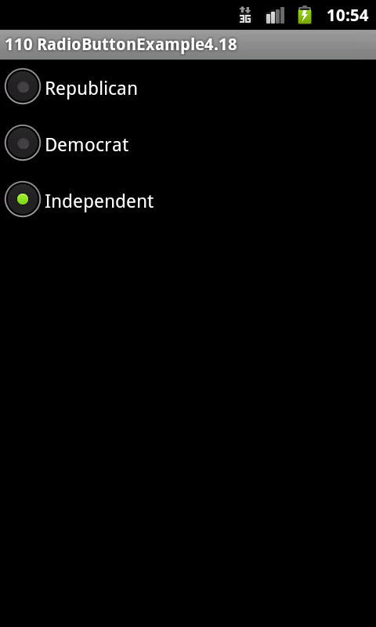

A radio button is like a checkbox that cannot be unchecked. Selecting one radio button unselects a previously selected one.
A group of radio buttons is put into a RadioGroup

Radio Buttons Example, XML layout
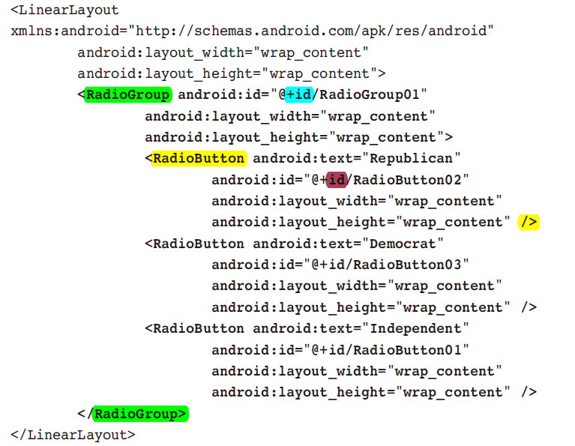
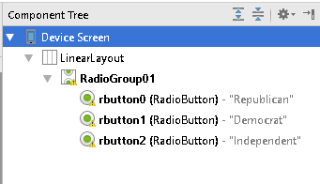

Radio Buttons source AS
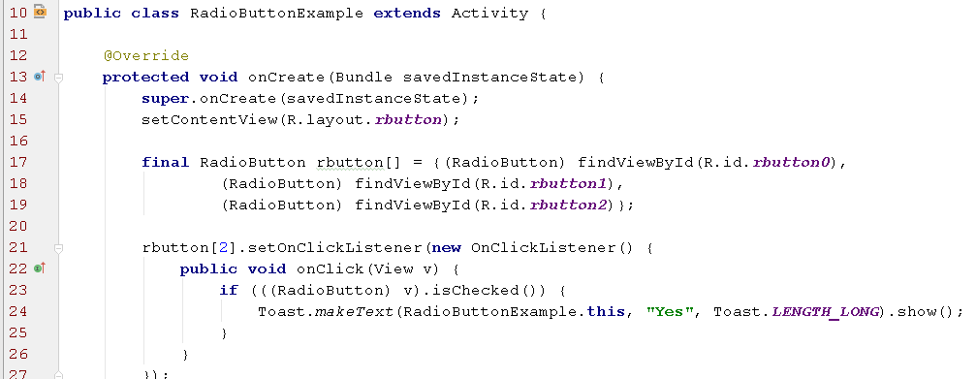
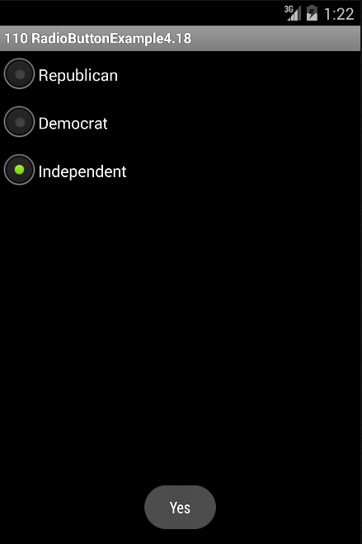

Spinner Example 1 111

A drop down list, or pop-up menu is called a Spinner in Android
Spinner entry layout is not limited to text, but can include images.

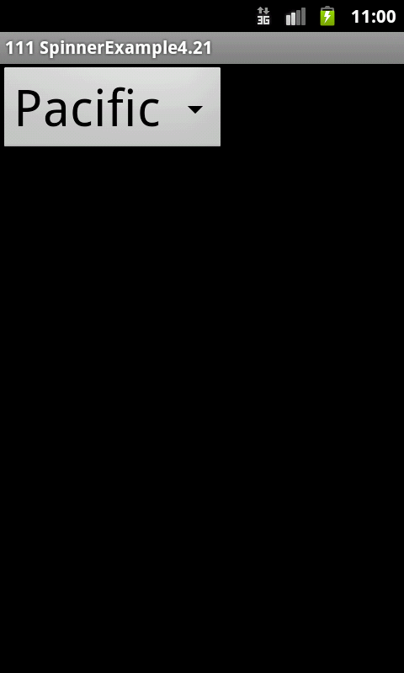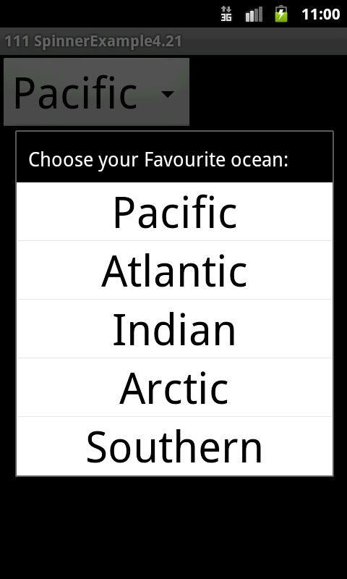
XML files next page

Spinner example XML Files

res/layout Just one component, the Spinner →
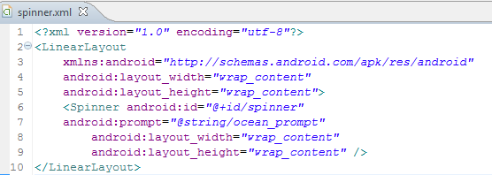
The title of the drop-down menu can be specified with the android:prompt attribute.
res/layout - Separate layout with a TextView used to display spinner menu →
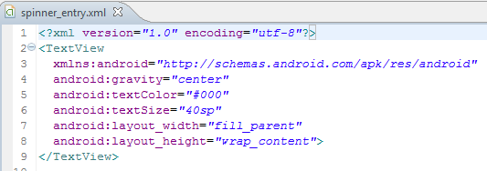
res/values - Spinner text to display while showing choices →
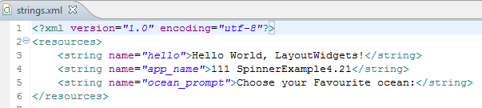

Spinner Example code source AS
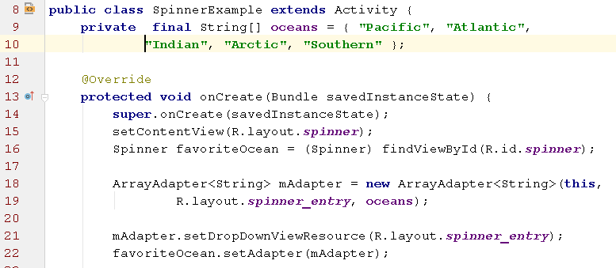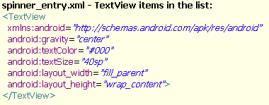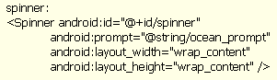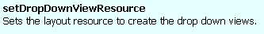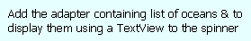
layout file with the spinner
krg 2015
The activity to call the spinner needs to declare an Adapter to fill the drop-down menu with the view from the spinner entry layout file.

Spinner entries are defined by the string array oceans[], which is passed to the ArrayAdapter constructor. This implementation assumes the spinner entries do not change during run time.

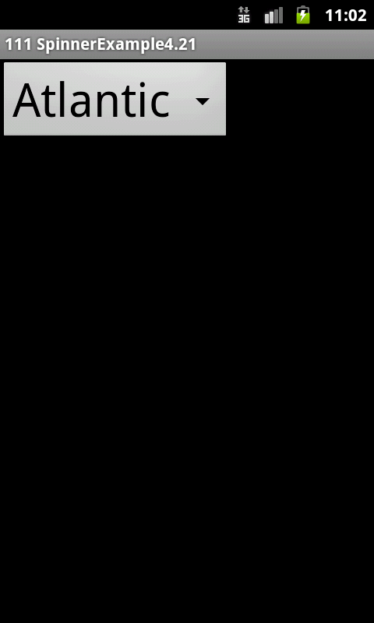

Editable Spinner Entries

To specify a more general case where spinner entries can be added or manipulated, mAdapter needs to be built using its add() method

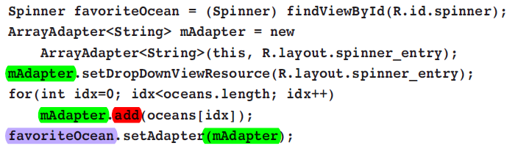

This ArrayAdapter allows the add(), remove(), and clear() methods to change the selection list during run-time.

String Array - How to Define in XML, then inflate in java
from: https://developer.android.com/guide/topics/resources/string-resource.html
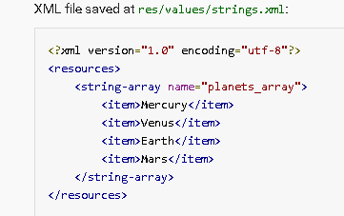
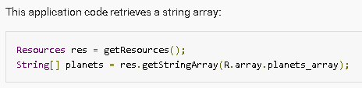
It’s done differently with an adapter by using createFromResource():

Spinner - reacting to selection events: OnItemSelectedListener
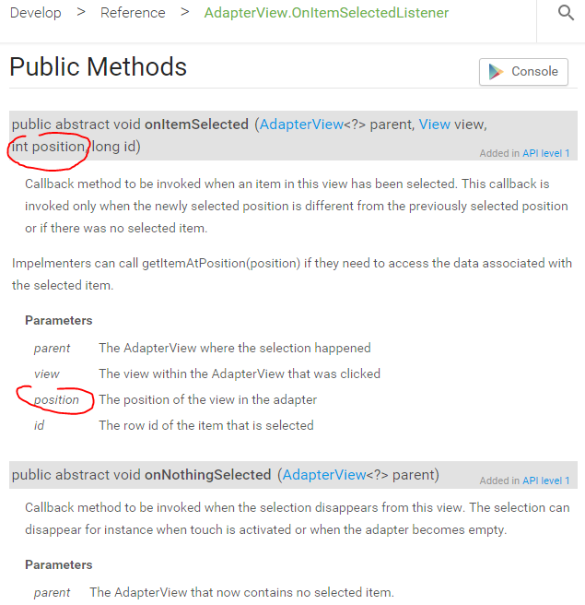

Spinner Example 2 using an XML String array:
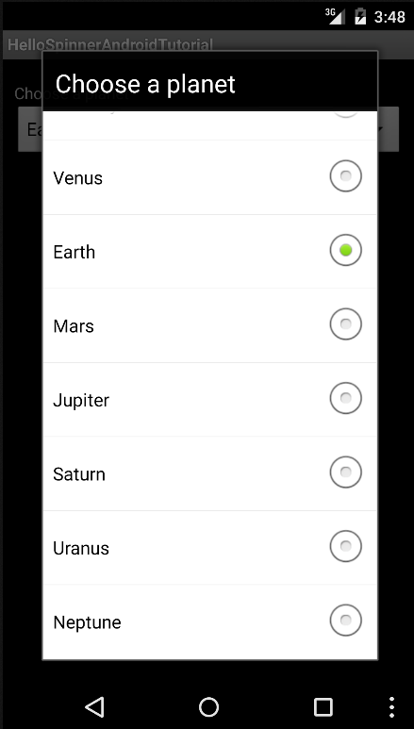
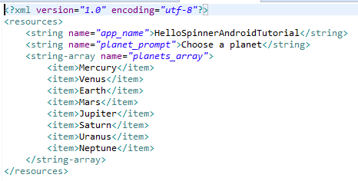

Spinner Example 2 react to spinner events - show toast on selection. source AS from: http://developer.android.com/resources/tutorials/views/hello-spinner.html
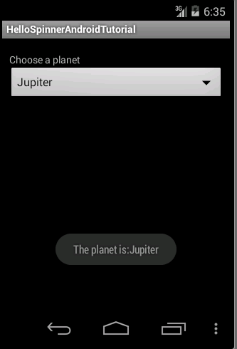
Toast shows newly selected item
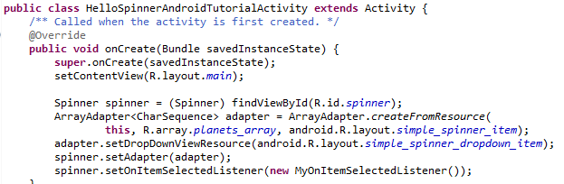
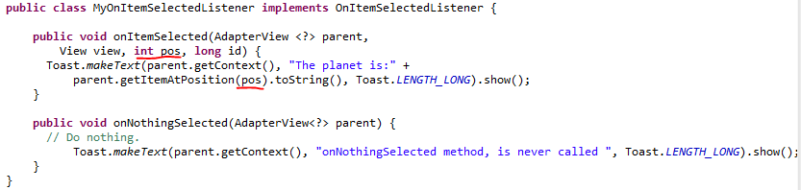
This Example has a listener object associated with the spinner.
simple_spinner_item above is not ours XML - comes from android.R.layout...

ListActivity (and implicit intents)
An alternative to the Spinner component for showing the user a list of choices is the ListActivity, a subclass of Activity, and triggering an event based on what choice was made.
Use a ListActivity instead of a spinner:
- A large number of items to choose from
- To dedicate an entire screen for the choices
- Filtering is required using a keyboard letter

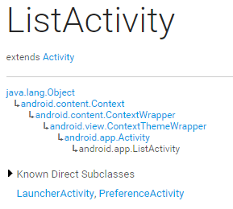

Implicit Intents
The ListActivity example also demonstrates Implicit Intents (see Explicit intents covered earlier).

Implicit intents do not specify an exact component to use.

Instead, they specify the functionality required through a filter, and the Android system will determine the best component to utilize.

An intent filter can be either an action, data, or a category.

The most commonly used intent filter is an action, and the most common action is ACTION_VIEW. This mode requires a uniform resource identifier (URI) to be specified and then displays the data to the user. It does the most reasonable action for the given URI.

Steps to launch a Activity using an Implicit Intent

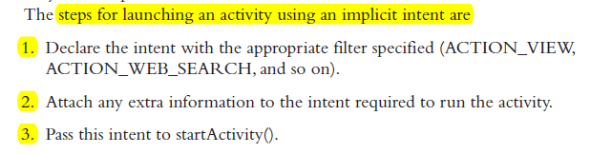

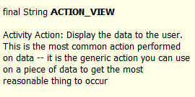

ListActivity Example
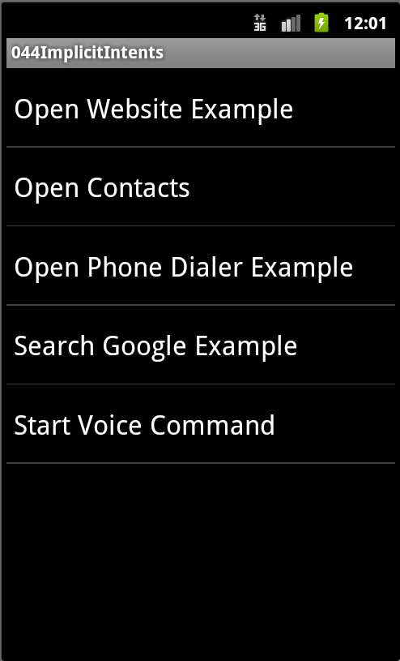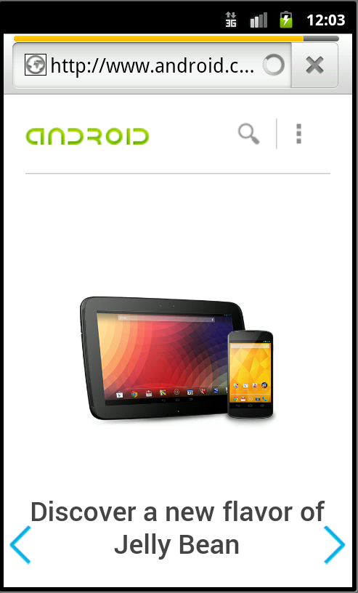

ListActivity steps...
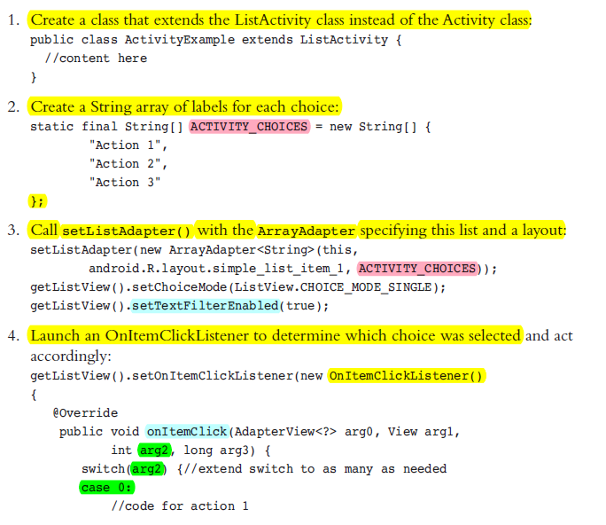

Note - same mechanism as Spinner covered earlier

ListActivity Example code 1/2 source AS (implicit intents)

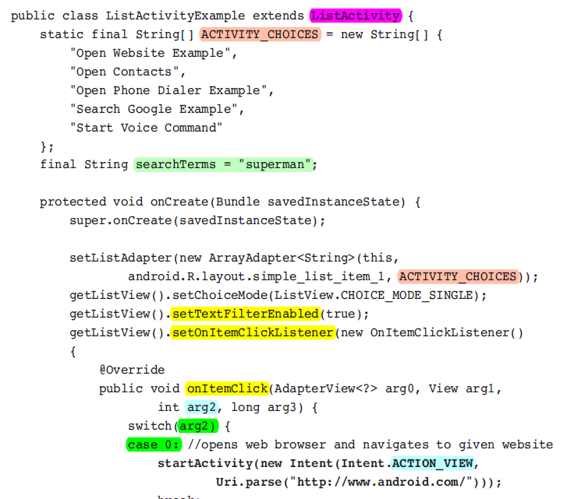

code on previous page info from API:
setTextfilterEnabled
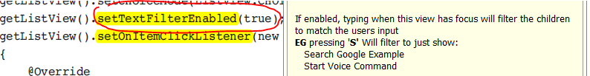

ListActivity - onItemClick
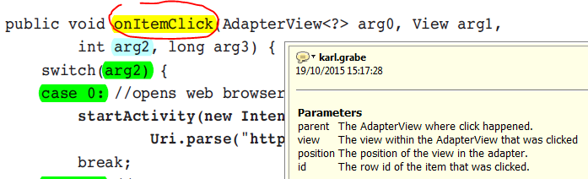

Uri.parse()
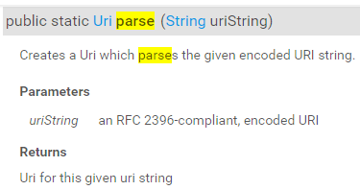
Uniform Resource Identifier (URI): a string of characters used to identify the name of a resource (WikiPedia)
RFC 2396 link for you to look up in case you're bored.

ListActivity Example code 2/2

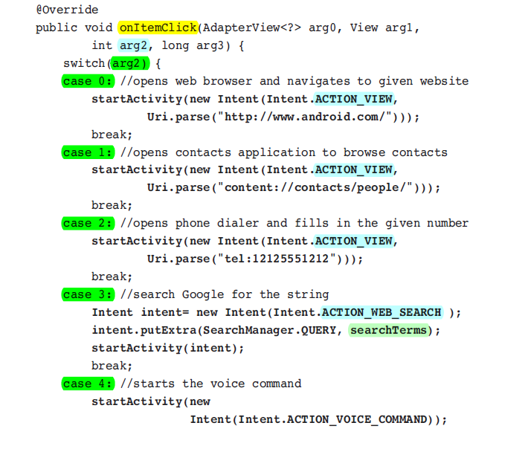

ListActivity Example output...
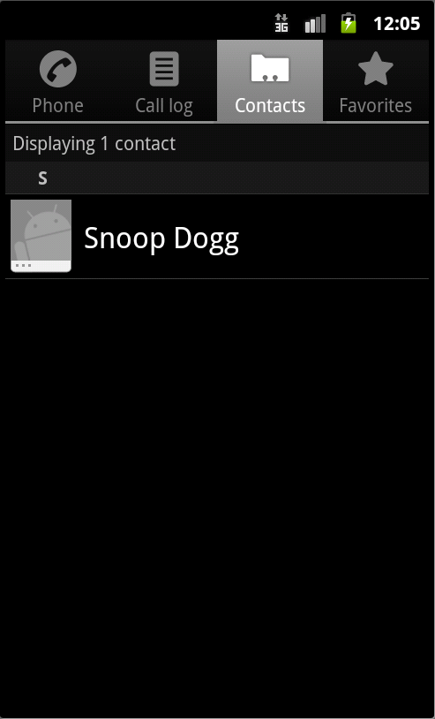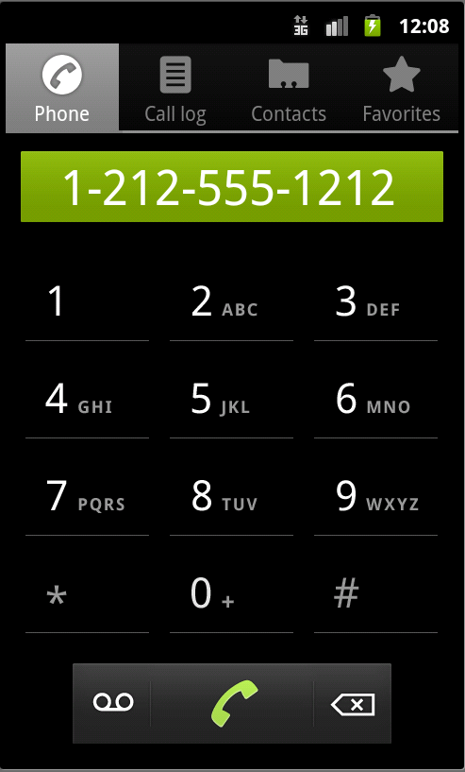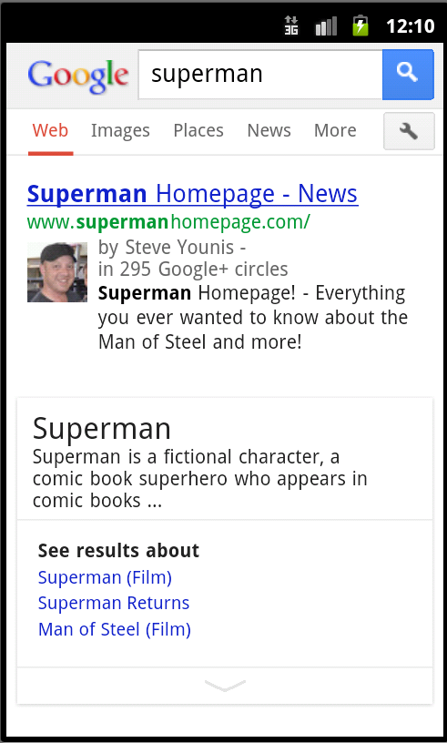

Progress Bar

- Visual indicator of progress in some operation or status of some variable (e.g. volume setting, room temp etc)

- Displays a bar to the user representing how far the operation has progressed.

- The application’s Activity can change the amount of progress (modifying the length of the bar) as it moves forward.

- The user cannot change the progress with this widget (use a seekbar for that).

- There is also a secondary progress displayable which is useful for displaying intermediate progress, such as the buffer level during video streaming →
Progress Bar showing progress & optional secondary progress.

Progress Bar Example

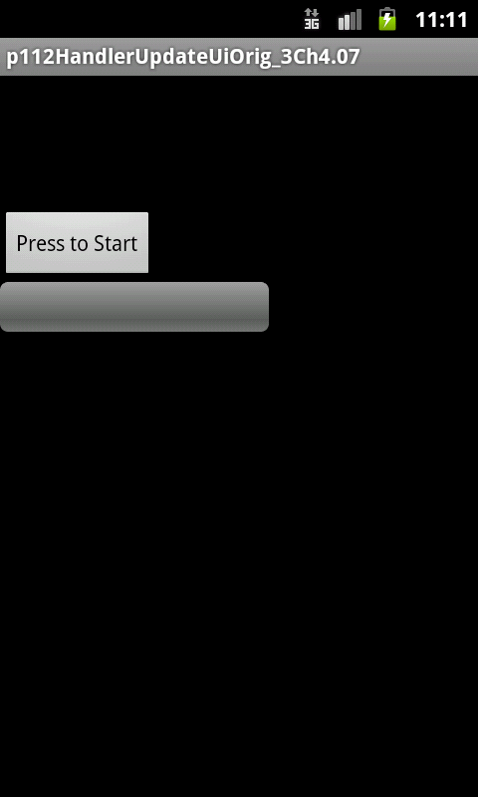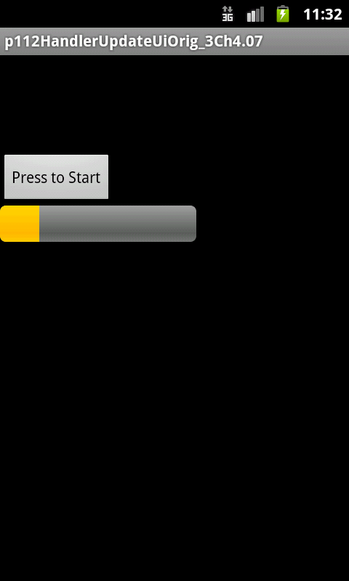
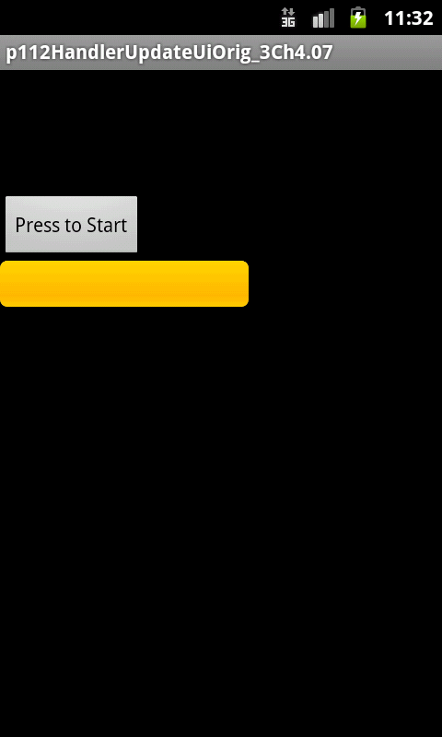

Progress Bar

Progress Bar XML in layout file →

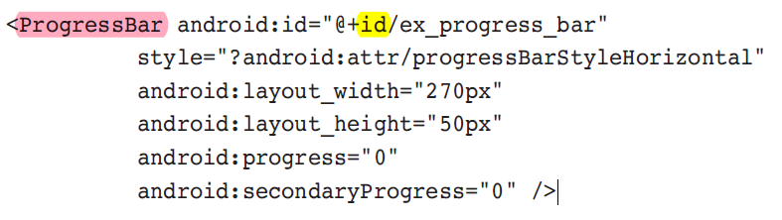

API →

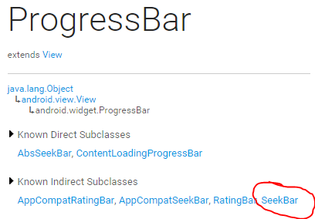

Progress Bar API →

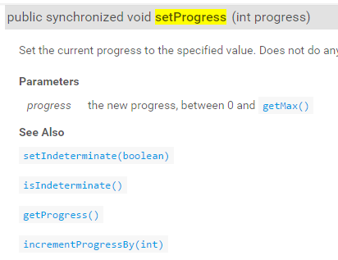
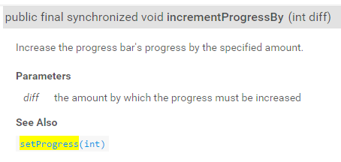

Note both methods are synchronized which “prevents thread interference and memory consistency errors”. A complex area, for the brave: learn more & stackOverflow

Progress Bar Example source: goo.gl/j7d7Gs (eclipse) in folder : goo.gl/767xyj
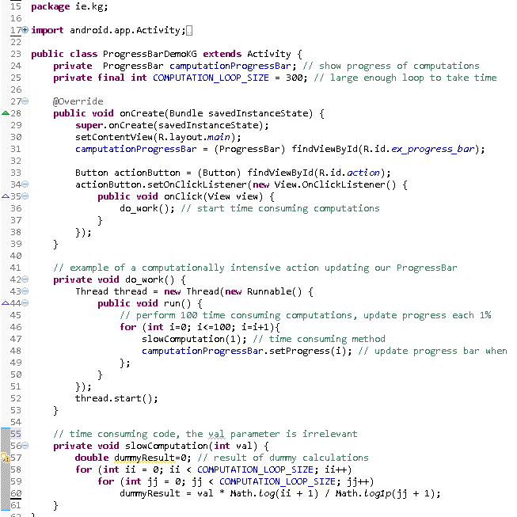
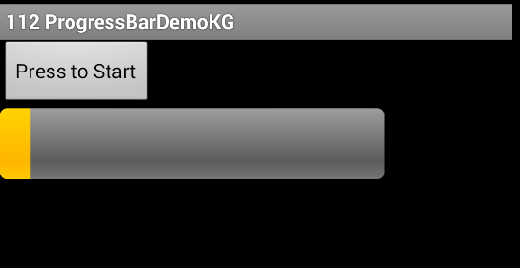

Progress Bar Example cntd.

Note that the progress bar is updated from the thread created in the doWork() method.
Normally you can’t update GUI components this way (e.g. using TextView’s setText method) as they are running in a different Thread . However the setProgress method from ProgressBar is synchronized, which makes it thread safe.
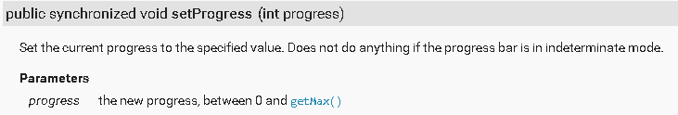
Suppose you wanted to update a TextView component in the above example in the same place we’re updating the progress bar then you would try to update the TextView using its method setText (which in not synchronised), it won’t work - you need a different approach - see this link. Here’s the original progress bar book example that uses inter-thread communications: “Progress Bar UI thread comms”.
More info on how to make your own methods thread safe

SeekBar
A seek bar is similar to a progress bar that can take user input to change the amount of “progress”.
Current progress is indicated by a small sliding box called a thumb.
A user can click and drag the thumb to visually indicate the new place the “progress” has been set to.

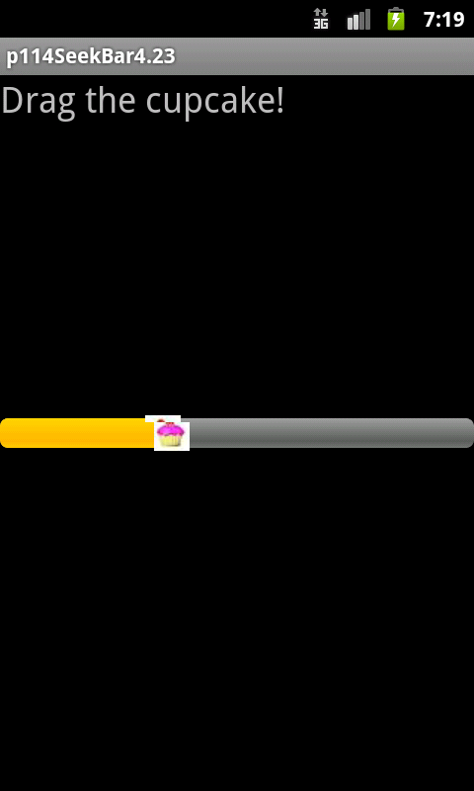

Seekbar API
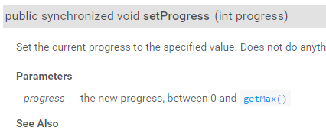

SeekBar Example 1 - Updated by User
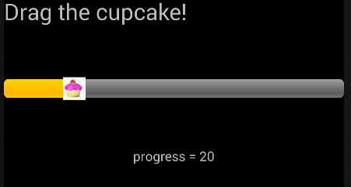
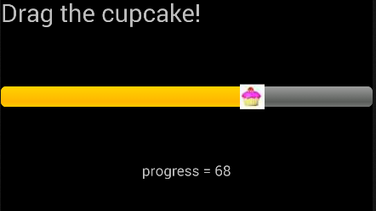
user moves the thumb, TextView instantly updates with new progress

Layout file XML snippet:
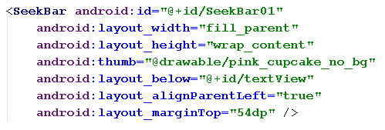
SeekBar Example 1 - Updated by User Only source AS
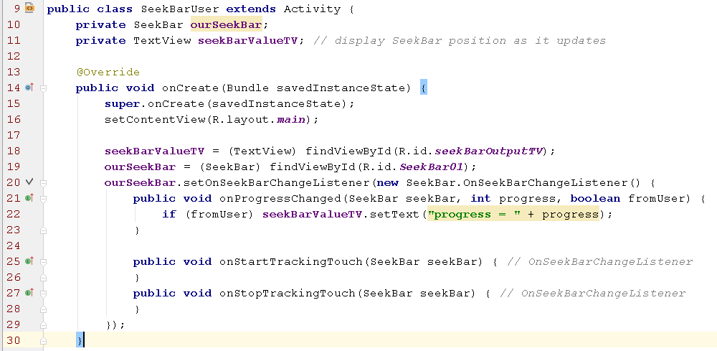

SeekBar example 2 - updated by user & program thread source AS
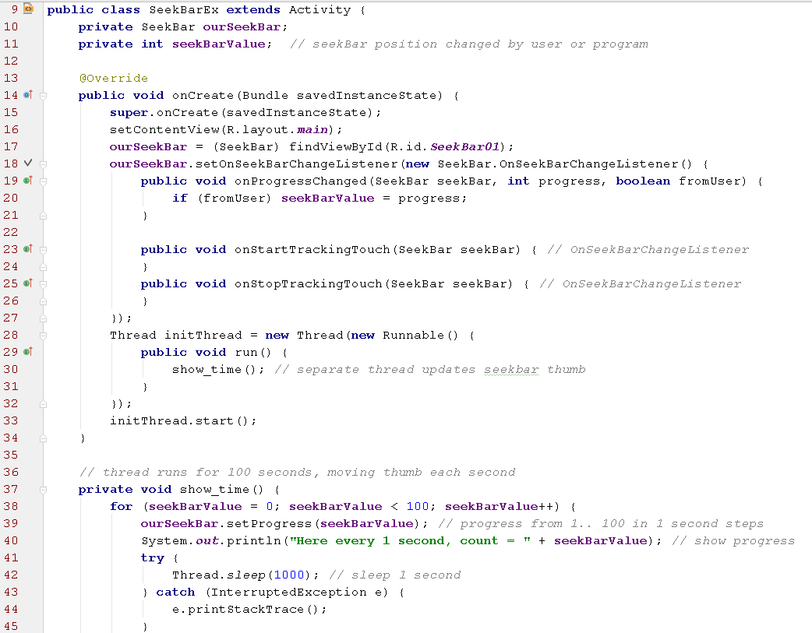
Aside: Can’t output the progress of the seekbar on line 40 to a TextView, setText() is not synchronised. However println () is:
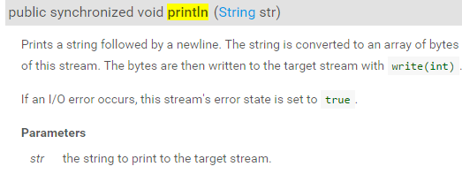
Thumb moves every 1 Second but can also be moved by the user

Logcat output, thumb moved back at count 18
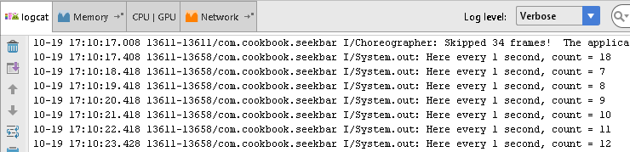

User Interface Events
Here we show how to handle events from a user, such as physical key presses, touch events, gestures and menu navigation.

Event Handlers and Event Listeners
- User interaction with an Android device is captured by the operating system and sent to a corresponding Activity callback method. For example, if the physical Back button is pressed, the Activity class eventhandler method onBackPressed() is called.

- Our own activity classes can, for example, change the default Activity behaviour for onBackPressed() by overriding it.

Intercepting Physical Keypresses
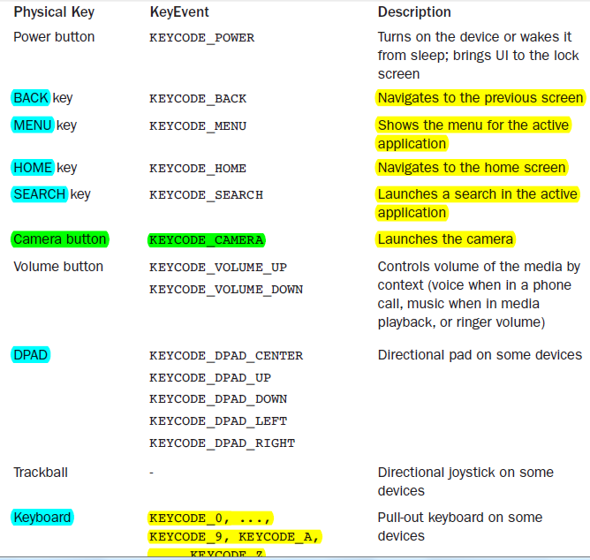

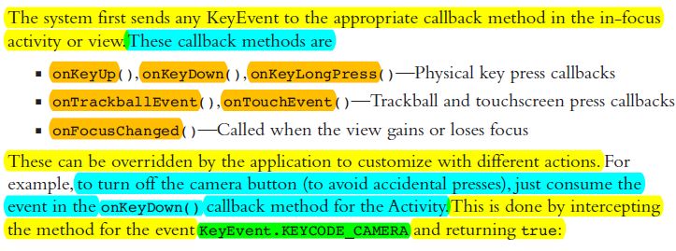
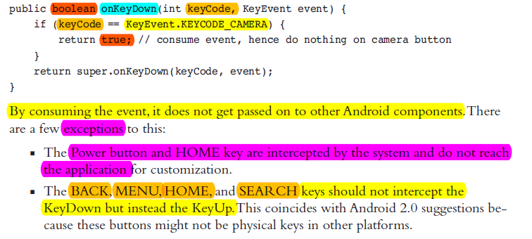

Intercepting Physical Keypresses - Example
The following example shows how to intercept key presses including:
- The Camera and DPAD left buttons are intercepted in onKeyDown() to show a message to the screen, and then it is consumed (by returning true).

- The Volume Up button is intercepted to show a message to the screen, but it is not consumed (returning false) and hence also actually increases the volume.

- The SEARCH key is intercepted in onKeyDown(), and the startTracking() method is used to track it through to the key up where a message is sent to the screen.

- The BACK key is intercepted in onBackPressed(). However an Android guideline for usability is that the BACK key should generally not be customized

Intercepting Physical Keypresses - Example, screens
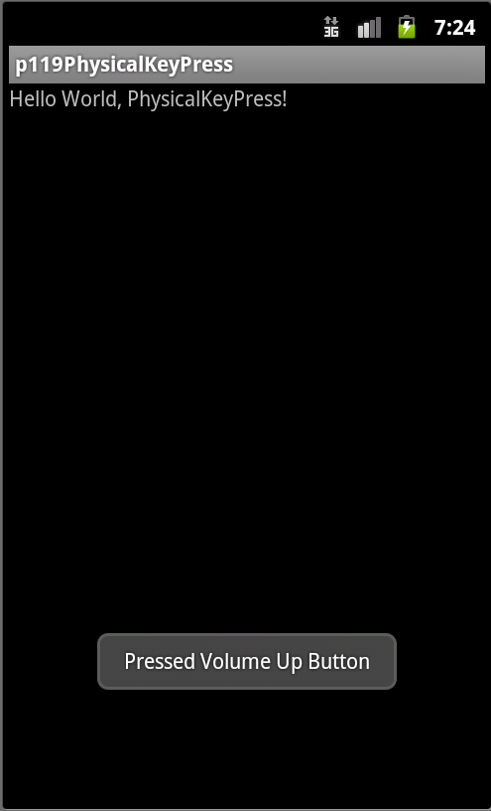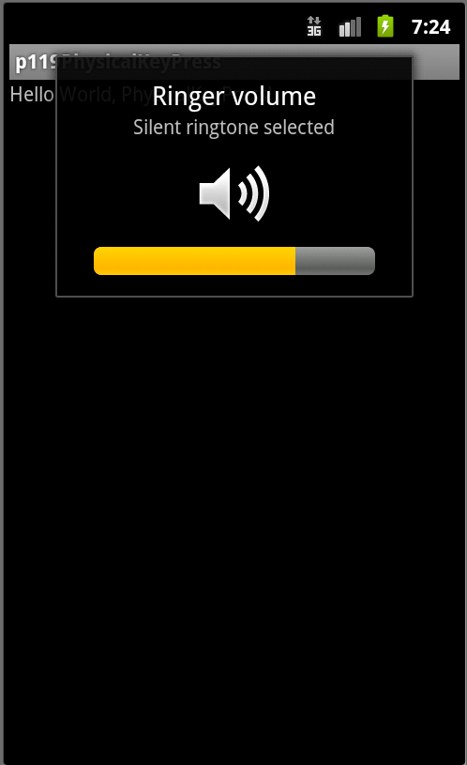
Pressing volume up – toast followed by volume actually changing as event is not consumed
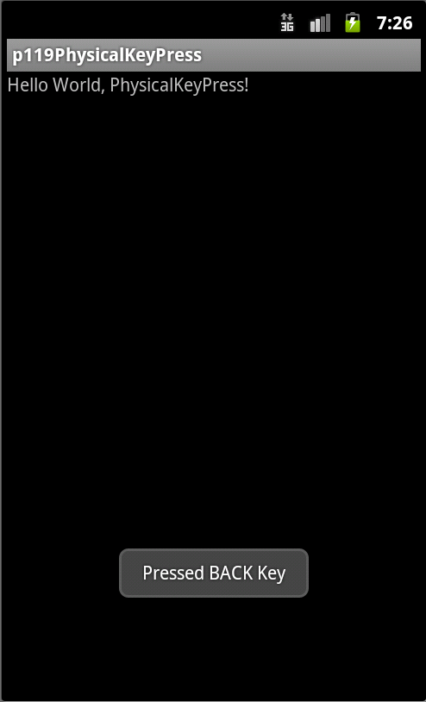Back key – toast and no Back operation occurs = event was consumed (not recommended)

Intercepting Physical Keypresses - Example Code 1/2 source AS

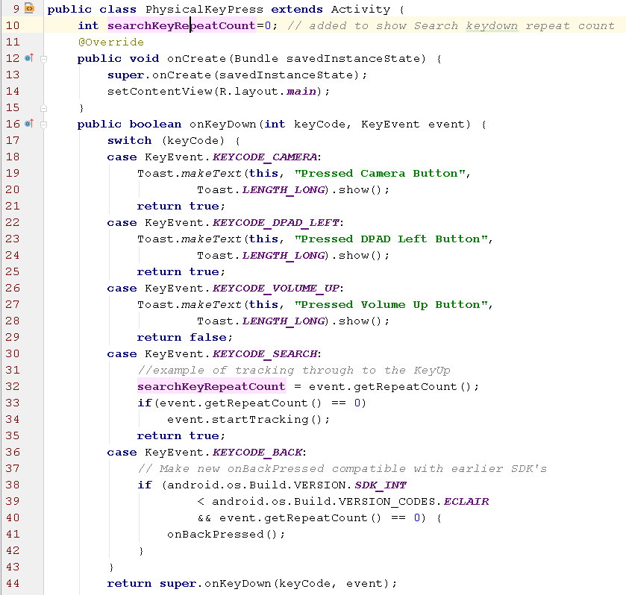

Intercepting Physical Keypresses - Example Code 2/2
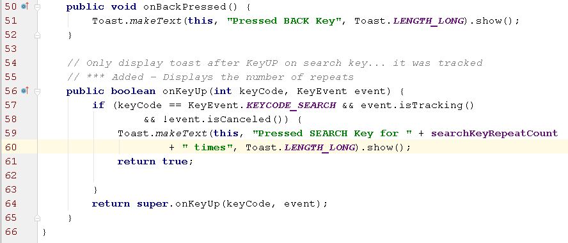

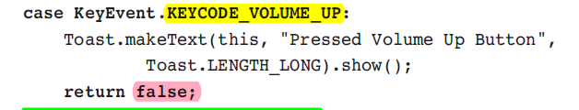
return false so DON'T consume and volume DOES change.

search key might not work on emulator it is tracked until keyUp when a toast is displayed:
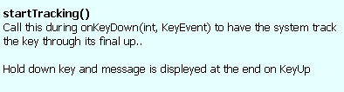

Menus
Menus are a common user interface component in many types of applications.

Provide a familiar and consistent user experience use the Menu APIs to present user actions and other options.

From Android 3.0 (11) Android devices are no longer required to provide a dedicated Menu button so apps should migrate away from 6-item menu panel and instead use the action bar to present common user actions.

Although the design and user experience for some menu items have changed, the semantics to define a set of actions and options is still based on the Menu APIs.

Menus - Old & New looks but same Menu class more
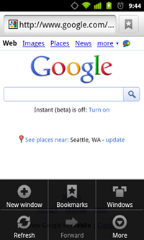
Options menu in the Browser, on Android 2.3.

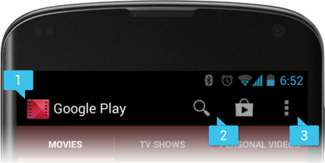
Action bar from the Honeycomb Gallery app, showing navigation tabs, camera action item & menu (#3). To develop with ActionBar ensure you have the support library installed - see how to. Then here’s how to add an Action Bar.

Options Menu - Example Program
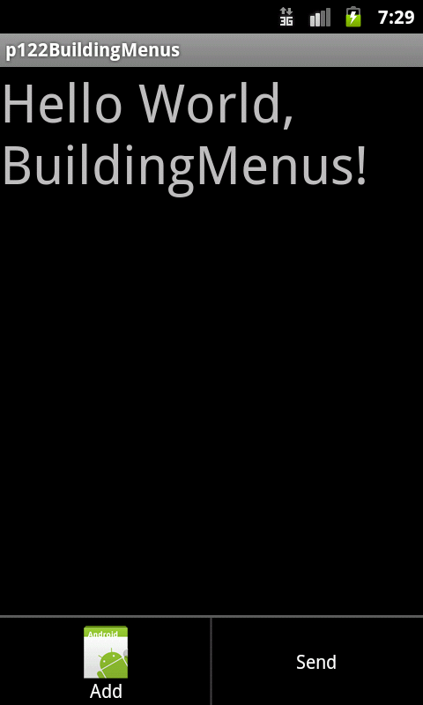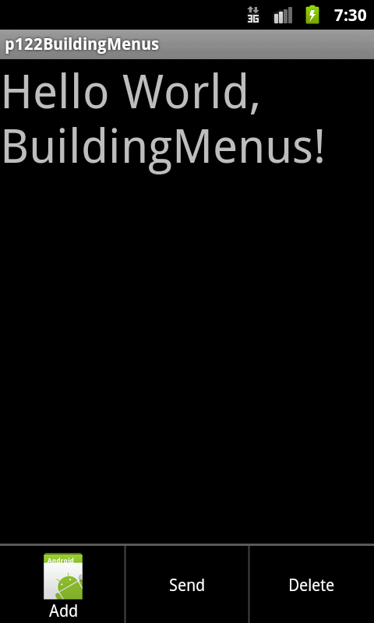
Selecting Add results in Delete being shown next time menu key is pressed
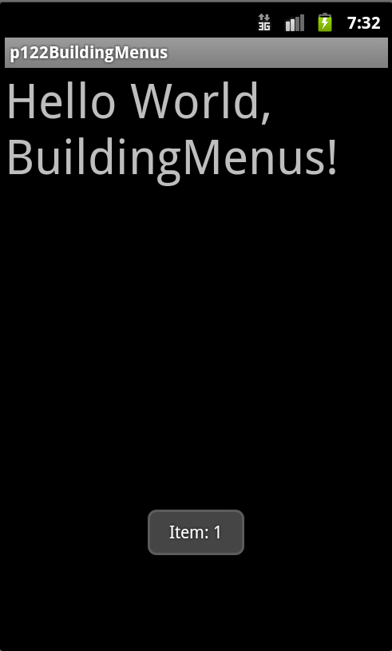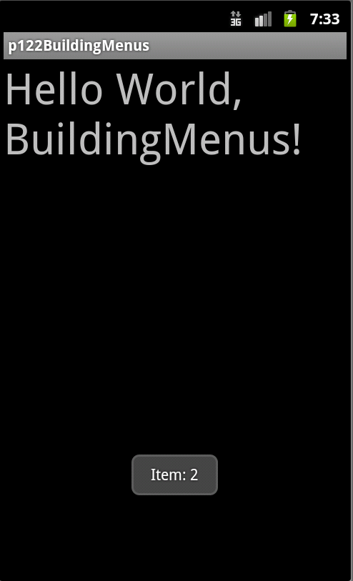
Each Add causes another ‘item’ to be shown when Send menu is pressed.

Options Menu example program operation:
- Add – first time adds one item and enables the Delete menu

- Add – Adds an ‘item’ to the ‘send Q’, the item number is incremented each time Add is pressed.

- Delete – removes an item from the ‘send Q’, the item number is decremented each time Delete is pressed

- Send – ‘sends’ the item

Option Menus Example source AS

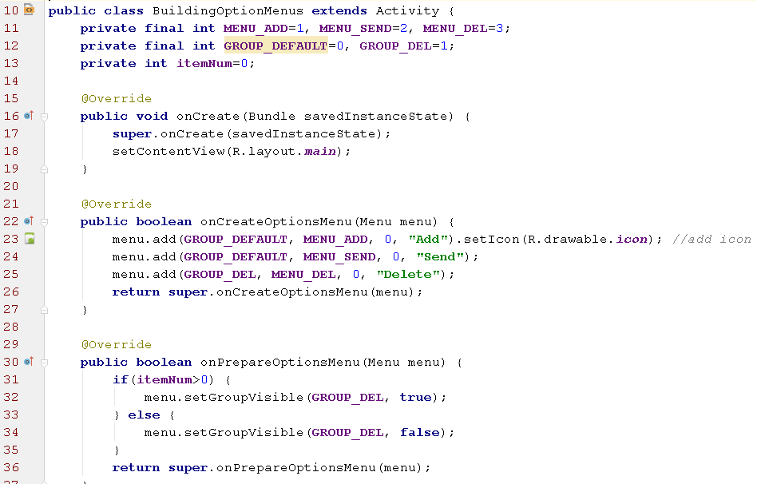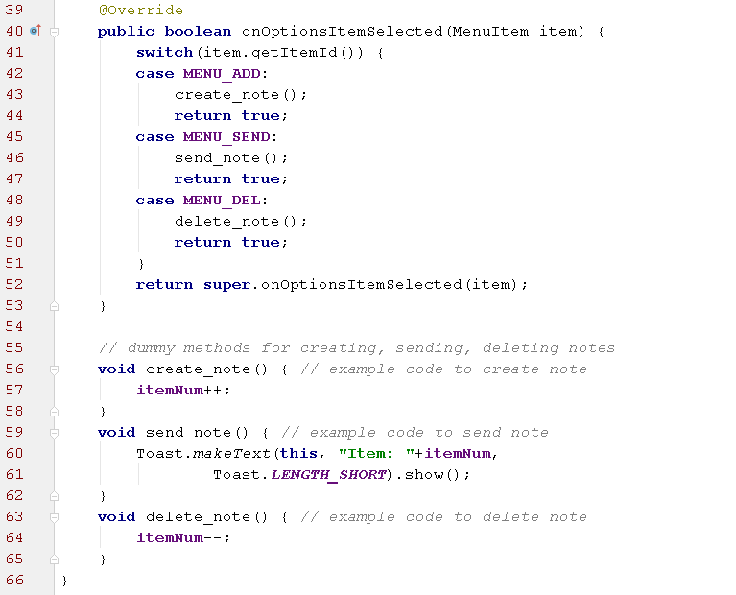

Contextual Menus
A contextual menu offers actions that affect a specific item or context frame in the UI.
You can provide a context menu for any view, but they are most often used for items in a ListView, GridView.

Two ways to provide contextual actions:
- In a floating context menu. A menu appears as a floating list of menu items (similar to a dialog) when the user performs a long-click (press and hold) on a view that declares support for a context menu.

- (not covered) contextual action mode: This mode is a system implementation of ActionMode that displays a contextual action bar at the top of the screen with action items that affect the selected item(s).

Contextual Menus -

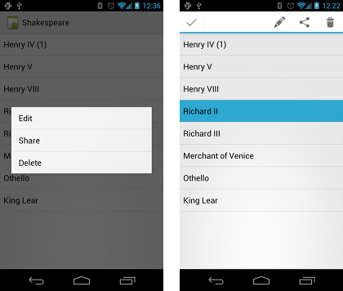

Screenshots of a floating context menu (left) and the contextual action bar (right).

Our example shows how to implement a floating context menu ...

Context Menus Example: floating context menu

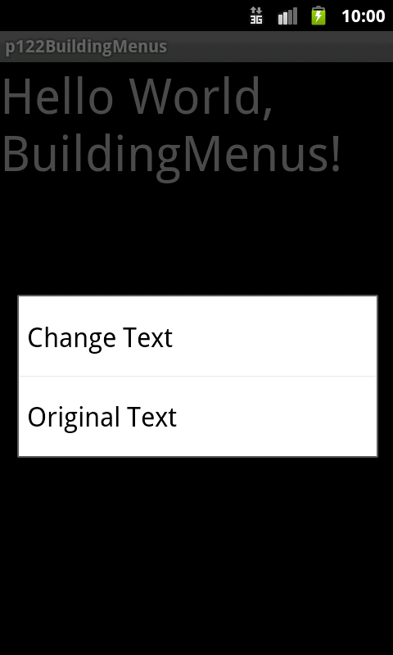 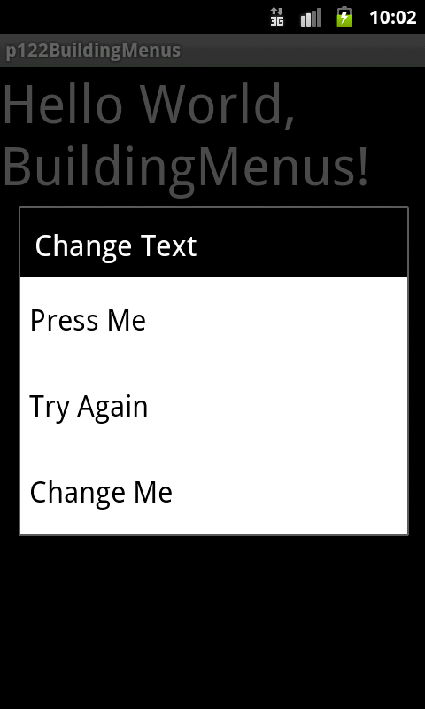 Context Long Press on “Hello world…”menu appears, then select Change Text for submenu
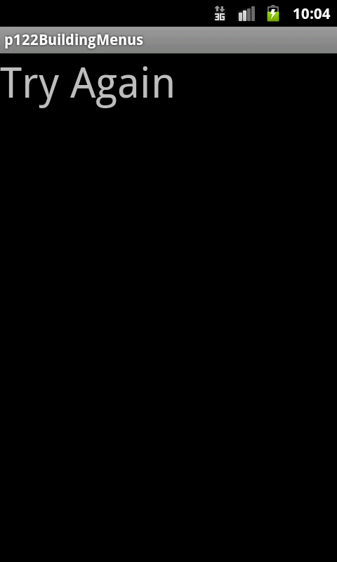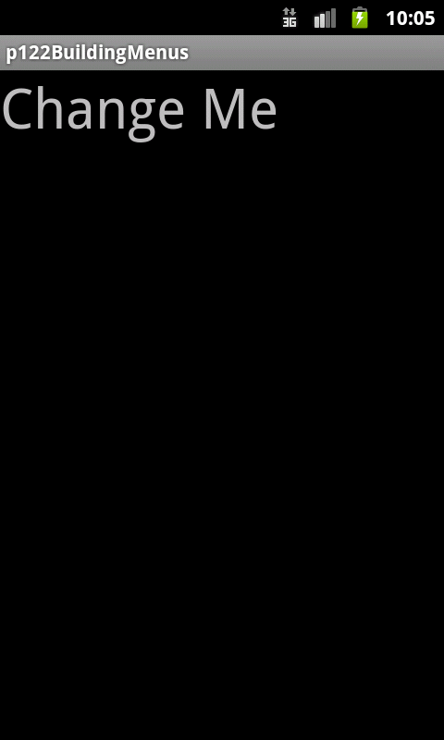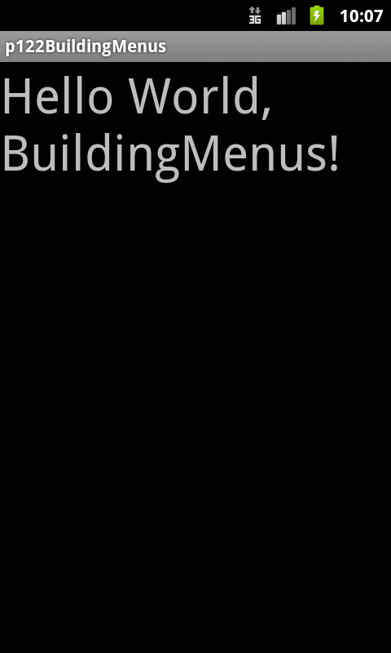
Try Again or Change Me selected. Also ‘Original Text’ on main context menu resets text.

Context Menus Example source AS

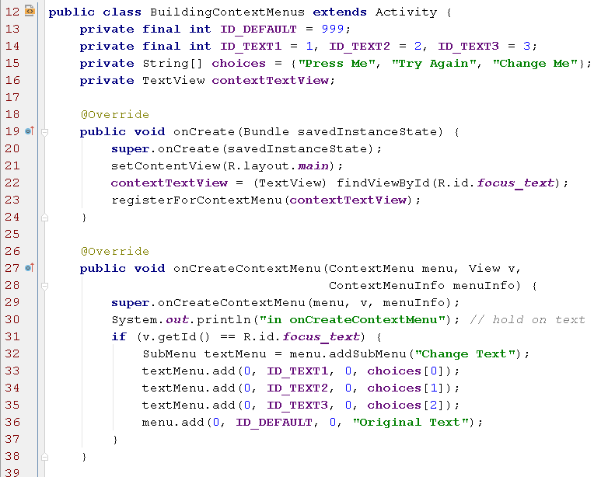
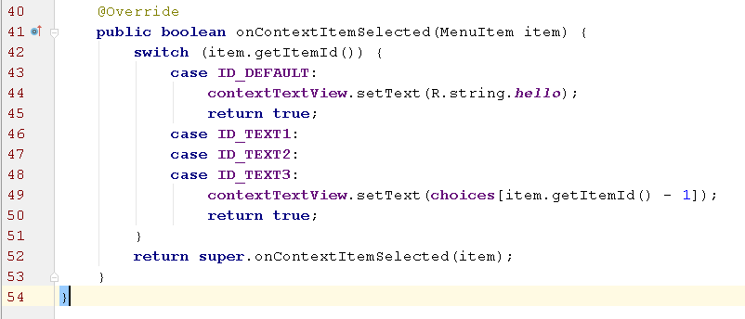

Context Menus using Menu items defined in XML source AS
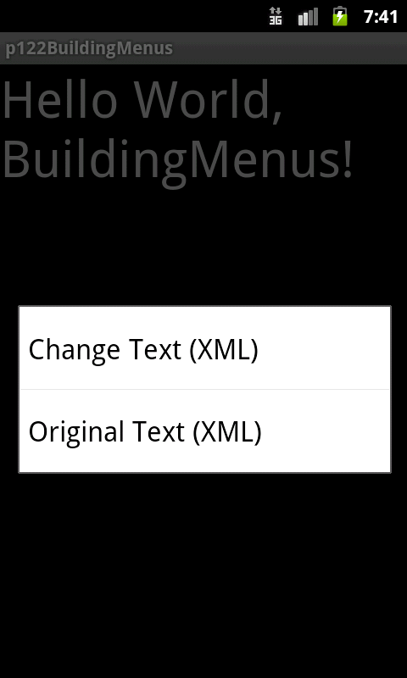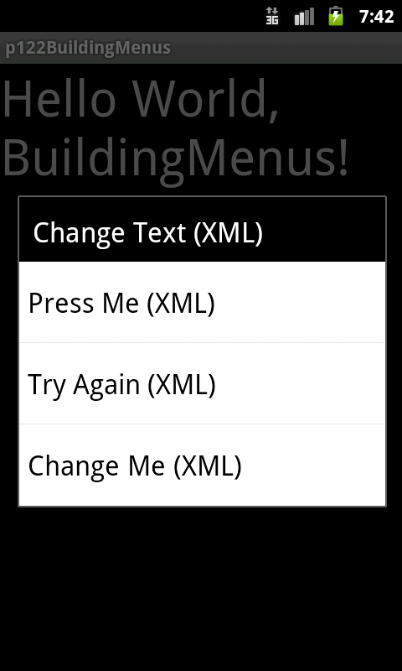
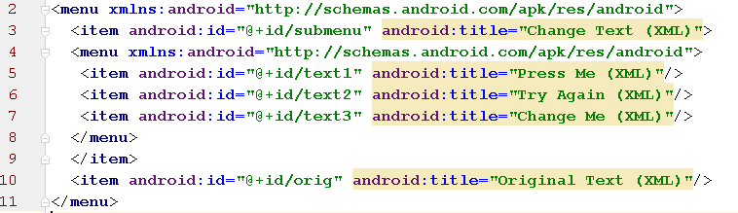
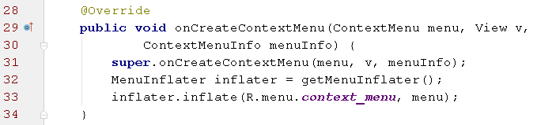
R.menu.context_menu refers to the xml file context_menu.xml containing the menus.
Rjava: app\build\generated\source\r\debug\com\cookbook\building_menus\R.java in project view

Touch Examples ‘normal’ & ‘long’ clicks
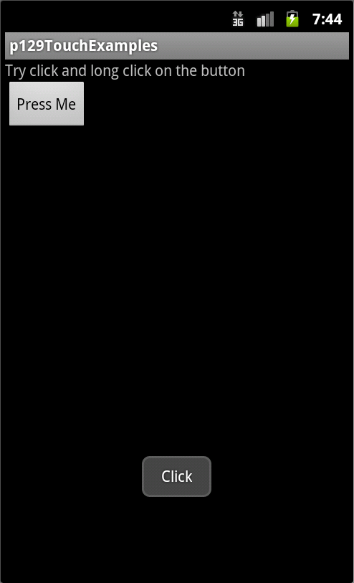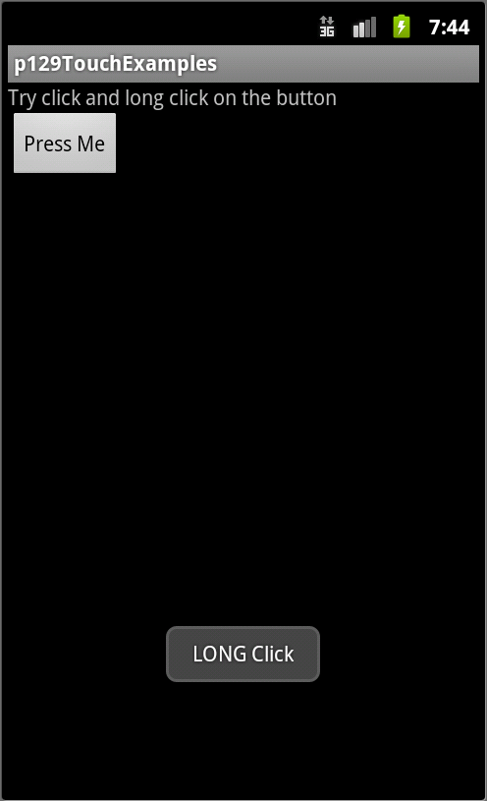
A toast is displayed for click and long click

We’ve already seen onClickListener with it’s onClick() method, here’s the Long Click interface:
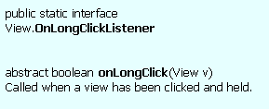

Example with ‘normal’ & ‘long’ clicks on a TextView source AS
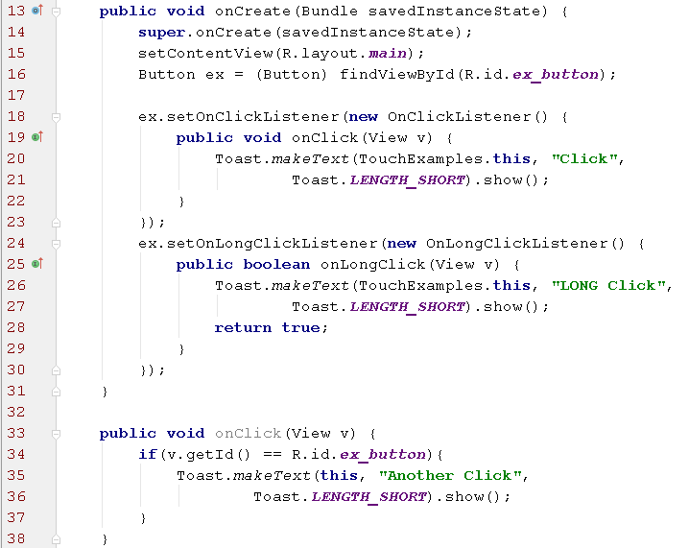

Long Click works on any View component as well as TextView, but you will need to inform the user of that functionality.

Above example uses anonymous inner classes on lines 18 & 24 for normal and long click event handling. Following examples show different ways of writing the listener object class - named inner class and external class.

OnClickListener using named inner classes source AS
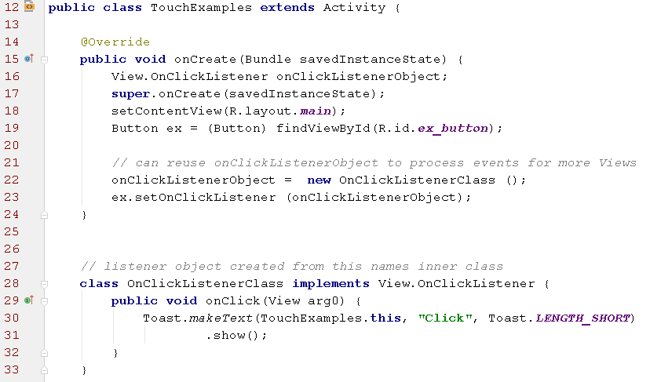
The named inner class, OnClickListenerClass, on line 28 has access to Activity methods and variables in the the class TouchExamles. So the Toast on line 30 works, as it does for the anonymous inner class example before.
☝ Same functionality as before and also in the next code example using an external class.

OnClickListener using external class source AS

The external Listener Class which knows nothing about Activities, Toasts etc to we need to pass in a reference to the Activity that creates an object from the class to its constructor (line 19)
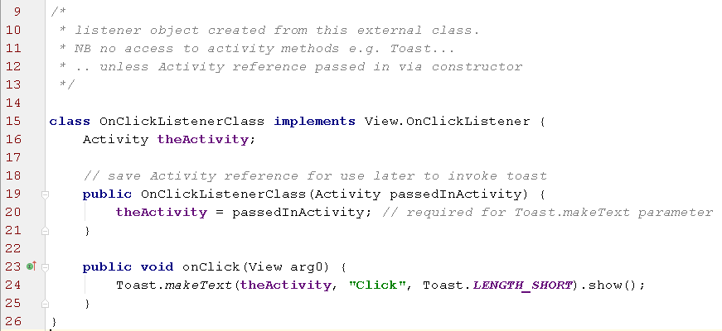

Activity Class that creates the listener object on line 21 from the class above
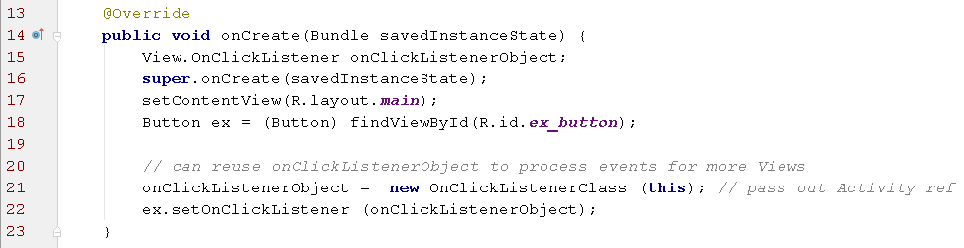
Finally 👏 OnClickListener using the existing Activity class
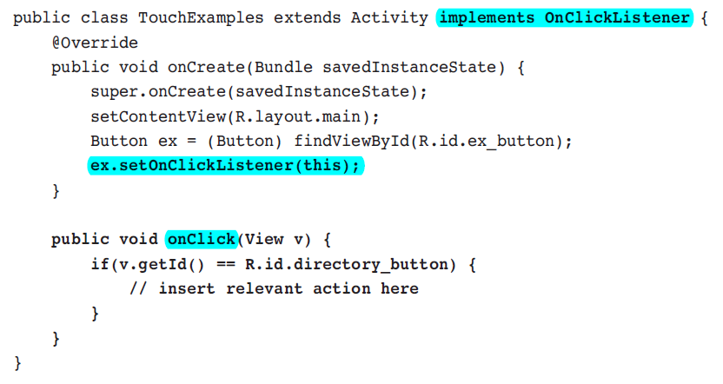

- Note that all clicks for ALL views (Button, EditText etc) will come through here the onClick method.
- So use the View's ID (an int) to find out which View caused the event.
- Then use switch/case implement functionality depending on what was clicked.

Which type of listener class to to implement?
Use an anonymous inner class when the event handler, e.g. onClick(), has only a few lines of code, otherwise use a named inner class.

Listening to Fling Gestures

A Gesture is a hand drawn shape on a touch screen
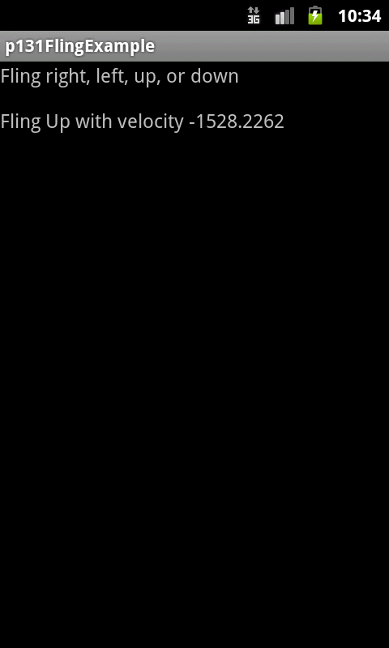
We will look at how to listen for gestures. In this example a finger is dragged and flung across the screen from which our program can determine the direction and velocity of the fling gesture.
Later examples will show how to recognise a pattern gesture drawn on the screen.

Each view has an onTouchEvent() method associated with it. It can be overridden with a gesture detector that sets a gesture listener using the OnGestureListener interface.

The gestures in GestureDetector.OnGestureListener interface are:
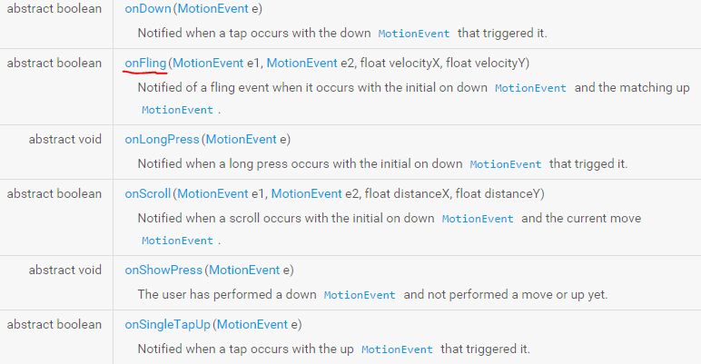

If you don’t want to implement all of the above methods there’s a convenience class that implements all the methods with no functionality: GestureDetector.SimpleOnGestureListener

A SimpleXXXX class is the equivalent to an Adapter class in Oracle’s Java (JSE, JEE etc).

The onFling() method in OnGestureListener interface
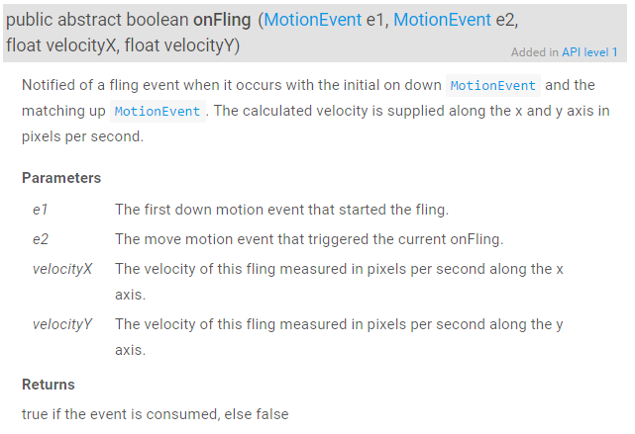
- A fling consists of two events with dragging motion in between them: a touch down (the first MotionEvent) and a release (the second MotionEvent).

- Each motion event has a specified location on the screen given by an (x,y) coordinate pair, where x is the horizontal axis and y is the vertical axis.

- The (x,y) velocity of the event is also provided.

Fling gesture example
XML Layout File:
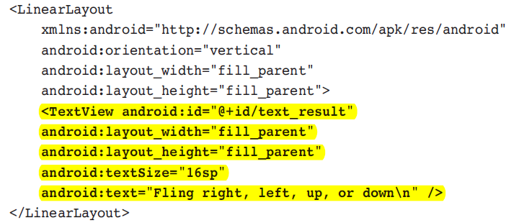

Nothing special needed in the Layout file, there’s just a single TextView showing instructions text.

Fling gesture example - code source AS
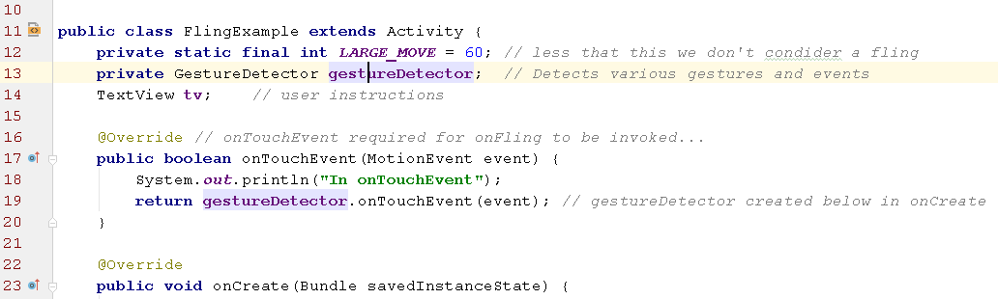
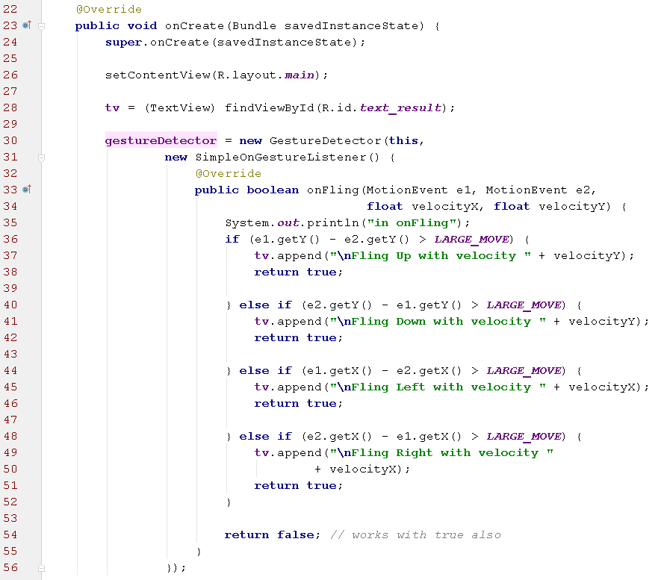

Fling gesture example - code snippets with API

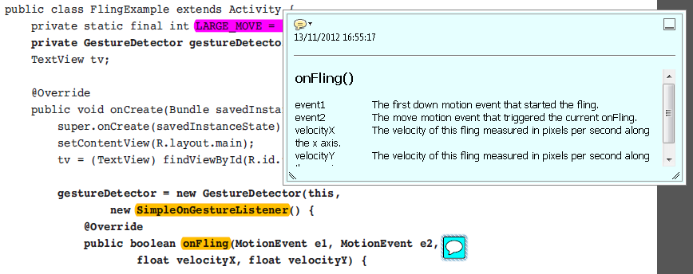

Fling gesture example - output

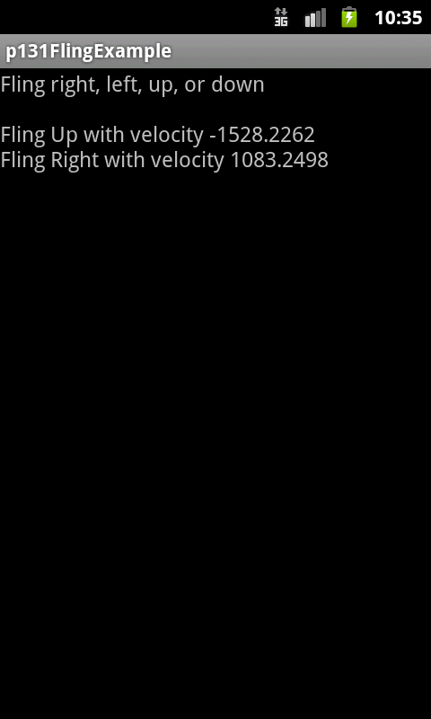
Drag finger & fling up, then for 2nd screen fling right

Paper Toss
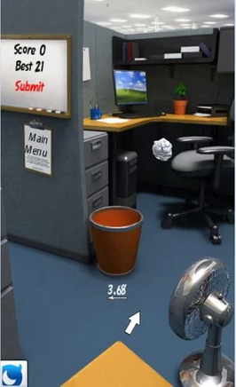
The paper toss App uses flings to control the direction and velocity of the piece of paper being thrown. The aim is to get it into the bin.

Multitouch
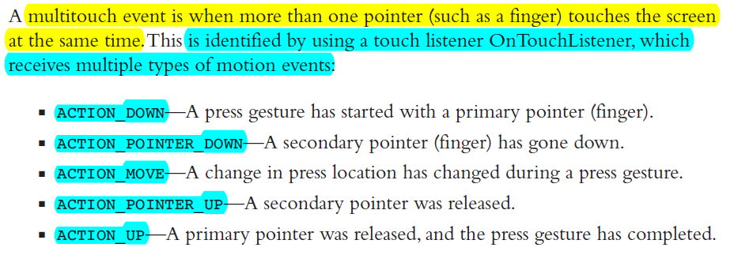

The the emulators that run on a desktop PC only have a single pointer so it’s normally not possible to run programs using Multitouch. Here’s an example to try on a phone. source AS

Using Gestures Example, setup
As mentioned a hand-drawn shape on a touch screen.

We can use custom gestures in our App by creating a library of gestures during App development.

When a user of our App then draws a gesture our App can try and match it against a gesture in our library.

The android.gesture package provides libraries to recognize & compare these gestures.

We can build our gesture library using the GestureBuilder App that comes with the Android SDK. It’s normally pre-installed on the emulator. But if not, or if you want it on your own phone, here’s the App, source and all in Android Studio format: GestureBuilder.

The Gesture Builder App
The Gesture Builder App produces a file called gestures in this directory in the emulator (or real phone): /sdcard/gestures.
First create a ‘gestures’ file for use with the example...
Ensure your Emulator has SD card memory “installed” - edit your emulator if not and change as follows:
Android Studio Tools | Android | Avd Manager
Click ‘pencil’ edit icon on a Virtual Device
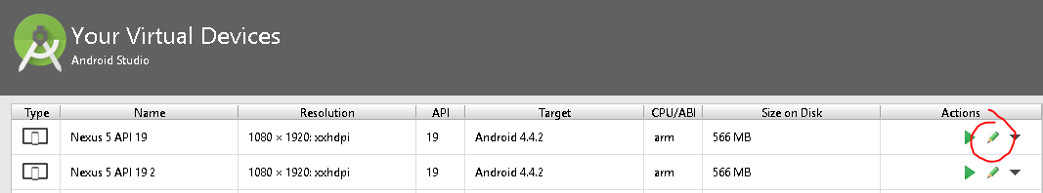
Select “Show Advanced Settings” and scroll down to “Memory & Storage” panel and assign some storage to the SD card e.g. 100MB in this case.
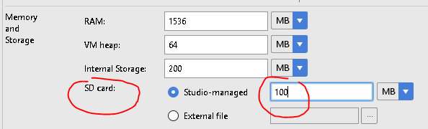

GestureBuilder - creating gestures
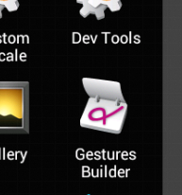Launch the app
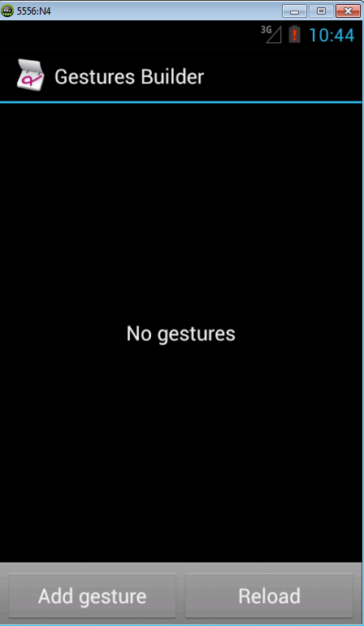 Add some gestures
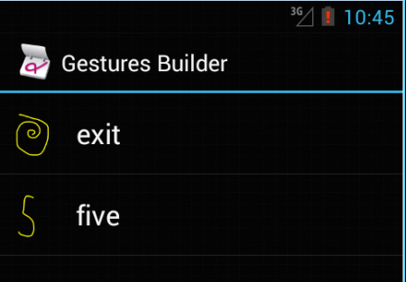 Exit & five gestures added

Pulling a file from the emulator (or phone) e.g. gestures file
To See and grab the gesture file launch in Android Studio: Tools | Android | Android Device Monitor and find the gestures file by clicking on the device and then the File Explorer Tab:
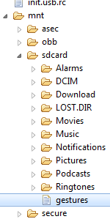 or maybe → 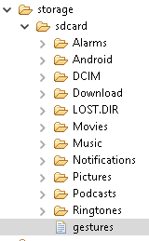
Now find the icon below, hovering over it shows the text: “pull a file from the device”. Then save the gestures file on your computer.
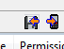 ‘tis the one on the left
Then save the gestures file on your computer.
The gesture file must be copied into your application under folder "res/raw".
Now you can run the next example “Gestures”

Gestures: creating a gesture file Example
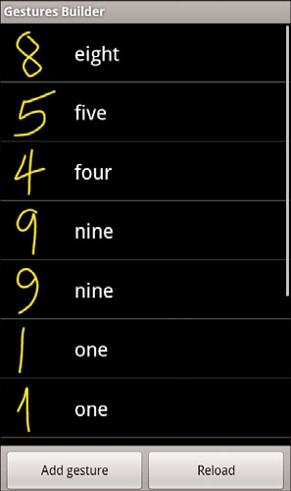
A file of handwritten numbers can be generated using GestureBuilder App

Multiple gestures can have the same name, as providing different examples of the same gesture is useful to improve pattern recognition.

So one & nine have two samples drawn.

After this file is created for all numbers from 0 to 9 in all variants of interest, are to copied to res/raw/numbers and our example program will use this file.

Gestures - Adding the gestures library
drag the gestures file, in this case called ‘numbers’ into Android Studio ‘raw’ folder:
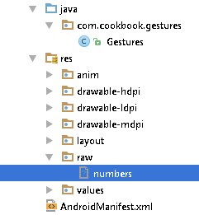

Using Gestures, example program source AS
Dragging the outline of the number 5
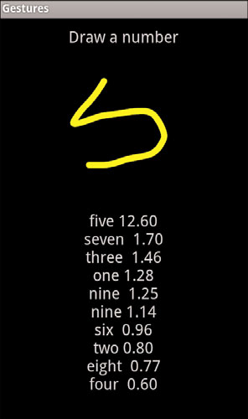

Gestures example Code source AS
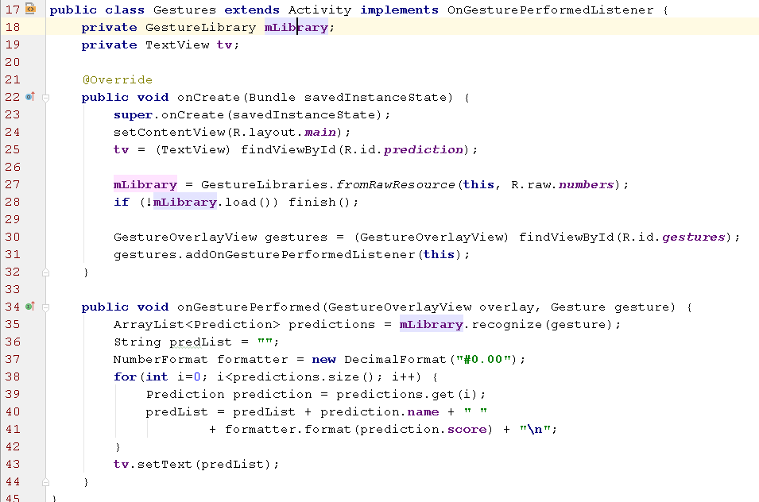

In the Activity code above the GestureLibrary is initialised with the numbers raw resource, one line 27.
The example adds a GestureOverlayView on top of the screen and implements an OnGesturePerformedListener.

Line 28 is a good example of bad programming!! Just exit if the library is missing!
When a gesture is drawn, the gesture is passed to the onGesturePerformed() method, which compares it with all the gestures in the ‘numbers’ library and and returns an ordered list of predictions starting with the most likely.

As long as the first entry has a score greater than one, and it a good bit greater than the next prediction, it’s generally a match.

Gestures Example - Layout File

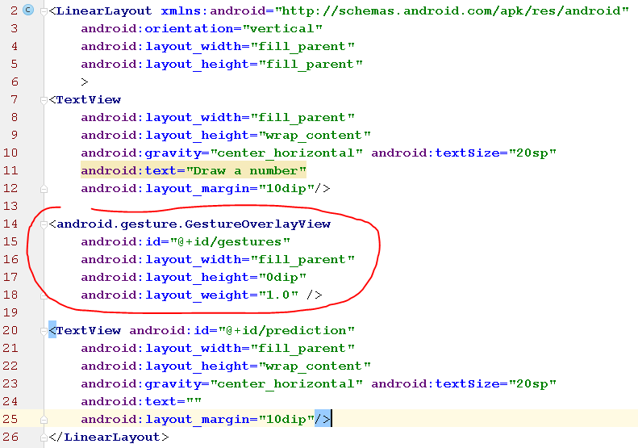
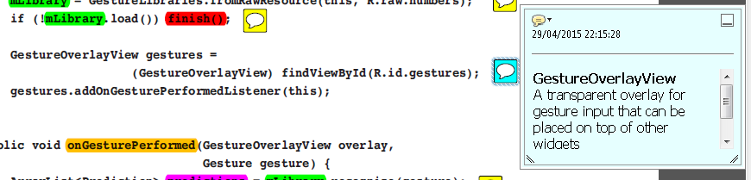

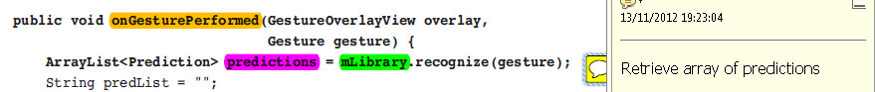Gestures Example - program output

The predictions are shown with TextView tv, and on line 43 in the java source, it expands with “\n” as its height is defined with WRAP_CONTENT
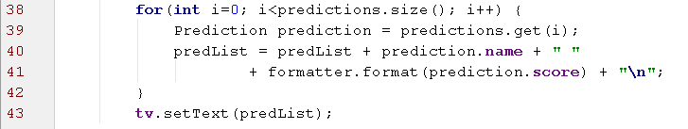

Data Storage Methods

Mobile Apps often need to save App state or other data persistently.

Android OS offers various different storage methods:
- Shared Preferences (including UI Framework)
- SQLite Database
- Java flat file storage

We will cover Shared Preferences and Java flat file storage.

Shared Preferences

SharedPreferences is an interface that an application can use to quickly and efficiently save data in name-values pairs, similar to a Bundle. Comes with a supporting UI framework, if needed.

The information is stored in an XML file on the Android device. Because it’s stored in XML, and not a some binary format, it can easily be read by a text editor which helps with debugging.

Shared preferences are usually used for saving application settings such as user settings, name/password, theme, and other general application properties.

If an App with package called ie.karl.calculator¹ creates a shared preference, the Android OS creates a new XML file on the device in the following directory²:
/data/data/ie.karl.calculator/shared_prefs

- as defined in the Apps Manifest file (and in most cases the source files too)
- to view: Android Studio | Tools | Android | Android Device Monitor; File Explorer tab

Creating and Retrieving Shared Preferences
The shared preferences data is accessible by every component of the application which created it but if desired by other applications also, see mode parameter below.

The shared preferences for an activity can be accessed using the getPreferences() method:
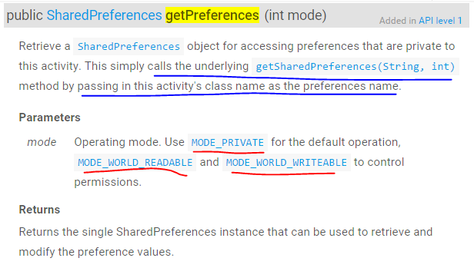
mode controls access to the XML shared preferences file:
- MODE_PRIVATE: Only the calling app has access
- MODE_WORLD_READABLE: All apps can read
- MODE_WORLD_WRITEABLE: All apps can read/write

getPreferences is from the Activity class.

Creating and Retrieving Shared Preferences/2
getPreferences()& getSharedPreferences ( )
getSharedPreferences is used when you use more than one sharedpreferences file in your application - it allows you to specify the name of the XML file, as well as the mode:
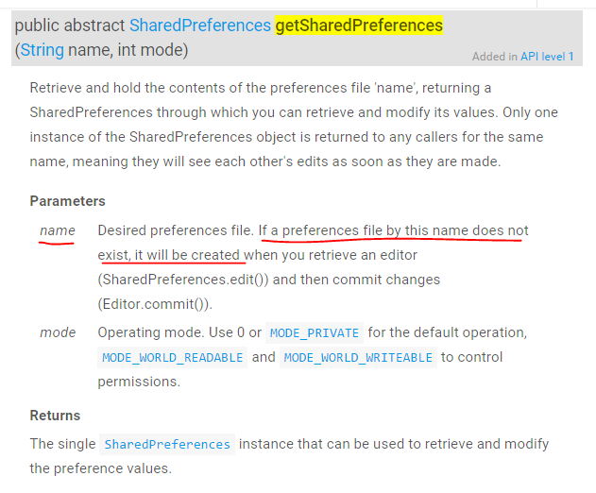
Use getPreferences if a single XML file is sufficient, it then calls getSharedPreferences with the specified filename.
getSharedPreferences is from the ContextWrapper class.
Creating and Retrieving Shared Preferences/3
Having retrieved a SharedPreferences object (using either getPreferences or getSharedPreferences) an SharedPreferences Editor object is needed to write the name-value pairs to the XML file using the putInt etc. methods.
Currently, there are five primitive types supported: int, long, float, String, and boolean. The following code shows how to create and store shared preferences data:
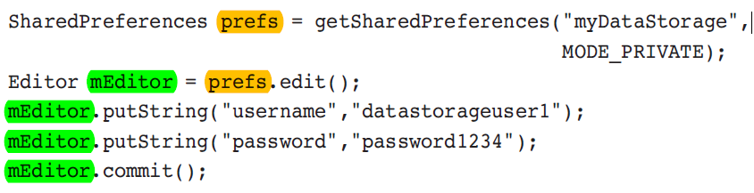
and then retrieve:
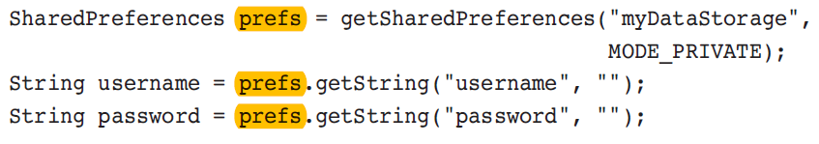
API Link: SharedPreferences Editor showing putString etc

It’s possible to store objects in shared preferences but the object must be converted to some format that will work as String (so no biary code) e.g. JSON see this and this.

Using the Preferences Framework
Android provides a standardized framework for setting preferences across all applications.
The framework uses category preferences and screens to group related settings.
PreferenceCategory is used to declare a set of preferences into one category.
PreferenceScreen presents a group of preferences in a new screen. It represents a top-level Preference that is the root of a Preference hierarchy. A PreferenceActivity points to an instance of this class to show the preferences. To instantiate this class, use createPreferenceScreen(Context).
PreferenceScreen is the root element with two EditTextPreference elements for username and password.
Other possible elements are CheckBoxPreference, RingtonePreference, and DialogPreference.

The Android system then generates a UI to manipulate the preferences. These preferences are stored in shared preferences, which means they can be retrieved by calling getPreferences().

Preferences Framework Example source AS

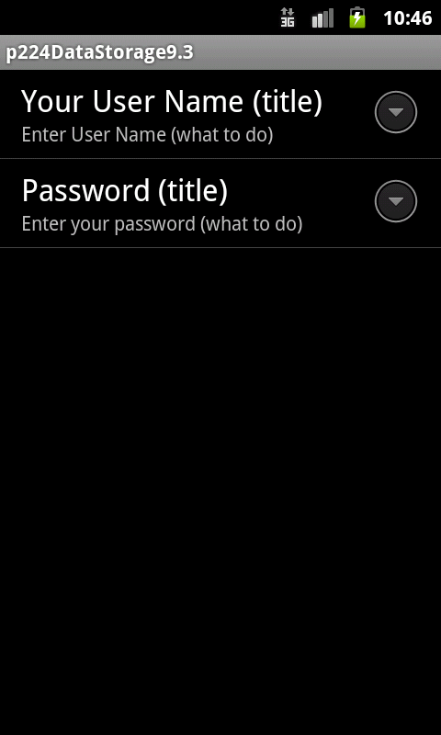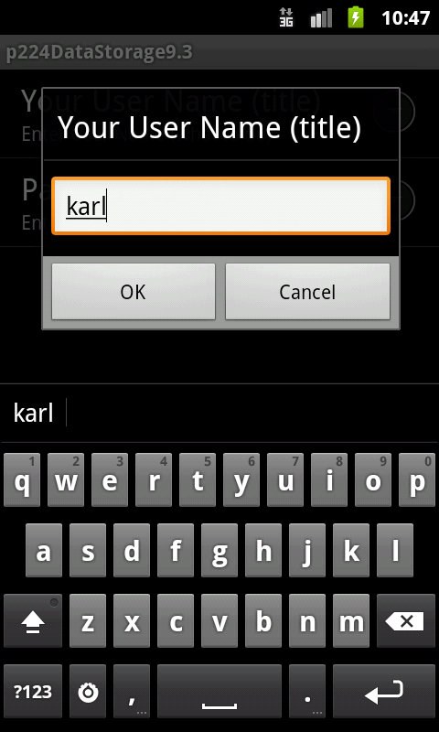

On first running the App, no name and password has been set (screenshots above), the user is asked to enter Name and Password using screens from the preferences framework. Name and password are then saved as preferences.
Subsequent launches of the App sees that name & password have been set so asks for the name and password (next page). They must match what as previously saved in order for the user to uses the App.

Preferences Framework Example/2

Second and subsequent App launches ask for name and password and these are checked against what was previously saved in the preferences file.
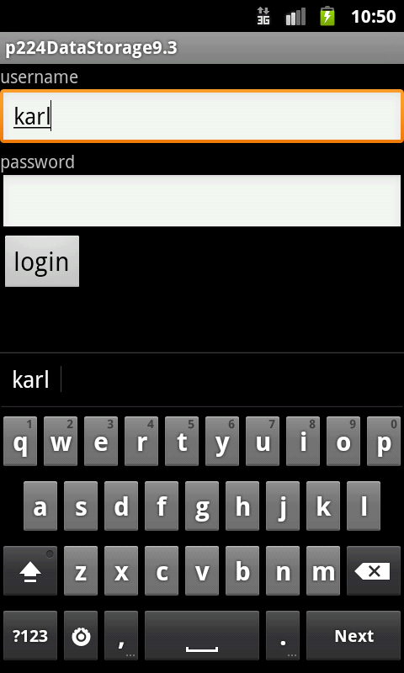

Preferences Framework Example/3

This App uses the preferences defined in this XML file
res/xml/preferences.xml
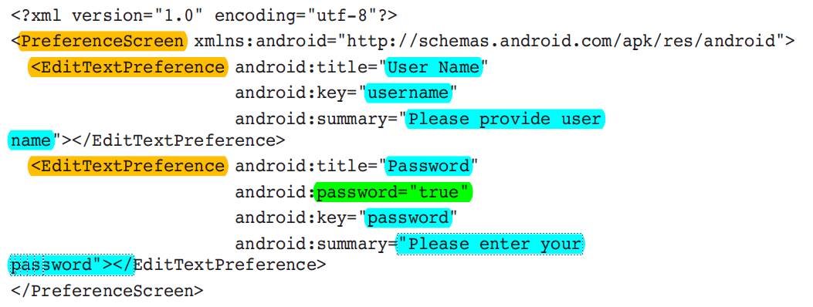
PreferenceScreen is the root element with two EditTextPreference elements for username and password.
Other possible elements are CheckBoxPreference, RingtonePreference, and DialogPreference.

Preferences Framework Example/4
Then an activity extending the PreferenceActivity calls the addPreferencesFromResource() method to include these preferences in the activity:
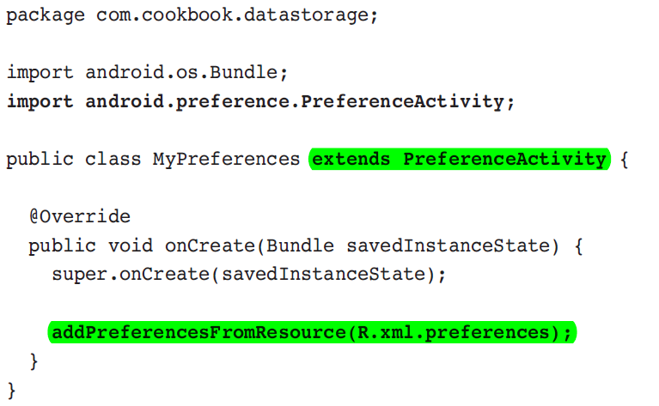

NB addPreferencesFromResource is deprecated as example doesn’t use fragments
Preferences Framework Example/5
The main activity needs to launch the PreferenceActivity when needed (for example, when the Menu button is pressed). Here’ a simple example of showing the preferences upon startup of the activity (we expand this code in the actual solution - see next page)

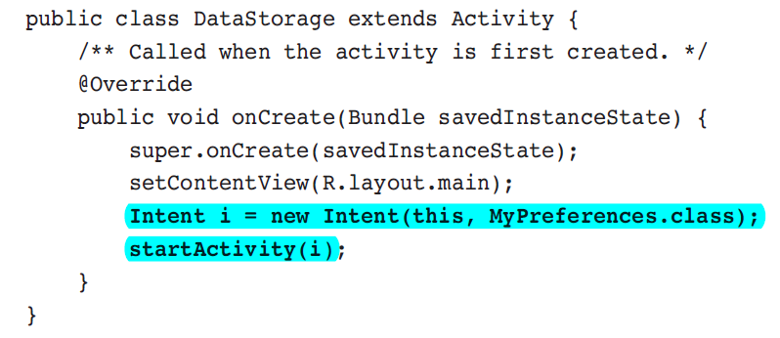
Preferences Framework Example/6
src/com/cookbook/datastorage/DataStorage.java (actual example code)
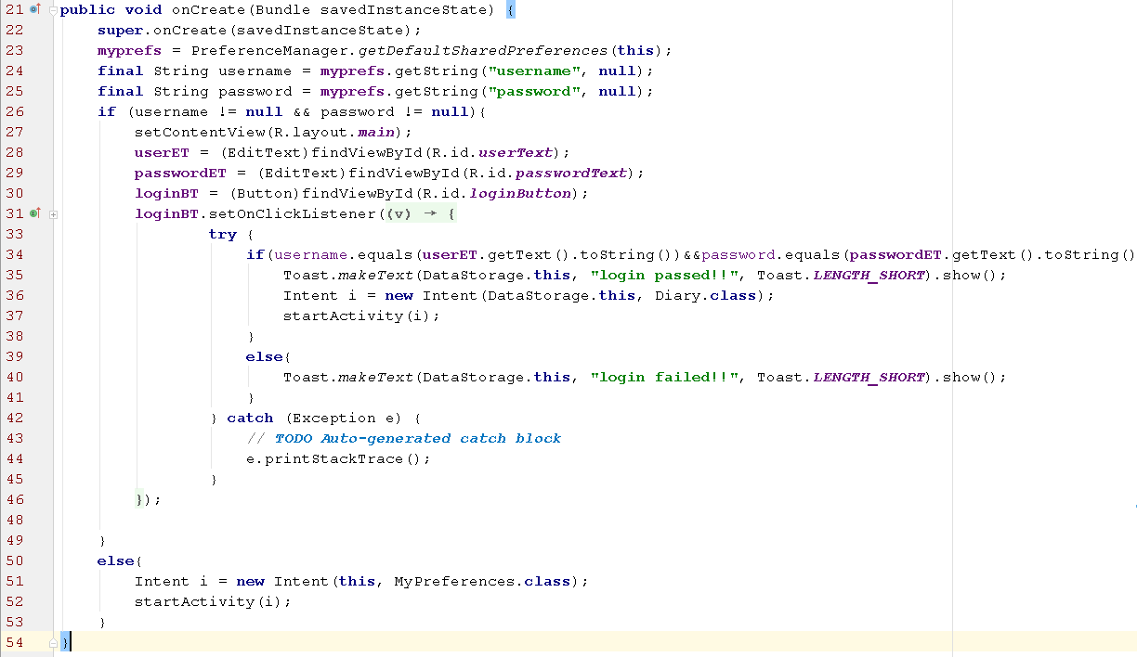
Lines 23-25 Retrieve and check if name & password exist in preferences.
Lines 26+ if name & password exist ask user for name and password using editTexts.
Line 34-37 If entered username and password match then proceed to Diary class.
Line 50+ if name & password don’t exist show the user the preferences screen to allow initial entry of name and password.

Preferences Framework Example - Output

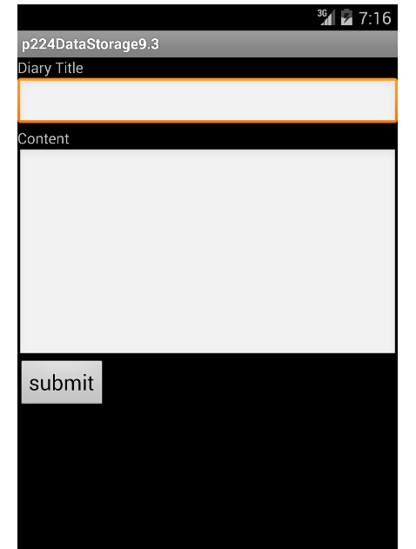

Correct name and password allows access to the diary functionality, screen on right.
This is a fully functional diary App, it uses SQLite - not covered, but see source code link at the start of this example.

Preferences Framework Example - Viewing XML file
You can use the file explorer to pull the datastorage_preferences.xml file - see how to in AdditionFileIO Example later in this document (link).

data/data/com.cookbook.datastorage/shred_prefs/com.cookbook.datastorage_preferences_xml
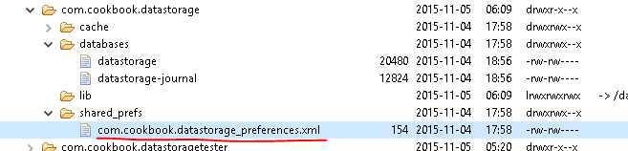

The file when pulled from the emulator showing how name and password were stored:
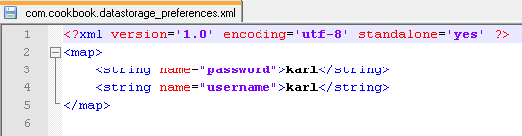

SQLite Database
For more complex data structures, a database provides a quicker and more flexible access method than flat files or shared preferences.
Android provides a built-in database called SQLite that provides full relational database capability utilizing SQL commands.
Each application that uses SQLite has its own instance of the database, which is by default accessible only from the application itself. The database is stored in folder:
/data/data/<package_name>/databases
Seen here from previous example which as well as a preferences file also has an SQLite database:
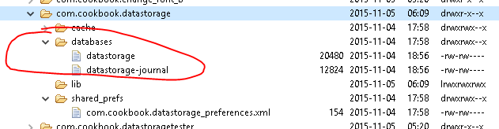

SQL is not covered here, but see Preferences Framework Example (above), look at the project source, for SQLight example code.

File Saving and Loading

In addition to the Android-specific data storage methods (SharedPreferences) and SQLite mentioned previously, the standard java.io.File Java package is available, too.

This provides for flat file manipulation, such as FileInputStream, FileOutputStream, InputStream, and OutputStream

Reading and writing to a file:
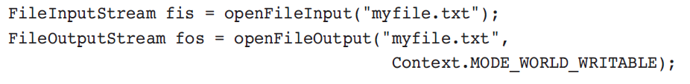

Saving a bitmap camera picture to PNG file:
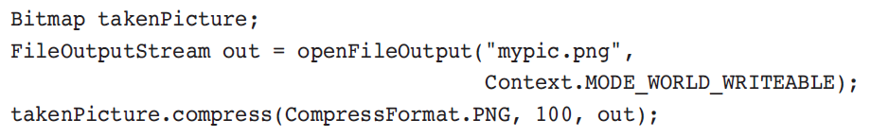

AdditionFileIO File Saving & Loading example source AS

This App is the same as the one covered earlier (link) but with Java.io added for to save the runningTotal int in file “addition_file”.

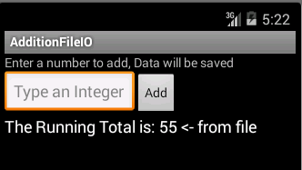

The class and some variables used:
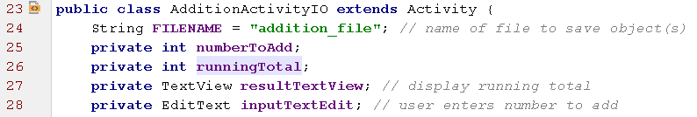
The file name is addition_file (no extension is used)
The int runningTotal is the sum of all numbers entered so far and it is this int that is saved in the file.

AdditionFileIO example startup

Here the App has just been launched and the int runningTotal has been retrieved, with value 55, having been previously saved in the onPause() method:
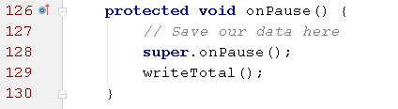

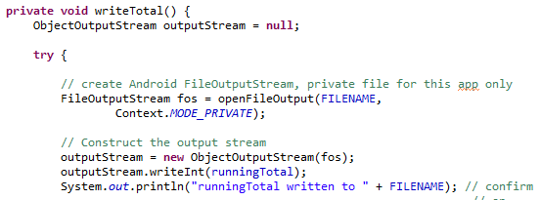

AdditonFileIO: Retrieve runningTotal in onCreate()

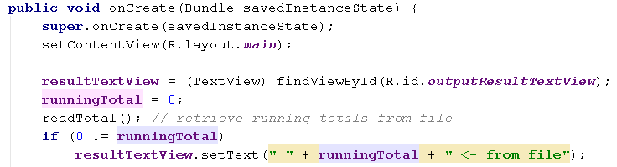

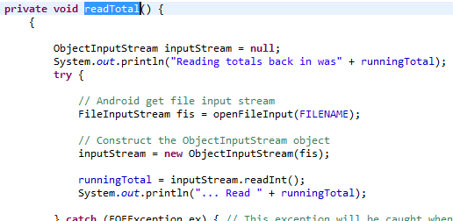

During debugging we may need to see what our App is actually saving in the file so let's do that….
AdditonFileIO pulling the data
To view the saved file, containing the runnintTotal int, see: “Pulling a file from the Emulator" earlier.
In the manifest file the package is: g.k so the file is in:
data/data/g.k/files/addition_file. It’s 10 bytes in size.
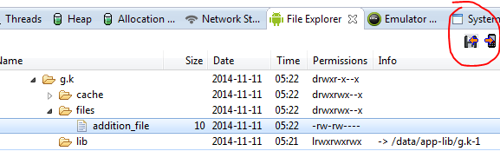
Downloading the addition_file and viewing it with Notepad++ we see:
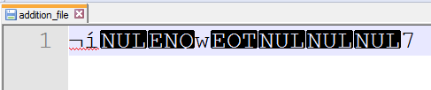
It’s binary code, so we need to view using an online hex editor.
showing the value when it’s 1 in the addition_file (it’s at the end) →
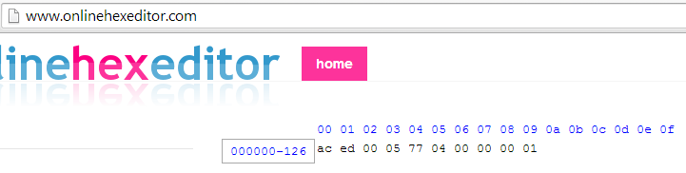
The number 55 (hex is 37) --> 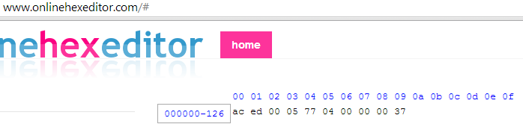

Writing and Reading Objects WriteReadAnyObject source AS

This example Writes and then reads back an object of one of our own classes eg. Person class
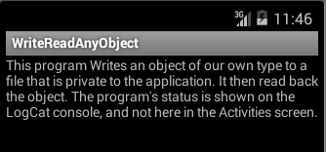
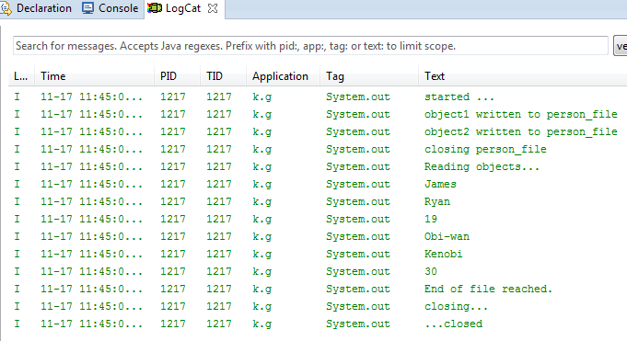

WriteReadAnyObject - code

We want to save objects created from this class we’ve written ourselves:
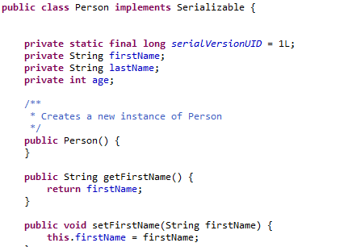
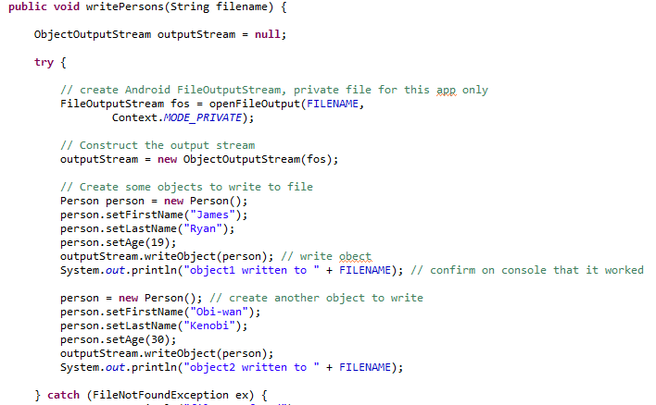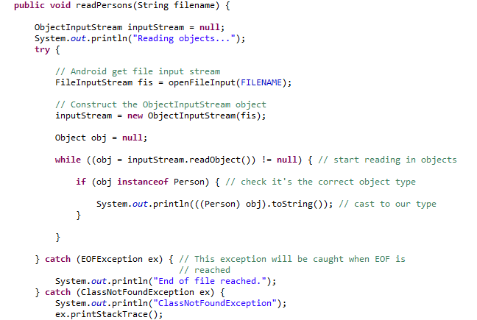

Graphics

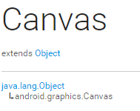
The Canvas class holds the "draw" calls. To draw something, you need 4 basic components: A Bitmap to hold the pixels, a Canvas to host the draw calls (writing into the bitmap), a drawing primitive (e.g. Rect, Path, text, Bitmap), and a paint (to describe the colors and styles for the drawing).

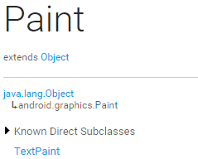

The Paint class holds the style and color information about how to draw geometries, text and bitmaps.

onDraw ( ) from the View class
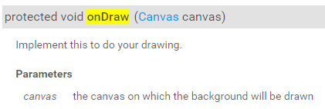

To create a custom component extend the View class, override its onDraw() method and implement your drawing using the Canvas object that is passed in.

In order to draw we also need to to set style and colour and a Paint object is created to do that.

View class

The View class represents the basic building block for user interface components and EditText, Button etc. extend from it.

A View occupies a rectangular area on the screen and is responsible for drawing and event handling.

View is roughly equivalent to the JComponent class in Java Standard Edition and the equivalent of the onDraw(Canvas) method is paint(Graphics).

Drawing in a View

Drawing: Create a Paint object
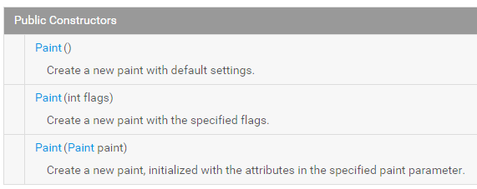

(Flags include dithering, anti-alias, strikethrough etc.)

Paint myPaint = new Paint ( );

Drawing: Set the style
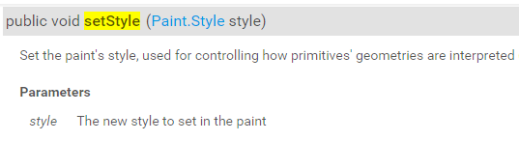

Styles:

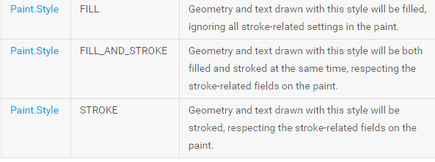

myPaint.setStyle(Paint.Style.FILL);

Drawing: SetColor
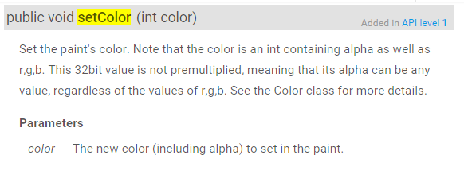

method in the Paint class

Snippet from CustomWidget example below
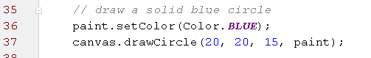

CustomWidget - our own customised view source AS

CustomWidget class draws shapes, is added to our layout along with two TextViews, one is created programmatically.

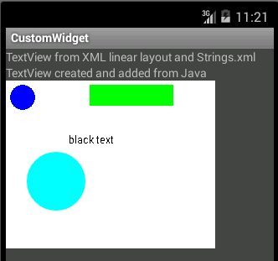

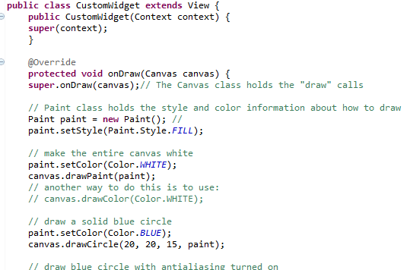

CustomWidget/2

The main.xml layout file with just one TextView
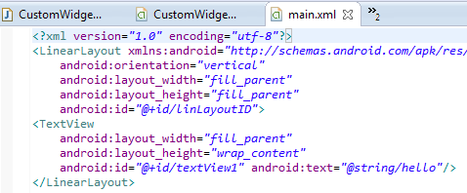

Add another TextView programmatically along with an object of our CustomWidget class in the Activity code:

CustomWidget/3
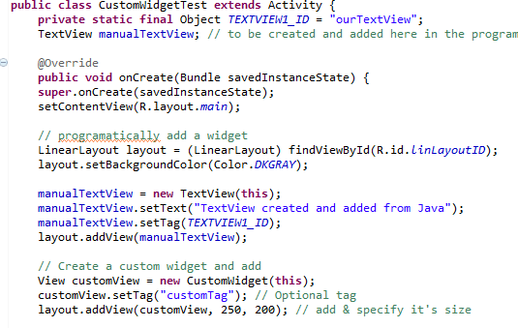

DemoGraphicsView - entire activity as a drawing source AS

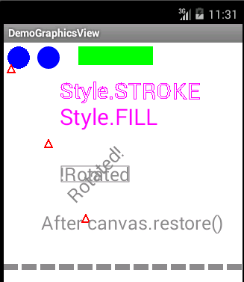

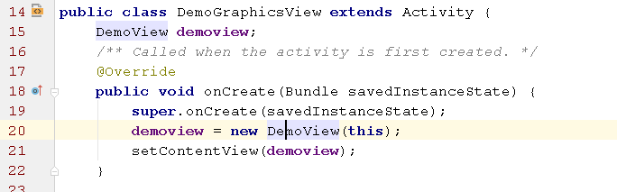
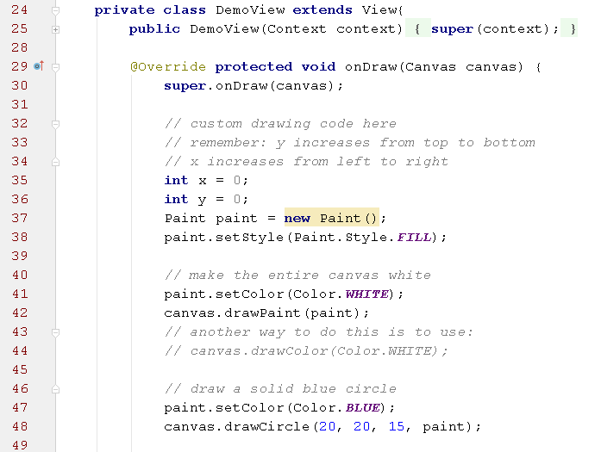

Background Services

(Android Reference) 2017.11.16

Android services are for long-running processes that may need to keep running even when decoupled from an activity. (BCG book “Services and the Command Pattern”)

A service is a component which runs in the background without direct interaction with the user. As the service has no user interface, it is not tied to the lifecycle of an activity.

Examples:
- Playing music even if the “player” activity is destroyed
- Polling the Internet for RSS/Atom
- Feed updates, and maintaining an online chat connection even if the chat client loses focus due to an incoming phone call.
Services can be used in two ways as the following service lifecycle diagram shows (ref).

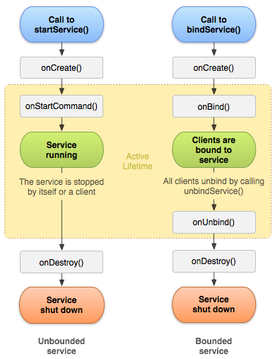
We will look at the left one, starting a service with startService ().

Running in a Background Service (Android Reference)
Most of the operations in an app run in the foreground on the UI (user interface) thread.
Long-running foreground operations can cause problems and interfere with the responsiveness of your user interface, which annoys users and can even cause system errors.
To avoid this, the Android framework offers several classes that help you off-load operations onto a separate thread that runs in the background.

The most useful of these is IntentService.
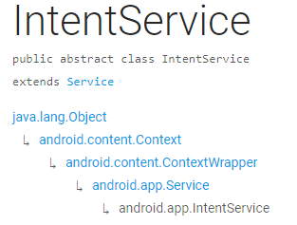
IntentService is a base class for Services that handle asynchronous requests (expressed as Intents) on demand.
Clients send requests through startService(Intent) calls; the service is started as needed, handles each Intent in turn using a worker thread, and stops itself when it runs out of work.

Creating a Background Service (Android Reference)

- The IntentService class provides a straightforward structure for running an operation on a single background thread.
- Handles long-running operations without affecting your user interface's responsiveness.
- Not affected by most user interface lifecycle events
- Can't interact directly with the user interface. To put its results in the UI, you have to send them to an Activity.
- An operation running on an IntentService can't be interrupted.

Create a class that extends IntentService, and within it, define a method that overrides onHandleIntent().
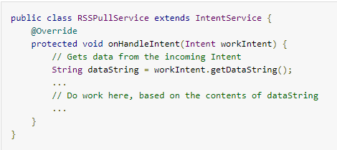

Define the IntentService in the Manifest:
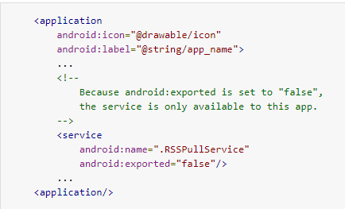
The <service> element doesn't contain an intent filter.
The Activity that sends work requests to the service uses an explicit Intent, so no filter is needed...
..So only components in the same app or other applications with the same user ID can access the service.

Sending Work Requests to the Background Service (ref)

Create an explicit Intent, add work request data to it, and send it to IntentService by calling startService().
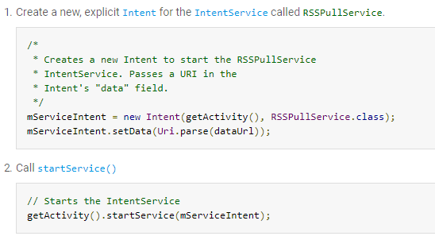

The work request can be called from anywhere in an Activity or Fragment

Once startService() is called, the IntentService does the work defined in its onHandleIntent() method, and then stops itself. See onHandleIntent method in the code two pages back.

Reporting Work Status (ref)
Now we report the status of a work request, running in a background service, to the component that sent the request.

For example to report the status of the request in an Activity object's UI.

The recommended way to send and receive status is to use a LocalBroadcastManager, which limits broadcast Intent objects to components in your own app.

So we’ll report the status from an IntentService….

Report Status From an IntentService
To send the status of a work request in an IntentService to other components, first create an Intent that contains the status in its extended data.
Next, send the Intent by calling LocalBroadcastManager.sendBroadcast(). This sends the Intent to any component in your application that has registered to receive it. To get an instance of LocalBroadcastManager, call getInstance().

For Example...
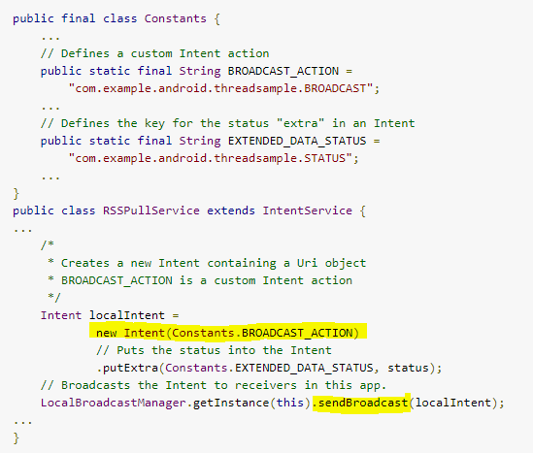

Receive Status Broadcasts from an IntentService…

To receive broadcast Intent objects, use a subclass of BroadcastReceiver.
In the subclass, implement the BroadcastReceiver.onReceive() callback method, which LocalBroadcastManager invokes when it receives an Intent.
LocalBroadcastManager passes the incoming Intent to BroadcastReceiver.onReceive().

For example
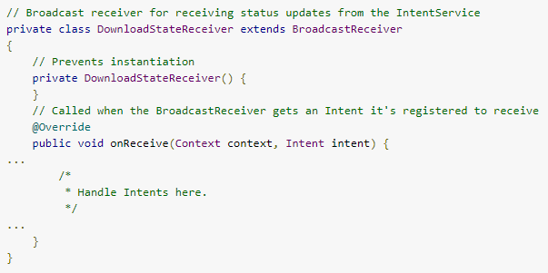

Once you've defined the BroadcastReceiver (above), you can define filters for it that match specific actions, categories, and data. For more info see here.

Service Example Code from the Busy Coder's Guide:
https://github.com/commonsguy/cw-omnibus/tree/v8.8/Service

Countdown Timer service example:
https://deepshikhapuri.wordpress.com/2016/11/07/android-countdown-timer-run-in-background/

End of Lecture Notes

Resources Oct 2017

Android Developer main site
- Developer.Android.com
  - Developer.Android.com / reference / package index - Android API
  - Developer.Android.com/ tools - Developer tools inc Android Studio
  - Developer.Android.com / samples - Code samples in Android Studio format

NewsLetter - subscribe by email
- Newsletter - subscribe by email: http://androidweekly.net/
- Online book “The Busy Coder's Guide to Android Development” €20 annual subscription

Karl Grabe (own + others)
- cit.karlgrabe.com/mob - mobile module
- cit.karlgrabe.com/sources - source code (login required) NB most now in this document
  - cit.karlgrabe.com/sources … / Android book examples
  - cit.karlgrabe.com/sources … / (other) android examples
- Assignment Procedure
- eBook: The Busy Coder's Guide to Android Development. Free old versions. Source Code
- Book: Android Developer's Cookbook eBook (1st Edition) http://ow.ly/6rAAB; ebook + paper:http://ow.ly/6rACk. try eBay too. Outdated at this stage.
- Android Icon Creating tool (use chrome browser)
- Android platform distribution
- Android Google Apps Play Store
- Android market publishing login - publish your app
- Java Programming language basics (sources)
- Tomi Ahonen Blog Twitter: @tomiahonen
- New boston android tutorial. haven't tried it.
- genymotion emulator
- free student tools: https://education.github.com/pack
- Android Design in Action - youtube playlist discussion various elements of Android Design.
- Ins and outs of Gradle
- Model View Presenter on Android
- Create an Android wear watch face
- Android weather library
- uTube tutorial “Android Tutorial for Beginners” via Danielle Murphy

Simon Long (own + others)
- Simon’s youTube tutorials
- http://mcom.cit.ie/staff/computing/SimonLong/ (link broken 2014.10.05)
- http://www.i-programmer.info/programming/android/
- http://code.tutsplus.com/series/android-user-interface-design--mobile-22577
- https://www.coursera.org/course/android

new nov 2014 “The Secrets to App Success on Google Play” : http://android-developers.blogspot.ie/2014/11/introducing-new-guide-secrets-to-app.html
- Utilities (not mobile) http://www.econsultant.com/i-want-freeware-utilities/

Android Lab Exercises.

Exercise 1.0 First Program
- Create an android program using the steps in getting started
- Find the "hello word" text in the (Strings or Layout) XML document and modify

Exercise 1.1 Using Graphical Layout Builder
- Create an Android program using the steps in getting started
- Open main.xml in graphical mode and drag user interface element onto the screen and run the apps to see how they work
- Take a new activity and open its layout resource XML file. Here e.g. the main.xml file.
- Click the Design tab.This shows how the layout would look graphically.
- Click the Text Tab to see the XML Code. Replace all the XML code by pasting over with this:
<?xml version="1.0" encoding="utf-8"?>
<LinearLayout xmlns:android="http://schemas.android.com/apk/res/android"
android:orientation="vertical"
android:layout_width="fill_parent"
android:layout_height="fill_parent"
>
</LinearLayout>
- You now have a blank LinearLayout with out any components.
- Click and drag a layout from the Layouts Selector to the COMPONENT TREE. For example choose LinearLayout horizontal and drag over to the component tree. Repeat so you now have one overall LinearLayout (vertical) and two horizontal ones embedded e.g.:
- Click and drag any some components to the two horizontal LinearLayouts.
- Add a Button and CheckBox to the first row.
- Add TextViews to the second Horizontal LinearLayout, and a TimePicker to the third.
- Add a Spinner and VideoView view etc.

Exercise 1.2 Addition Example source AS
Get the Addition example working. Look at the code, try making some changes.

Exercise 2.0 LifeCycle - Using System.out instead of 'Toast'
- Load and run “Activity Lifecycle” Listing 2.6 folder / source
- Change the Toast messages to System.out.println("....
- Find the LogCat view - click on
- Run the program and see the LogCat tab.
- Looking at the LogCat tab look at the type of messages being shown when you exit and launch your program. It will be difficult to see the System.out message so we can create filter for them - see next step. OR select
- To create LogCat filter to filter out our “System.out.println” messages. In Android Studio - on RHS of logcat tab there’s a popdown menu to the right - select edit filter configuration. Name your filter (e.g. sys out) and enter System.out (NB no println added on) in the Log Tag field.
- Now only our System.out messages are displayed in LogCat e.g. : 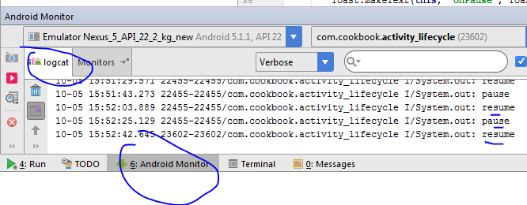
- Try Exiting the app (tap return) going to the home screen (tap home) System.out messages in LogCat. Change emulator orientation (Cntrl-F12 on older emulators or the icon ) which will destroy/recreate the app and check LogCat again for System.out messages to see that it was destroyed.

Exercise 2.1 LifeCycle - see how long a variable is kept in memory
- Continuing with ActivityLifecycle.java)...
- In the onCreate( ) method generate a random number using Math.random() method. Save in a variable.
- Modify each of the Toast or System.out.println () methods to display that random number to see when it changes (indicating the original number was lost)
- Run, change orientation, pause, exit, restart etc. the app to see what things cause the original random number to be lost.

Exercise 2.2 LifeCycle - Saving a variable using onRestoreInstanceState( )
- Load the modified version of ActivityLifecycle_kg. it's in the sources folder here. See the new code in the onCreate method and also the 2 methods onRestoreInstanceState and onSaveInstanceState and observer how the variable resumeCnt is saved/lost when you exit the app or switch to a different app or change the Apps orientation (Ctrl -F12).
- Again - Run, change orientation, pause, exit, restart etc. the app to see what things cause resumeCnt value to be lost..

Exercise 3.0 Tapping a Button displays a message
- Create an app with one activity - the activity has a Button and a TextView.
- Declare an int variable.
- Tapping on the button increments a counter and it's new value is displayed in the TextView.
- See the code example in the “Addition” above to get you going. “Addition” source: source AS

Exercise 3.1 One Activity Launches another
- Run the project with this Listing earlier in notes ( menuscreen.java, the one with one button launching a second activity).
- Add a new button to MenuScreen labelled 'show scores' that launches an 3rd activity - call is 'show scores' which displays some text. See section 4 of main index Add a second activity. Don’t forget to update the manifest file with the new 3rd activity.

Exercise 4.0 Controlling width & height of UI Widgets
- Create an activity with a horizontal linear layout with buttons (see: Controlling Width and Height of UI Elements #heading=h.rqararb06h5v)
- See the impact of changing the following parameters for each button: width, height (wrap & fill parent, exact dimension)
- Change the padding (left right etc)
- Replicate the screen shots from the book - figs 4.4, 4.5, 4.6

Exercise 4.1 Combining Horizontal & Linear layouts
- Using top level Vertical Layout that fills the screen horizontally.
- Add 4 Horizontal Layouts - e.g 4 rows
- The 1st horizontal layout (row) contains 4 TextView items (columns) right-justified and each taking up the same space. The column headings are:
  - Expense
  - 2011
  - 2012
  - 2013
- Add 3 rows each with TextView containing expenses data e.g. Electricity 500 550 900
- Make some data values to big e.g. 200,000 or more to see how the layout manages.
- Check behaviour with the emulator in horizontal and vertical portrait modes.
- Add a 5th row with 1 button on the far right labelled 'Clear'
- Pressing the clear button sets the expenses in columns 2, 3, and 4 to '0'. So some java code needed.

Exercise 4.2 Programming Relativelayout
- Run example 'programmatic layout' in sources folder (web source here)
- Add a new TextView in the top right hand corner

Exercise 4.3 Capturing Text from an EditText Object
- Create a new project and use code on P101 of book to capture text from user.
- Set the entry mode for the EditText to only accept numbers
- When the enter key is pressed the activity converts the entered text to an int and adds it to previous numbers added

Exercise 5.0 Battery Status
Create an App that displays a coloured bar to display a car battery's status. The battery voltage is entered into the App as a floating point number.
Display a bar graph as follows:
0-9.5 - Red (battery dead)
>9.6 <12 - Yellow (battery poor)
>12 <14.4 - Green (battery good)
>14.4 - Blue (Alternator faulty)

Exercise 6.0 Secret Text
Develop an App that has a TextField and Label GUI components.
When a piece of text is entered the App 'encrypts' the text by replacing each letter using the following mapping:

MLKJIHGFEDCBA
NOPQRSTUVWXYZ
So A -> Z, N-> M, B-> Y, O->L etc
Display the encrypted text back in the TextField (so pressing enter should give you back the original text).
Display the length of the entered text using the Label.

Exercise 7.0 Missing Letter Game
Develop an App or application that displays a word at random with a random letter(s) missing. The user has to guess the missing letter(s) by entering it/them into a text field(s). You canuse an array or vector to store some words internally in the program.

Some tips intended for karl but may be of use:
copy / don’t replace windows 10 - compare files, check everything
emulator window too big to move: Alt-Space, m. then use arrow keys/mouse

file | other settings… | editor | File encodings

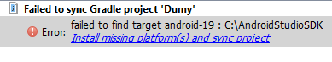
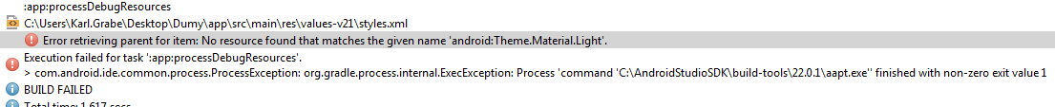
Material.Light theme require API level 21 for project. Set Project Build Target for project from Properties->Android->Project Build Target to API 21.
(try delete v21 folder)

Android Studio Shortcuts (from this link)
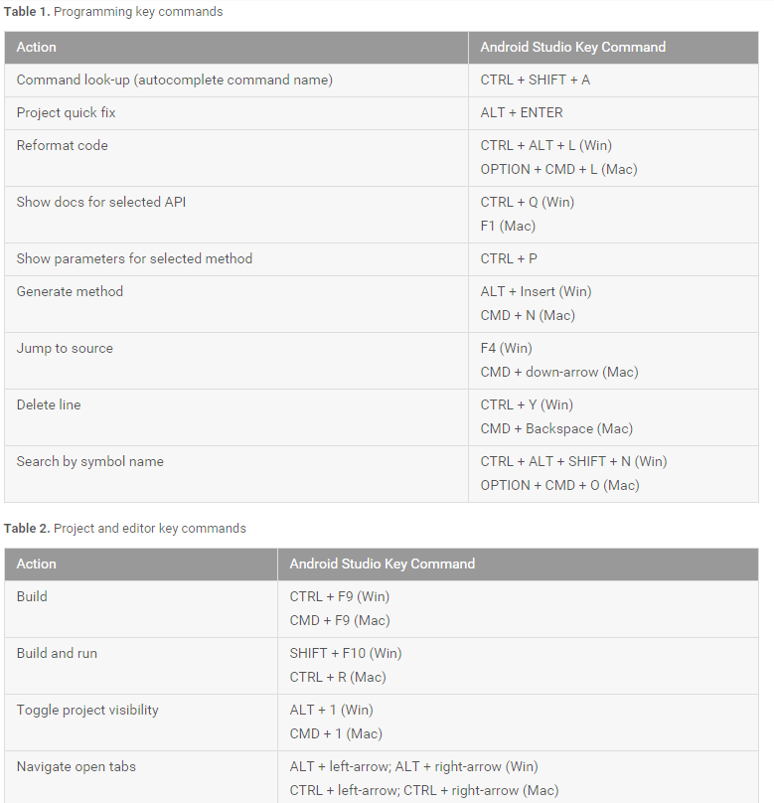

misc stuff to be tidied away somewhere
/* // Prevent back button exiting app
public boolean onKeyDown(int keyCode, KeyEvent event) {
System.out.println("in onKeyDown: " + keyCode);

if (keyCode == KeyEvent.KEYCODE_BACK) {
System.out.println("not exiting!");
return true; // consume event, hence do nothing on back button (so you can't exit)
}
return super.onKeyDown(keyCode, event);
}*/

+++ Karl’s to do list:
- callbacks from XML & why not to do it
- support libraries, appcompat activity
- fragments
- actionbar
- localisation summary/tips, check creating locale folders
- notification, better example with fragments
- TextWatcher
- embed video + https://www.udacity.com/course/developing-android-apps--ud853
- Add legend - e.g. orange outline = API docs

